

FASHION DEMAND FORECASTING USING MACHINE LEARNING AND DOMAIN ADAPTATION
TrendCast: XGBoost demand forecasting with importance-weighted domain adaptation on H&M retail data
A project report submitted in partial fulfilment of the requirements for the award of the degree of
BACHELOR OF TECHNOLOGY
in
COMPUTER SCIENCE AND ENGINEERING
Submitted by
B SHILPA | 23K91A0547
B HARI NARAYANA | 23K91A0544
A RANI THEJASWINI | 23K91A0516
A SANJANA | 23K91A0511
Batch A17 (CSE-A)
Under the esteemed guidance of
DEEPTHI
[DESIGNATION]
DEPARTMENT OF COMPUTER SCIENCE AND ENGINEERING
TKR COLLEGE OF ENGINEERING & TECHNOLOGY (AN AUTONOMOUS INSTITUTION)
Medbowli, Meerpet, Balapur, Hyderabad, Telangana - 500 097
Academic year [ACADEMIC YEAR]

CERTIFICATE
This is to certify that the project report entitled "Fashion Demand Forecasting Using Machine Learning And Domain Adaptation" is a bonafide record of the work carried out by B SHILPA (23K91A0547), B HARI NARAYANA (23K91A0544), A RANI THEJASWINI (23K91A0516), A SANJANA (23K91A0511), in partial fulfilment of the requirements for the award of the degree of Bachelor of Technology in Computer Science and Engineering, during the academic year [ACADEMIC YEAR], under my supervision.

Project Guide | Head of the Department | Principal
Deepthi | [HOD NAME] | [PRINCIPAL NAME]
[DESIGNATION] | Department of Computer Science and Engineering | TKR College of Engineering & Technology

External Examiner: [NAME AND SIGNATURE]
Place: [PLACE]
Date: [DATE]

DECLARATION
We hereby declare that the project report entitled "Fashion Demand Forecasting Using Machine Learning And Domain Adaptation", submitted to the Department of Computer Science and Engineering, TKR College of Engineering & Technology, in partial fulfilment of the requirements for the award of the degree of Bachelor of Technology in Computer Science and Engineering, is a record of original work carried out by us under the guidance of Deepthi, [DESIGNATION]. The results embodied in this report have not been submitted to any other university or institution for the award of any degree or diploma.

B SHILPA 23K91A0547
B HARI NARAYANA 23K91A0544
A RANI THEJASWINI 23K91A0516
A SANJANA 23K91A0511

Place: [PLACE]
Date: [DATE]

ACKNOWLEDGEMENT
We express our sincere gratitude to our project guide, Deepthi, [DESIGNATION], for valuable guidance, encouragement and constructive suggestions throughout this project.
We thank [HOD NAME], Head of the Department of Computer Science and Engineering, for providing the facilities and support needed to complete this work, and [PRINCIPAL NAME], Principal, TKR College of Engineering & Technology, for the encouragement given to us.
We thank the project coordinators and all faculty and staff members of the department for their help, and our families and friends for their constant support.
We also acknowledge the authors of the base paper, L. N. Mishra, B. Senapati, S. K. Nayak and A. J. Rangari, whose explainable retail demand forecasting work framed this project; H&M Group, whose released articles, customers and transactions tables made an honest test on real retail data possible; and the maintainers of the open-source software used here: XGBoost, scikit-learn, pandas, NumPy, FastAPI, React, Vite, Recharts and Playwright, and LightGBM, which we used only as a comparison model.

B SHILPA
B HARI NARAYANA
A RANI THEJASWINI
A SANJANA
Fashion retailers must decide how much of each article to stock before demand is known, and a forecasting model fitted on one sales context loses accuracy when it is moved to another. This project builds TrendCast, a demand-forecasting application that turns H&M-style retail transactions into daily units sold per article, forecasts them with XGBoost on calendar, price, product-attribute, lag and rolling features, and adds importance-weighted domain adaptation, in which a logistic domain classifier gives each source row the weight p/(1-p), so that a model trained on one sales domain can be tested on a shifted one. It is delivered as a FastAPI service with 22 routes and a 13-page React console, and is covered by 39 unit and API tests and a 26-check smoke test.
We measured it on a real subset of the H&M data: the 300 best-selling articles, 684,392 transaction rows, 2018-09-20 to 2019-01-04. On the last 20 % of the dates (the Christmas peak and the January sales), XGBoost reaches an RMSE of 11.09 against 12.89 for the product's moving-average baseline, but not against simply repeating yesterday's demand (9.22). Domain adaptation as shipped improved RMSE on 2 of 6 source-target pairs; the one clear gain (+11.9 %) disappears (-2.8 %) once the source model may not train on dates inside the target test window, and badly scaled weights can make XGBoost predict a constant. Recursive 7 to 30-day forecasts were worse than a flat 7-day mean. We report these findings as measured, with the controls that expose them.
Keywords: fashion demand forecasting, XGBoost, domain adaptation, covariate shift, importance weighting, retail analytics, inventory planning, explainability, H&M dataset.

TABLE OF CONTENTS
CERTIFICATE i
DECLARATION ii
ACKNOWLEDGEMENT iii
TABLE OF CONTENTS v
LIST OF FIGURES viii
LIST OF TABLES x
LIST OF ABBREVIATIONS xi
CHAPTER 1: INTRODUCTION 1
1.1 Introduction to the Project Domain 1
1.2 Background and Motivation 2
1.3 Problem Statement 2
1.4 Need for the Proposed System 3
1.5 Project Objectives 3
1.6 Scope of the Project 4
1.7 Project Contributions 4
1.8 Limitations and Assumptions 5
1.9 Organization of the Report 5
CHAPTER 2: LITERATURE SURVEY 6
2.1 Overview 6
2.2 Base Paper Analysis 6
2.3 Gradient Boosting and Forecasting Competitions 8
2.4 Explainability of Forecasting Models 9
2.5 Covariate Shift and Domain Adaptation 9
2.6 Fashion and New-Product Forecasting 10
2.8 Strengths and Limitations of Existing Research 10
2.9 Research Gap 11
CHAPTER 3: FEASIBILITY STUDY 13
3.1 Technical Feasibility 13
3.2 Economic Feasibility 14
3.3 Operational Feasibility 14
3.4 Schedule Feasibility 14
3.5 Advantages and Constraints 15
CHAPTER 4: SYSTEM REQUIREMENTS AND ANALYSIS 16
4.1 Existing System 16
4.2 Limitations of the Existing System 16
4.3 Proposed System 16
4.4 Advantages of the Proposed System 17
4.5 Functional Requirements 17
4.6 Non-Functional Requirements 18
4.7 Hardware Requirements 18
4.8 Software Requirements 18
4.9 User Roles and System Constraints 19
CHAPTER 5: SYSTEM DESIGN 20
5.1 Design goals and architecture 20
5.2 High-level workflow 21
5.3 Data flow diagrams 22
5.4 UML design 24
5.5 Database and state design 26
5.6 Core algorithm design 27
5.7 Module design 28
5.8 API design 29
5.9 User interface design 30
CHAPTER 6: METHODOLOGY AND SOFTWARE IMPLEMENTATION 31
6.1 Overall methodology 31
6.2 Dataset 31
6.3 Preprocessing 32
6.4 Feature engineering 33
6.5 Algorithm choice and justification 34
6.6 Mathematical formulation 35
6.7 Model architecture and training 37
6.8 Domain adaptation procedure 37
6.9 Application architecture 38
6.10 API design 39
6.11 Security and error handling 40
6.12 Installation and execution 41
CHAPTER 7: SYSTEM TESTING 42
7.1 Testing strategy 42
7.2 Unit testing 42
7.3 Integration and API testing 43
7.4 Functional testing 44
7.5 Security testing 44
7.6 Validation and edge cases 45
7.7 Performance testing 45
7.8 User acceptance and the browser walk-through 46
7.9 Limits of the testing done 47
CHAPTER 8: RESULTS AND OUTPUT SCREENS 48
8.1 Experimental set-up 48
8.2 Output screens 48
8.3 Forecast accuracy 52
8.4 Multi-day recursive forecast 53
8.5 Domain adaptation 54
8.6 Explainability 56
8.7 Inventory impact 57
8.8 Products without history 57
8.9 Comparison with the base paper 58
8.10 Sample inputs and outputs 58
8.11 Success and failure analysis 59
8.12 Limitations of the evaluation 59
8.13 Objectives versus outcomes 60
8.14 Summary of findings 60
CHAPTER 9: CONCLUSION 61
9.1 Summary 61
9.2 Objectives achieved 61
9.3 Key findings 61
9.4 Practical applications 62
9.5 Known limitations 62
CHAPTER 10: FUTURE SCOPE 64
10.1 Improvements to the existing system 64
10.2 Additional features 64
10.3 Scalability and deployment 64
10.4 Further research 65
REFERENCES 66
APPENDIX A: IMPORTANT CODE 68
A.1 Cleaning (`preprocessing.py`) 68
A.2 Importance weights and weighted training (`domain_adaptation.py`) 68
A.3 The domain-adaptation route (`backend/main.py`) 68
A.4 One domain pair with its controls (`scripts/run_experiments.py`) 69
A.5 Safe MAPE (`evaluation.py`) 69
APPENDIX B: INSTALLATION AND USER GUIDE 71
B.1 Requirements 71
B.2 Installation and start with run.bat 71
B.3 Manual start 71
B.4 Configuration (`.env`) 71
B.5 Using the console 72
B.7 Tests and experiments 72
B.8 Troubleshooting 72
APPENDIX C: ADDITIONAL SCREENS 73

LIST OF FIGURES
Figure 1: Layered architecture of TrendCast: React console, Vite proxy, FastAPI application with 22 routes, the src/ pipeline modules, and in-memory state plus joblib model files. 20
Figure 2: End-to-end workflow: upload, clean and merge, daily demand, features, chronological split, baseline and XGBoost, domain adaptation, evaluation, forecast and optional AI explanation. 21
Figure 3: Context diagram (DFD level 0): TrendCast as one process with the analyst, the dataset provider and the optional Gemini service. 22
Figure 4: DFD level 1: seven processes (ingest, aggregate, features, train, adapt, evaluate and forecast, explain) and the data stores. 22
Figure 5: DFD level 2: the domain-adaptation process 5.0 expanded into six sub-processes. 23
Figure 6: UML class diagram: the FastAPI application, request models, the shared state, and the src/ modules with their main functions. 24
Figure 7: Sequence diagram: running domain adaptation from the browser, from the click to the before-and-after report. 25
Figure 8: Use-case diagram with the analyst, the optional Gemini service and the developer or evaluator. 26
Figure 9: Logical entity-relationship diagram: TrendCast has no database; the entities are the uploaded tables, derived tables and model files. 26
Figure 10: Flowchart of the core algorithm: from raw transactions to the recursive forecast, with the leakage guards marked. 27
Figure 11: Flowchart of importance-weighted domain adaptation as implemented in domain_adaptation.py and the /api/domain/run route. 28
Figure 12: Model architecture: 31 input features in four groups feeding one XGBoost regressor, with the baselines and the weighted variant. 28
Figure 13: Data Upload page with the transactions file (39.1 MB) and the articles file chosen and the row limit set to 0, meaning no limit. The optional customers file was not supplied. 49
Figure 14: Data quality report after loading: 605,178 transactions, 276,168 customers, 300 products, 29 columns, 0 missing values, 0 duplicate rows remaining and 79,214 rows removed of the 684,392 read. 49
Figure 15: Data Exploration: 605,178 units sold, 30,481 product-days over 107 days, and the daily total demand line with the pre-Christmas peak. 49
Figure 16: Data Exploration, lower part: units by department and by colour group and the other category charts that show where the demand is concentrated. 49
Figure 17: Demand Analysis: the aggregated daily table, one row per article per day with units sold, mean price and channel, beginning with article 108775015 on 2018-09-20 (21 units). 49
Figure 18: Feature Engineering page before the table is built, with the description of what will be added (calendar, cyclical, lag and rolling features). 49
Figure 19: Feature table built: 31,094 rows, 36 columns and 31 model inputs, with the list of input names and a preview of the first rows. 50
Figure 20: Model Training: chronological split (24,579 training rows to 2018-12-13, 6,515 test rows from 2018-12-14) and the test metrics of the default XGBoost run: RMSE 11.065, MAE 6.991, MAPE 140.5 %, R2 0.337, with the moving-average baseline in the comparison below (RMSE 12.891, R2 0.101). 50
Figure 21: Model comparison table and bar chart for the moving average and XGBoost, switchable between RMSE, MAE and MAPE. 50
Figure 22: Tuned XGBoost: RMSE 10.341, MAE 6.881, MAPE 147.0 %, R2 0.421, and the best parameters found (subsample 0.7, 400 trees, minimum child weight 5, depth 12, learning rate 0.01, column sample 0.6). 50
Figure 23: Domain Adaptation form: domain-defining column (sales channel), source value (channel 1) and target value (channel 2), with the explanation of the weight p/(1-p). 50
Figure 24: Result header for channel 1 to channel 2: the domain classifier is 66.3 % accurate (a moderate shift), 12,240 source rows, 18,854 target rows of which 9,890 are held out for testing, and a mean instance weight of 1.58. 50
Figure 25: Distribution and box plot of the most shifted feature (lag_1), and the before-and-after cards: RMSE 18.989 (0.0 % worse), MAE 7.404 (0.6 % worse), MAPE 51.7 % (0.2 % worse), R2 0.435 (0.1 % worse). The page reports a result that is not an improvement without softening it. 51
Figure 26: Model Evaluation: baseline versus XGBoost with the RMSE, MAE and MAPE charts. 51
Figure 27: Domain adaptation before-versus-after table (RMSE 18.9835 to 18.9893, improvement -0.03 %) and the top-20 feature importance of the tuned model, led by is_month_end, lag_1, day_of_year, month_cos and rolling_mean_7. 51
Figure 28: Demand Forecast settings and result: article 108775015 (Vest top, 3,735 units sold), 14-day horizon, 383.1 units in total and 27.37 units per day. 51
Figure 29: History-and-forecast chart for the same article and the dated forecast table, which starts on 2019-01-05, the day after the data end. 51
Figure 30: AI Insights page. Gemini is configured but returned 503: This model is currently experiencing high demand; the application shows the message and every other page keeps working. A retry script tried eight times and never obtained an answer, so no AI explanation text could be captured. 51
Figure 31: Change in target RMSE for the six pairs: as shipped, with weights rescaled to mean 1, in the time-clean protocol, and with randomly shuffled weights. 54
Figure 32: Distribution of the importance weights for the channel pair and for the department pair Knitwear to Trouser. Weights far below the minimum child weight of 1 prevent XGBoost from splitting. 55
Figure 33: RMSE improvement of the adapted model for the six source-target pairs under four protocols. 63
Figure 34: Additional screen: landing page, light theme, with the model, split, lag, rolling, weight and MAPE summary card. 73
Figure 35: Additional screen: landing page, dark theme. 73
Figure 36: Additional screen: Overview page after the whole pipeline has run, with the progress checklist and the step cards. 73
Figure 37: Additional screen: About page with the goal, the techniques used and the data tables. 73
Figure 38: Additional screen: Feature engineering page before the feature table is built. 74
Figure 39: Additional screen: Domain adaptation form with the domain column, source and target values. 74
Figure 40: Additional screen: Model evaluation page in the dark theme, with the comparison table and the RMSE chart. 74

LIST OF TABLES
Table 1: Abbreviations used in this report xi
Table 2: Objectives of the project and their outcome 3
Table 3: Base paper at a glance 7
Table 4: Base paper and TrendCast compared 8
Table 5: Comparison of the surveyed work 10
Table 6: Technical risks and the measurements that retired them 13
Table 7: Functional requirements 17
Table 8: Non-functional requirements and measured values 18
Table 9: Hardware 18
Table 10: Software 18
Table 11: Modules, sizes and responsibilities. 28
Table 12: The 22 routes of the TrendCast API. 29
Table 13: The real subset used for every reported number. 32
Table 14: The 31 model inputs. 33
Table 15: Model comparison on the real subset (test window 2018-12-14 to 2019-01-04, 6,515 rows). 34
Table 16: Feature-group ablation (XGBoost default, mean of three seeds). 35
Table 17: Test levels, tools and results. 42
Table 18: Unit tests of the pipeline, grouped by module (tests/test_pipeline.py). 43
Table 19: Security-relevant behaviour of the product. 44
Table 20: Edge cases, expected behaviour and observed result. 45
Table 21: Stage times of the pipeline on the real subset (one run, seconds). 46
Table 22: Latency of repeated calls (20 each, milliseconds). 46
Table 23: Data used in the evaluation. 48
Table 24: Test-window accuracy of all models (RMSE and MAE in units per article-day; lower is better, R2 higher is better). 52
Table 25: Feature-group ablation (default XGBoost, mean of three seeds). 52
Table 26: Recursive forecast accuracy by horizon (RMSE; WAPE % by band). 53
Table 27: Domain adaptation, RMSE on the held-out target rows (mean of five seeds). Change columns are % change in RMSE (positive = better). 54
Table 28: Mean absolute SHAP value (units of demand) and gain importance of the ten most influential features. 56
Table 29: Shortfall and excess of each forecast on the test window (units and share of actual demand). 57
Table 30: Forecasting articles unseen in training (5-fold grouped cross-validation). 57
Table 31: TrendCast against the base paper (different data; indicative only). 58
Table 32: Article 108775015, last actual days and 7-day recursive forecast (default XGBoost). 59
Table 33: The six project objectives against what was measured. 60
Table 34: Objectives against outcomes 61
Table 35: Domain adaptation on six source-target pairs (RMSE on held-out target rows, mean of 5 seeds; improvement in percent) 62
Table 36: Settings read from .env 71
Table 37: Pages and what to do on them 72
Table 38: Common problems 72

LIST OF ABBREVIATIONS
Table 1: Abbreviations used in this report
Abbreviation | Expansion | Abbreviation | Expansion
AI | Artificial Intelligence | MASE | Mean Absolute Scaled Error
API | Application Programming Interface | ML | Machine Learning
CORS | Cross-Origin Resource Sharing | NFR | Non-Functional Requirement
CSV | Comma-Separated Values | PDP | Partial Dependence Plot
DA | Domain Adaptation | PFI | Permutation Feature Importance
DFD | Data Flow Diagram | R2 | Coefficient of determination
ER | Entity-Relationship | REST | Representational State Transfer
FR | Functional Requirement | RF | Random Forest
GBM | Gradient Boosting Machine | RMSE | Root Mean Square Error
HTTP | Hypertext Transfer Protocol | SHAP | SHapley Additive exPlanations
ICE | Individual Conditional Expectation | SKU | Stock-Keeping Unit
JSON | JavaScript Object Notation | UI | User Interface
KPI | Key Performance Indicator | UML | Unified Modeling Language
MA | Moving Average | WAPE | Weighted Absolute Percentage Error
MAE | Mean Absolute Error | XAI | Explainable Artificial Intelligence
MAPE | Mean Absolute Percentage Error | XGBoost | eXtreme Gradient Boosting

CHAPTER 1: INTRODUCTION

1.1 Introduction to the Project Domain
Fashion retail is one of the hardest settings for demand forecasting. A garment is designed, produced and sold within a season or two, so most articles have a short life; demand follows the calendar (weekday, month, holidays, sales periods) and the weather; prices and promotions move demand; and every new collection puts articles on the shelf that have no sales history at all. A retailer that forecasts too high is left with unsold stock that must be marked down; one that forecasts too low loses the sale and the customer. Demand forecasting, the task of predicting how many units of each product will sell on each future day, is therefore the input to purchasing, allocation to stores and channels, and replenishment.
Two families of tools are used. Classical statistical methods such as exponential smoothing and ARIMA describe each series with a few parameters and are easy to explain, but they assume smooth, stationary behaviour that promotions and holidays routinely break. Machine-learning methods treat forecasting as supervised learning on a table of engineered features, and gradient-boosted decision trees [8], [2], [3] have become the standard tool for such tables: in the large M5 retail forecasting competition, entries built on boosted trees with hand-made features were among the best [6]. This project follows that route and uses XGBoost, the regularised gradient-boosting library of Chen and Guestrin.
A second problem sits on top of the first. A model learned from one sales context, for example one channel, one product group or one season, is often used in another whose data are distributed differently. Statisticians call this covariate shift when the inputs change but the relation between inputs and demand does not [10], and domain adaptation is the family of methods that respond to it [13]. This project implements the simplest and most inspectable of them, importance weighting, in which each source row is given a weight that says how much it resembles the target domain [10], [12], and measures honestly whether it helps.
Terms used throughout: an article is one sellable product variant (H&M's article_id); demand is the number of units of an article sold on a day; a domain is a subset of the data defined by a column such as the sales channel; the source domain is the one the model is trained on and the target domain the one it must serve; a lag feature is the demand a fixed number of days earlier; RMSE, MAE and WAPE (sum of absolute errors divided by the sum of actual demand) measure forecast error, and R2 the share of variance explained.

1.2 Background and Motivation
The project starts from the batch's base paper, "Explainable retail demand forecasting: a hybrid LightGBM-SHAP framework for inventory optimization" [1]. Its authors pair a LightGBM forecaster with four explanation levels (permutation importance, partial-dependence plots, SHAP and individual conditional expectation) because planners distrust forecasts they cannot interpret, and validate it on the UCI Online Retail II transactions (1.07 million rows, 4,631 products), reporting an RMSE of 33.71 and an R2 of 0.243 on daily product-level demand. That paper tests one data set from one market. It does not ask what happens when the model leaves the market it was trained on, and it does not treat products with no history; its own limitations section says that multi-domain validation would strengthen the work.
This is the gap the batch abstract sets out to fill: add domain adaptation so that a model trained in one retail context can serve a differently distributed one, and measure forecasts with RMSE, MAE, MAPE and R2. The data chosen is the H&M Personalized Fashion Recommendations release [23]: real transactions of a global fashion retailer with article attributes, two sales-channel codes and prices. We used a real subset of it, the 300 best-selling articles of the first transaction shard (684,392 rows from 2018-09-20 to 2019-01-04), because the full table of 31.8 million rows does not fit the in-memory design of the application on the machine used.

1.3 Problem Statement
The batch problem statement lists four difficulties: forecasting models trained on one market lose accuracy when applied to another; new products have no sales history, so conventional forecasting cannot cover them; fashion trends shift within a season and invalidate models trained on older data; and forecasts delivered without explanation are not trusted by inventory planners. The need is a forecasting system that adapts across markets and categories and explains the drivers behind each forecast.
We restate the problem as one we can test. Given daily unit sales of fashion articles in a source domain, build a forecaster that is accurate on a held-out future period, and measure whether re-weighting the source rows by their similarity to a differently distributed target domain makes the forecaster more accurate on that target, compared with the same model without re-weighting and with simple controls. Forecast accuracy, the effect of the adaptation and the explanation of the forecast drivers are each reported with the number that supports them.

1.4 Need for the Proposed System
• Accuracy across contexts. Retailers sell through several channels, product groups and seasons. A single model fitted on pooled history can hide a context in which it performs badly; the first step to correcting that is to measure the shift and the loss it causes.
• A tool, not a notebook. Forecasting experiments usually live in notebooks that only their author can rerun. A guided, gated application (upload, explore, features, train, adapt, evaluate, forecast) lets a planner repeat the whole analysis on new files.
• Honest baselines. A model is only useful if it beats something simple. The system always shows a moving-average baseline next to the learned model, and our experiments add naive and rolling-mean forecasts.
• Leakage-safe evaluation. Random train and test splits let a time-series model see the future. The system splits by date, shifts every lag and rolling feature by a day, and tunes with time-ordered cross-validation.
• Explanation. Planners override forecasts they cannot interpret. The evaluation page shows which features the model relies on; this report adds an exact SHAP analysis offline.

1.5 Project Objectives
The six objectives set for the batch, and where this report addresses each, are listed in the table below. The outcome column is the short version; Chapter 8 gives the measurements and Chapter 9 the full verdict.
Table 2: Objectives of the project and their outcome
No. | Objective | Outcome (summary)
1 | Collect historical fashion retail sales data and engineer seasonal, pricing and category features | Achieved: real H&M subset, 31 model inputs, leakage guards. H&M has no promotion or fabric columns.
2 | Train gradient-boosting models such as XGBoost to forecast demand at product and category level | Achieved at article (product) level; no separate category-level model.
3 | Apply domain adaptation to transfer the model across markets and product categories | Implemented and applied to sales-channel, product-group and department domains; the two channels are the only 'markets' in the data.
4 | Compare adapted and non-adapted models on a target market with a different data distribution | Done on 6 pairs x 5 seeds with four controls; adaptation helped on 2 pairs.
5 | Explain forecast drivers so planners understand why demand is predicted to move | Partly: gain importance in the application; exact TreeSHAP offline; no per-forecast explanation in the application.
6 | Evaluate with MAE, RMSE and MAPE, and translate error into inventory impact | Metrics achieved; inventory impact (under- and over-stock units) computed offline only.

1.6 Scope of the Project
In scope. Uploading the three H&M tables; validation, cleaning and merging; daily demand per article; exploration charts; feature engineering; chronological split; moving-average, XGBoost (with optional time-ordered tuning) and, as comparison, random-forest and LightGBM models; importance-weighted domain adaptation on a chosen column and pair of values with a before-and-after report; evaluation with RMSE, MAE, safe MAPE and R2; recursive 7, 14 and 30-day forecasts; an optional plain-language explanation from the Gemini service; a FastAPI back end with 22 routes and a React front end of 13 pages; the original Streamlit application; and the tests and scripts that reproduce every number in this report.
Out of scope. Training on the full 31.8 million-row table; images or text of the products; promotion, price-plan or weather data (not in the files); multi-store or regional hierarchies; probabilistic forecasts; deep-learning and adversarial domain adaptation; automatic ordering or optimisation of stock levels; multi-user accounts and persistent storage; and deployment beyond a single machine.

1.7 Project Contributions
1. An end-to-end, gated forecasting application. A pipeline from raw H&M tables to forecasts, exposed through 22 REST routes and a 13-page console, with plain-language gating messages and 400, 409 and 422 error handling, and covered by 39 unit and API tests and a 26-check smoke test.
2. Leakage-safe feature engineering and evaluation. Lag and rolling features are built from values shifted by one day, the split is by date, and tuning uses time-ordered folds; this report adds a rolling-origin backtest.
3. A working implementation of importance-weighted domain adaptation that reports the domain-classifier accuracy, a per-feature shift table, the weight statistics and a before-and-after metric table.
4. An honest evaluation of that adaptation. Six source-target pairs, five seeds and four controls (target-only oracle, unweighted pooling, shuffled weights, a time-clean protocol) show when the adaptation helps and when it does not, and expose a weight-scaling defect that makes XGBoost predict a constant.
5. Measured comparison with simple forecasts and with the base paper's findings, including a feature-group ablation, exact TreeSHAP attributions, an inventory-impact calculation and an unseen-article (cold-start) test, all reproducible from the scripts in the repository.

1.8 Limitations and Assumptions
• Small slice of the data. 300 articles and 107 days (2018-09-20 to 2019-01-04); no earlier year to learn yearly seasonality from, and a test window (Christmas peak, January sales) that is unusually hard.
• Cleaning understates demand. Exact duplicate rows (79,214 of 684,392, 11.6 %) are dropped, but identical H&M rows are usually real repeat purchases.
• Channel labels and known inputs. The files code the channels 1 and 2 without saying which is which; the daily channel is the most frequent channel of that day while demand counts both; the day's price and channel are assumed known when forecasting.
• Adaptation protocol. The source model may train on dates inside the target test window; a time-clean control measures what that costs.
• Not in the application. Cold start, SHAP and inventory impact were measured offline; the optional AI Insights page depends on an external service that answered 503 or timed out during our screenshot run.

1.9 Organization of the Report
Chapter 2 surveys the literature and analyses the base paper. Chapter 3 studies feasibility and Chapter 4 sets out the existing and proposed systems and the requirements. Chapter 5 gives the design: architecture, workflow, data flow and UML diagrams, the logical data model and the user interface. Chapter 6 describes the methodology and implementation: data, preprocessing, the XGBoost model, the domain-adaptation method with its mathematics, the API, security and error handling, and how to install and run it. Chapter 7 reports testing. Chapter 8 presents every output screen, the model results, the comparison with the base paper's findings and the objectives against outcomes. Chapter 9 concludes and Chapter 10 sets out the future scope. The references and three appendices (important code, installation and user guide, additional screens) follow.

CHAPTER 2: LITERATURE SURVEY

2.1 Overview
The survey has four threads, because the project joins four bodies of work. The first is gradient-boosted forecasting of retail demand and the forecasting competitions that established it. The second is explainability of such models, which is the subject of the base paper. The third is covariate shift and domain adaptation, which is what the base paper does not do and what this project adds. The fourth is fashion forecasting and the new-product (cold-start) problem, which motivates why adaptation matters in fashion. The base paper [1] is analysed in depth in Section 2.2; every claim about it in this report was checked against the paper itself, which is in the batch folder. Claims about the other works come from their own abstracts or from the base paper's account of them, and are limited to what those sources state.
The batch literature survey (5.LITERATURE SURVEY.docx) lists five works: the base paper and four 2026 papers on AI-driven demand forecasting and inventory. We searched for the four by title and could not locate them online, so they are listed in the reference list as the batch gave them and are not described or used for any claim here.

2.2 Base Paper Analysis
Reference. L. N. Mishra, B. Senapati, S. K. Nayak and A. J. Rangari, "Explainable retail demand forecasting: a hybrid LightGBM-SHAP framework for inventory optimization," IEEE Access, vol. 14, 2026, doi 10.1109/ACCESS.2026.3675540 [1].
Problem. Gradient-boosting models predict retail demand well, but inventory planners distrust predictions they cannot interpret and override them even when the model beats their heuristics. The authors build on an earlier LightGBM study that explained its model only with global methods (permutation importance and partial-dependence plots) and add two further levels, so that planners can see both why a specific forecast was made and whether an average effect hides different behaviour in different products.
Method. A seven-stage pipeline: preprocessing, feature engineering, LightGBM training with Optuna tuning under time-ordered cross-validation, and four explainability levels. Level 1 is permutation feature importance (a global ranking); level 2 is partial-dependence plots (marginal effects); level 3 is SHAP, specifically TreeSHAP, for instance-level attribution; level 4 is individual conditional expectation (ICE), whose crossing curves reveal products that react to a feature in opposite ways and so justify segment-specific inventory policies. The authors name this fourth level as their main extension.
Data and preprocessing. The UCI Online Retail II data: transactions of a UK-based online giftware retailer from December 2009 to December 2011, about 1.07 million rows and 4,631 products. Preprocessing removes rows with non-positive quantity, missing customer identifier or non-positive unit price, and cancelled invoices; aggregates quantity by product and date; keeps products with at least 1,000 units sold and 150 active days; and removes outliers per product by the interquartile-range rule. The target is daily demand per product, forecast one day ahead.
Features. 41 engineered features in five categories (temporal, lag, rolling and derived features among them). Temporal features include weekday, month, quarter and sine-cosine encodings of the cycles; lag features are demand 1, 7, 14 and 28 days earlier; rolling statistics use windows of 3, 7, 14 and 28 days. The authors state a temporal-integrity rule: every feature at time t uses only information from t-1 or earlier, and rolling statistics are shifted by one step so that the current day is excluded. TrendCast adopts the same rule.
Table 3: Base paper at a glance
Aspect | What the base paper reports
Model | LightGBM, Optuna Bayesian (TPE) tuning, 30 trials, 3-fold TimeSeriesSplit, about 2 minutes
Baselines | Naive lag-1; 7-day moving average; linear regression; random forest (100 trees, depth 10); XGBoost and CatBoost (30 Optuna trials each)
Headline result | RMSE 33.71 and R2 0.243 on daily product-level demand; MASE 0.799 (20.1 % better than naive)
Against baselines | CatBoost 33.83 RMSE (difference 0.12, p = 0.917, not significant); XGBoost 33.89; random forest 0.45 RMSE worse; moving average 2.86 worse; naive lag-1 14.06 worse
Statistics | Paired t-tests on per-sample absolute errors with Bonferroni correction; 1,000-resample bootstrap confidence intervals; Durbin-Watson 1.91 on the residuals
Dominant features | Permutation importance: rolling_mean_28 (191.23) and price_relative (168.83) far ahead of all others
Ablation | Removing rolling features costs the most (change in R2 of -0.064); rolling features alone reach R2 0.184, 76 % of the full model, with 17 of 41 features; removing derived features costs -0.036

Interpretation by the authors. The three boosting libraries converge to within 0.5 % RMSE, which matches what the M5 competition reported, so the choice among them is made on speed and categorical handling. The R2 of 0.243 is modest, and the authors explain it with three factors: demand for individual products is intermittent and 'lumpy'; no promotion, holiday, weather or economic features were used on purpose, to isolate the contribution of transaction-derived features; and the data are a wholesale-like market with extreme heterogeneity across 4,631 products.
Limitations stated by the authors. One data set from one market, so generalisation to brick-and-mortar or other retail formats is unproven; a stationarity assumption that retail dynamics often break, with a need for drift monitoring; no external factors; a price-relative feature that divides by the product's mean price over all time and so leaks a little future information; SHAP's cost at scale; and one-day-ahead forecasting only, so multi-step error accumulation is not examined.
What this project takes and what it adds. We keep the problem (daily product-level demand), the temporal-integrity rule, the lag and rolling feature families, time-ordered tuning, a naive and moving-average baseline, and the interest in explanation. We change the learner to XGBoost, work on the H&M fashion data, and add what the paper lists as missing: a test of moving the model across contexts (domain adaptation) and a multi-step forecast. We do not reproduce the four-level explanation pipeline inside the application: the application shows gain importance, and exact TreeSHAP is computed offline. The table below sets the two side by side.
Table 4: Base paper and TrendCast compared
Aspect | Base paper | TrendCast
Learner | LightGBM (plus XGBoost, CatBoost, RF, linear baselines) | XGBoost (plus LightGBM, RF and simple baselines as comparison)
Data | UCI Online Retail II, UK online giftware, 1.07 M rows, 4,631 products, 24 months | H&M, fashion, subset of 684,392 rows, 300 articles, 107 days
Horizon | One day ahead | One day ahead (evaluation) and recursive 7, 14 and 30 days (application)
Features | 41, five categories, rolling dominant | 31, calendar, price, attributes, lag and rolling; lag and rolling dominant
Explanation | PFI, PDP, SHAP, ICE | Gain importance in the application; TreeSHAP offline
Distribution shift | Not treated; listed as a limitation | Importance-weighted domain adaptation, 6 pairs x 5 seeds, four controls
Tuning | Optuna TPE, 30 trials | RandomizedSearchCV, 10 iterations x 3 time-ordered folds
Significance tests | Paired t-test, bootstrap CI | Five seeds with standard deviation; no significance tests

2.3 Gradient Boosting and Forecasting Competitions
Gradient boosting builds an additive ensemble of shallow trees, each fitted to the residual errors of the ensemble so far [8]. XGBoost [2] added regularisation of the tree weights, sparsity-aware split finding and a parallel implementation, and became the default tool for tabular data; LightGBM [3] sped up training with histogram-based splitting and leaf-wise growth. Random forests [7], which average independent deep trees, are the usual non-boosted comparison.
For retail, the evidence is the M5 competition on Walmart item sales [6]. The base paper summarises it as showing that boosted trees with hand-made features matched or beat deep-learning models, and concludes that feature engineering is the main accuracy lever. That is the reason this project uses a tabular booster with lag, rolling and calendar features rather than a neural forecaster, and our ablation (Chapter 8) agrees: the lag and rolling features carry most of the accuracy.

2.4 Explainability of Forecasting Models
SHAP assigns each feature a Shapley value, the average marginal contribution of the feature over all orders of adding features, so that the contributions add up exactly to the prediction minus a baseline [4]. TreeSHAP computes these values exactly and quickly for tree ensembles [5]. XGBoost can output them directly (the pred_contribs option), which is how we compute them without a further library. The base paper layers permutation importance, partial dependence and ICE on top, for global ranking, marginal effects and heterogeneity. Its argument for ICE is that two products can respond to the same feature in opposite ways and a partial-dependence curve then averages to a misleading flat line.
Our measurement is a reminder that the choice of importance method matters. The built-in gain importance of the trained XGBoost ranks is_month_end, lag_1 and quarter highest, whereas the exact SHAP attribution on the test rows ranks lag_1 first by a wide margin; the rank correlation between the two is only 0.40. Gain overstates features, especially calendar columns, that are split on often but contribute little to the prediction.

2.5 Covariate Shift and Domain Adaptation
When a model is trained on data from one distribution and applied to another, its error on the new data can be much higher than on held-out data from the old one. The theory of learning from different domains [14] bounds the target error by the source error plus a measure of the divergence between the domains, which explains why unrelated domains transfer badly. Surveys of transfer learning [13] group the remedies by what changes between domains.
Covariate shift is the case in which the distribution of the inputs differs but the relation of demand to inputs is the same. Shimodaira [10] showed that weighting each training example by the ratio of the target to the source input density gives consistent fitting when the model is mis-specified. Sugiyama et al. [11] applied the same weights to cross-validation. Bickel et al. [12] avoid estimating two densities by modelling the shift with a discriminative classifier that tells training inputs from test inputs; the ratio of its class probabilities gives the weight. This classifier route is the one TrendCast implements: the weight of a source row is p/(1-p), where p is the domain classifier's probability that the row belongs to the target.
Neural methods learn features that are the same in both domains, either adversarially [15] or by aligning second-order statistics [16]. They were developed and tested largely on images, need more data and training than a tabular model, and are outside the scope of this project; we list them as future work. Two practical weaknesses of importance weighting are known from the literature and are visible in our results: the weights become extreme when the domains barely overlap, and they depend on how well the classifier is calibrated.

2.6 Fashion and New-Product Forecasting
Fashion adds two difficulties to retail forecasting. Thomassey [17] reviews clothing sales forecasting and names volatile demand, strong seasonality, many short-lived items and scarce history as the main obstacles, and proposes fuzzy, neural and data-mining models whose value is judged by their effect on the bullwhip effect in the supply chain. Recent work concentrates on items with no history. Ekambaram et al. [18] predict a new product's sales from its images, attributes and external factors such as holidays, events, weather and discounts with an attention-based multi-modal encoder-decoder, and report better accuracy and interpretability than k-nearest-neighbour baselines. Singh et al. [19] analyse large-scale fashion sales to find which attributes drive demand and forecast demand for new items from them. Skenderi et al. [20] fuse image-based Google Trends with product images and metadata on VISUELLE, a public data set of 5,577 products sold from 2016 to 2019, and forecast the whole horizon at once; Papadopoulos et al. [21] predict the visual popularity of new fashion products with a multimodal and quasi-autoregressive network. Outside fashion, Zhou et al. [22] forecast new-product life cycles from static descriptors and similar products with a conditional diffusion model, and report better point and probabilistic forecasts than classical baselines on Intel product life cycles.
These studies treat the cold start as the main problem and rely on images, text or external signals that the H&M files used here do not contain in usable form. TrendCast has no cold-start mode; Chapter 8 reports an offline test that shows how much (and how little) product attributes and the calendar can do for an unseen article.

2.8 Strengths and Limitations of Existing Research
The table below lists each surveyed work with its approach, data, reported result and limitation, using only what its paper or abstract states.
Table 5: Comparison of the surveyed work
Work | Approach | Reported result | Limitation
Mishra et al. (base paper) | LightGBM with four explainability levels (permutation importance, PDP, SHAP, ICE); 41 features; Optuna tuning | RMSE 33.71, R2 0.243; XGBoost 33.89, CatBoost 33.83; MASE 0.799 | One dataset and one market; no domain shift or new-product handling; one-step horizon; its own price feature leaks slightly (stated by the authors)
Chen and Guestrin | XGBoost: regularised, sparsity-aware tree boosting with a weighted quantile sketch | Became the default tabular learner; accepts per-row sample weights | Assumes training and test data come from one distribution
Makridakis et al. (M5) | Large retail forecasting competition; boosted trees with hand-built features among the best entries (as summarised in the base paper) | Gradient boosting matched or beat deep learning when given rich features | One retailer; hierarchical sales, not new-market transfer
Shimodaira | Weights the training loss by the ratio of target to source input density under covariate shift | Weighted fitting is the consistent choice when the model is mis-specified | Needs a density-ratio estimate; weights can become very large
Bickel et al. | Learns the covariate-shift weights with a discriminative (logistic) source-versus-target classifier | Avoids density estimation; the idea TrendCast implements | Weights depend on classifier calibration and overlap between the domains
Ben-David et al. | Bounds target error by source error plus a divergence between the domains | Explains why unrelated domains transfer badly | Bound is loose and not directly computable on tabular demand
Thomassey | Reviews clothing sales forecasting and proposes fuzzy, neural and data-mining models | Models judged by their effect on the bullwhip effect | Pre-dates gradient-boosted tabular models; no domain adaptation
Ekambaram et al. | Attention-based multi-modal encoder-decoder for new fashion products from images, attributes and external factors | Better accuracy and interpretability than k-nearest-neighbour baselines | Needs product images and a large history of other products
Zhou et al. (CDLF) | Conditional diffusion model for new-product life cycles from static descriptors and similar products | More accurate point and probabilistic forecasts than classical baselines | Not fashion-specific; heavy generative model

Strengths. Boosted trees on engineered lag and rolling features are accurate, fast and tabular-friendly; the base paper shows how to explain them at several levels and how to test differences statistically; the covariate-shift literature supplies a simple, theoretically grounded weighting scheme; the fashion literature identifies attributes, images and external signals as the way to forecast items without history.
Limitations. Retail forecasting studies, including the base paper, validate on one data set; explanation work stops at the model and rarely connects to the shift between contexts; importance weighting is known to be fragile when domains barely overlap, but retail applications seldom report the weights or compare against simple controls; and the cold-start methods need images or external signals. None of the works above reports a boosted-tree demand model moved across sales channels or product groups of one fashion retailer, with controls.
The four remaining titles of the batch survey (references [26], [27], [28], [29]) were not locatable online and are listed in the reference list without any claim about their content. The H&M release used here contains transactions, articles and customers tables [23].

2.9 Research Gap
The surveyed work either applies gradient boosting with explainability to one retail market, or builds neural models for new fashion items. A gradient-boosted demand model that is moved from one retail context to a differently distributed one by a simple, inspectable adaptation step, and then checked against honest controls, is not reported.

CHAPTER 3: FEASIBILITY STUDY

3.1 Technical Feasibility
Hardware. Every measurement in this report was taken on an Intel Core i5-12500 (6 cores, 12 threads) with 15.7 GB of memory, no graphics card used for computation, running Windows 11 Pro, while other jobs ran on the same machine. The project therefore shows that the whole pipeline, including 300-tree XGBoost training and hyper-parameter search, runs on an ordinary office PC. Smaller machines were not tested.
Software. All components are mature open-source packages: Python 3.11, pandas, NumPy, scikit-learn [24], XGBoost [2], FastAPI and Uvicorn for the service, and React with Vite and Recharts for the console. They install from the public package indexes; run.bat creates a virtual environment, installs the Python and Node packages and starts both servers on ports 8317 and 5317. LightGBM is used only for a comparison in the experiments.
Data. The H&M Personalized Fashion Recommendations release [23] is real, public for the competition and large (31.8 million transactions). The in-memory design of the application cannot hold all of it on the machine used, so a subset was taken: the 300 best-selling articles of the first transaction shard, 684,392 rows over 107 days. This keeps all experiments reproducible in minutes, at the price of a short history, discussed under limitations.
Evidence from measurement. The main technical risks were tested directly instead of argued, and are listed in the table below.
Table 6: Technical risks and the measurements that retired them
Risk | Measurement | Verdict
Loading and cleaning a realistic table is too slow | 684,392 rows uploaded, validated, cleaned and merged in 3.5 s; daily aggregation 2.7 s | Feasible
Feature engineering too slow | 31,094 rows x 31 inputs built in 0.9 s | Feasible
Model training too slow without a GPU | XGBoost default 1.1 s; with time-ordered tuning (10 iterations x 3 folds) 29.6 s | Feasible
Domain adaptation too slow for interactive use | One full run (source model, classifier, weights, adapted model) 3.7 s | Feasible
Forecast API too slow | Median 45 ms (7 days) to 156 ms (30 days), p95 169 ms; evaluation page 17 ms | Feasible
Forecasts accurate enough to be useful | XGBoost beats the moving-average baseline but not repeating yesterday's demand; recursive forecasts are worse than a flat 7-day mean | Partly: usable for one-day-ahead, weak beyond
Domain adaptation improves the target | Improved RMSE on 2 of 6 pairs; not robust | Not established

Environment problems that did occur. LightGBM 4.7 crashed with an access violation on this machine when pandas or XGBoost was imported before it, so the experiment script imports it first. scikit-learn's logistic regression, used as the domain classifier, does not converge in 1,000 iterations on the unscaled features and warns on every run. A Python client calling the service through the name localhost adds about two seconds per request on this machine because of an IPv6 fallback; all latencies in this report were measured on 127.0.0.1. None of these blocks the project, and each is recorded where it matters.

3.2 Economic Feasibility
The project was built with no licence cost: Python, the data libraries, XGBoost, FastAPI, React and Vite are open source, and the H&M files are released for the competition and used here for academic purposes only (the subset is not redistributed in the repository). The one paid-service dependency is optional: the AI Insights page calls the Gemini REST service with an API key from .env; the rest of the application works without it, and the page says so when no key is set.

3.3 Operational Feasibility
A planner needs no programming to use the tool. The console follows the order of the work: Data upload, Data exploration, Demand analysis, Feature engineering, Model training, Domain adaptation, Model evaluation, Demand forecast, AI insights. Each page tells the user what to do first when an earlier step is missing, because the API answers a plain-language 409 message rather than an error trace, and the sidebar ticks the steps already done. Validation errors, such as a transactions file without the required columns, return a 400 message that names the missing columns.
Operation is deliberately simple. The application is single-user and single-process: the pipeline state sits in memory behind a lock, uploads are read into memory, and only the trained models are saved to the models/ folder. That suits a demonstration or a planner working alone on one machine; it does not suit several simultaneous users or a restart-proof service, and Chapter 10 lists the changes needed for that. Maintenance is light: the src/ modules are small and commented, the API layer adds no logic of its own, and 39 automated tests plus a 26-check smoke test catch regressions.

3.4 Schedule Feasibility
The work followed the dependencies of the pipeline, with calendar dates left as placeholders [DATES]: problem study and base-paper reading; the data pipeline (loading, cleaning, merge, daily demand); features, split, baselines and XGBoost; domain adaptation and evaluation; the Streamlit application, then the FastAPI layer and the React console; testing, real-data experiments and screenshots; and documentation. Each phase depends only on the previous one and the heaviest compute step is the 30-second tuned XGBoost fit, so the schedule risk was data, not computation: results on synthetic sample files looked far better than they are, and the real-data run changed the conclusions.

3.5 Advantages and Constraints
• Advantages. No licence cost; runs on a desktop; every number is reproducible by a script; the pipeline is gated and explains its refusals; adaptation, baselines and explanation are in one place; the code is modular enough to swap in another learner.
• Constraints. Short history (2018-09-20 to 2019-01-04) and 300 articles; no promotion, weather or image data; single user and in-memory state; cleaning drops identical rows that are usually real repeat purchases; the optional AI explanation depends on an external service; no cold-start mode; multi-day forecasts are weak.

CHAPTER 4: SYSTEM REQUIREMENTS AND ANALYSIS

4.1 Existing System
Two things count as the existing system. In practice, a merchandiser or planner without a forecasting tool estimates next period's demand from the last few days or weeks of sales, usually in a spreadsheet: a moving average per article, adjusted by judgement for season and promotions. This is the baseline the application itself uses, because it is what the learned model has to beat.
In the project's own history, the existing system was the Streamlit application app.py (597 lines, 11 pages) over the src/ package. It already held the whole pipeline, from upload to forecast and domain adaptation, but exposed it only through Streamlit's session state: there was no HTTP interface, no automated tests, no gating messages through an API, and a user could only reach the functions through that one interface. It is kept, untouched, as a second front end; the FastAPI layer and the React console are additive.

4.2 Limitations of the Existing System
• Manual forecasting ignores calendar effects beyond what the planner remembers, cannot use product attributes or price, and does not say how good it is or how it behaves when moved to another channel or product group.
• The Streamlit-only application could not be called by other programs or tested through an interface; its state lived in a browser session; and its pages could not be reused in a different front end.
• Both lack a way to test whether a model trained in one sales context holds in another, and neither shows which inputs drive a forecast beyond an overall importance chart.

4.3 Proposed System
TrendCast keeps the src/ pipeline and adds three things: a FastAPI service that wraps every step in a documented route; a React console of thirteen pages that follows the work from upload to forecast; and a test and experiment layer (pytest, a smoke test, real-data experiment scripts, screenshot capture) that reproduces every number in this report. The pipeline is the one described in Chapter 6: validation and cleaning, daily article demand, leakage-safe features, a date split, a moving-average baseline and XGBoost with optional time-ordered tuning, importance-weighted domain adaptation, evaluation, recursive forecasts and an optional plain-language explanation.

4.4 Advantages of the Proposed System
• A guided order of work with gating messages in plain language, so a step cannot silently run on missing input.
• A baseline is always shown next to the model, and domain adaptation always reports the domain-classifier accuracy, the weight statistics and the before-and-after metrics, whether they are good or bad.
• A documented API (22 routes) that any other front end or script can call; the Streamlit page and the React console use the same code.
• Leakage guards by construction: lag and rolling features from shifted values, a split by date, tuning with time-ordered folds. Reproducibility: 39 tests, a 26-check smoke test and scripts for every experiment.
• Honest evaluation: a rolling-origin backtest, a feature-group ablation, controls for the adaptation and exact SHAP values offline.

4.5 Functional Requirements
The requirements below are those the delivered system meets; each is tied to the console page that offers it and the route(s) behind it.
Table 7: Functional requirements
ID | Requirement | Page | Route(s)
FR-1 | Upload the transactions and articles CSV files (customers optional) with a row limit; reject files with missing required columns | Data upload | POST /api/data/upload
FR-2 | Clean (dates, null ids, non-positive prices, duplicates) and merge; show a data-quality report | Data upload | POST /api/data/upload, GET /api/data/report
FR-3 | Show demand trends, top products, category and channel breakdowns and the price distribution | Data exploration | GET /api/explore
FR-4 | Show the aggregated daily demand table | Demand analysis | GET /api/demand/table
FR-5 | Build the feature table (calendar, cyclical, lag, rolling, encoded attributes) and list the model inputs | Feature engineering | POST /api/features/build, GET /api/features
FR-6 | Split by date with an adjustable training fraction (0.5 to 0.95) and show the split | Model training | GET /api/training/split
FR-7 | Train and score the moving-average baseline and XGBoost, with optional time-ordered tuning; save and reload the model | Model training | POST /api/training/baseline, /xgboost, /load; GET /api/training/results
FR-8 | Run domain adaptation for a chosen column, source and target; show classifier accuracy, feature shift, weights and before-and-after metrics | Domain adaptation | GET /api/domain/options; POST /api/domain/run; GET /api/domain/last
FR-9 | Compare models, show the domain report and the top-20 feature importance | Model evaluation | GET /api/evaluation
FR-10 | Forecast one article for 7, 14 or 30 days and show history, forecast and total | Demand forecast | GET /api/forecast/articles; POST /api/forecast
FR-11 | Explain results in plain language with the Gemini service when configured, from aggregated numbers only | AI insights | GET /api/ai/status; POST /api/ai/explain, /ai/forecast-summary
FR-12 | Show pipeline progress and the next step | Overview | GET /api/state
FR-13 | Report health and gate each step with a 409 message until its inputs exist | All pages | GET /api/health; all gated routes
FR-14 | Describe the project, data and techniques | About, Landing | (static)

Input rules enforced by the routes: the training fraction must lie between 0.5 and 0.95 (otherwise a 422 response); the forecast horizon must be 7, 14 or 30 days; a domain run needs two different values and a target with enough dates to hold out a test half; a forecast needs at least five rows of history for the article; and the optional customers file is accepted but not needed by any model.

4.6 Non-Functional Requirements
Table 8: Non-functional requirements and measured values
ID | Requirement | Measured value or evidence
NFR-1 | Performance: pipeline steps respond within interactive time on the target machine | Upload 3.5 s; features 0.9 s; XGBoost 1.1 s; tuned 29.6 s; domain run 3.7 s
NFR-2 | Latency: forecast and evaluation calls under half a second | Forecast median 45 / 75 / 156 ms for 7 / 14 / 30 days; evaluation 17 ms; health 3.2 ms
NFR-3 | Correctness: no future information in features; chronological split | Lag and rolling values shifted by one day (unit-tested); split by date; tuning with TimeSeriesSplit
NFR-4 | Reliability: invalid input returns a clear error, not a crash | 400 for bad files and values, 409 for missing prerequisites, 422 for out-of-range fractions; tested
NFR-5 | Reproducibility: every reported number can be regenerated | scripts/run_experiments.py writes experiments/**/metrics.json; docs/REPORT_FACTS.md is generated from them
NFR-6 | Usability: guided, accessible order of work | Sidebar with progress ticks, gating messages, light and dark themes; no accessibility audit was done
NFR-7 | Privacy: raw data stay on the machine | Only aggregated metrics, top features and a forecast summary go to the optional Gemini call
NFR-8 | Portability: runs on a standard desktop | Windows 11, Python 3.11, Node; no GPU
NFR-9 | Maintainability: tested, modular | 39 pytest tests (22 unit, 17 API) and 26 smoke checks, all passing

4.7 Hardware Requirements
Table 9: Hardware
Item | Minimum we would suggest | Used for the measurements
Processor | Any recent 4-core CPU | Intel Core i5-12500, 6 cores / 12 threads
Memory | 8 GB | 15.7 GB (the 684k-row subset needs well under this)
Storage | 2 GB free for packages, models and data | Packages, models and the git-ignored data folder
Graphics | None | No GPU used
Display | 1280 x 800 or larger | Screenshots at 1440 x 900

4.8 Software Requirements
Table 10: Software
Component | Version used | Role
Python | 3.11.9 | Language of the pipeline, the API and the experiments
pandas / NumPy | 2.2.1 / 1.26.4 | Tables and arrays
scikit-learn | 1.5.0 | Logistic regression, random forest, time-series split, randomised search, metrics
XGBoost | 2.0.3 | Main model; exact TreeSHAP through pred_contribs
LightGBM | 4.7.0 | Comparison model in the experiments only
FastAPI / Uvicorn | 0.143.3 / 0.54.0 | REST service
Streamlit | 1.66.0 | Original front end
React 19, Vite 8, Recharts | as in package.json | Console
Playwright, pytest | installed in the environment | Screenshot capture and tests
Operating system / browser | Windows 11 Pro / Chrome | Platform used

4.9 User Roles and System Constraints
There is one role, the analyst (a planner, student or evaluator) who runs the whole pipeline; there is no sign-in, because the product is a single-user tool run on one machine. A second role, the developer or evaluator, runs the scripts and tests that import the same src/ package. The optional Gemini service is an external actor that receives aggregated numbers.
• Single user and in-memory state. One shared pipeline state, protected by a lock; a second browser tab shares it. A new upload resets everything downstream.
• Order of work. Later steps refuse to run until earlier ones have produced their inputs; the domain pair must have two different values and enough dates in the target to hold out a test half.
• Data shape. The required columns are t_dat, customer_id, article_id and price in the transactions file and article_id and prod_name in the articles file; other columns are used when present.
• Forecast horizon. 7, 14 or 30 days, for an article with at least five rows of history; the forecast is recursive and is weak beyond a week.
• Network. The browser console talks to the API on the same machine; only the optional AI explanation needs internet access.

CHAPTER 5: SYSTEM DESIGN
This chapter describes how TrendCast is put together: the architecture and workflow, the data flow, the UML and data design, the modules, the API and the user interface. The diagrams were drawn from the code in src/ and backend/; the complete set, each with a longer explanation, is also in the Block Diagrams document. A note on scope: the product is a single-user analysis tool. It has no accounts, no database and no scheduler, and these absences are design choices that the sections below explain rather than hide.

5.1 Design goals and architecture
Five goals shaped the design. First, every number on screen must be computed from the uploaded files: nothing is hard-coded, and the project guide can upload a different slice of the H&M data and see different results. Second, no data leakage: lag and rolling features are shifted by one day, the train and test sets are split by date, and hyperparameters are tuned with time-ordered folds. Third, honest evaluation: every error is reported as measured, including negative improvements. Fourth, gating: a page that needs an earlier step refuses to run and says which step is missing. Fifth, a thin web layer: the machine-learning code stays in the src/ package and is shared by the original Streamlit pages and the new web console, so the two cannot disagree.
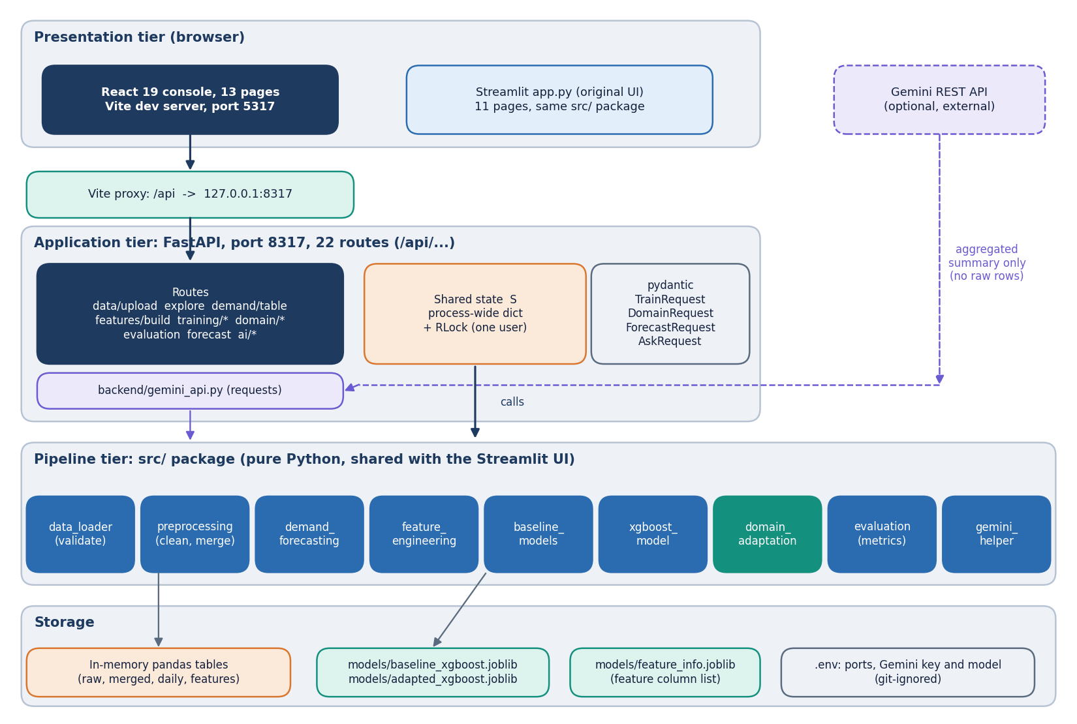
Figure 1: Layered architecture of TrendCast: React console, Vite proxy, FastAPI application with 22 routes, the src/ pipeline modules, and in-memory state plus joblib model files.
The React 19 console on port 5317 reaches the FastAPI application on 127.0.0.1:8317 through the Vite development proxy, so the browser sees one origin. The application exposes 22 routes. It keeps a single process-wide dictionary of pipeline state, guarded by a re-entrant lock, in the way the Streamlit pages used st.session_state. Each route calls the same functions as the corresponding Streamlit page; only the HTTP and JSON handling is new. The two src/ modules that import Streamlit (data_loader, gemini_helper) are used for their validators and context builder only, and the backend lowers the Streamlit logger to avoid its no-runtime warnings.

5.2 High-level workflow
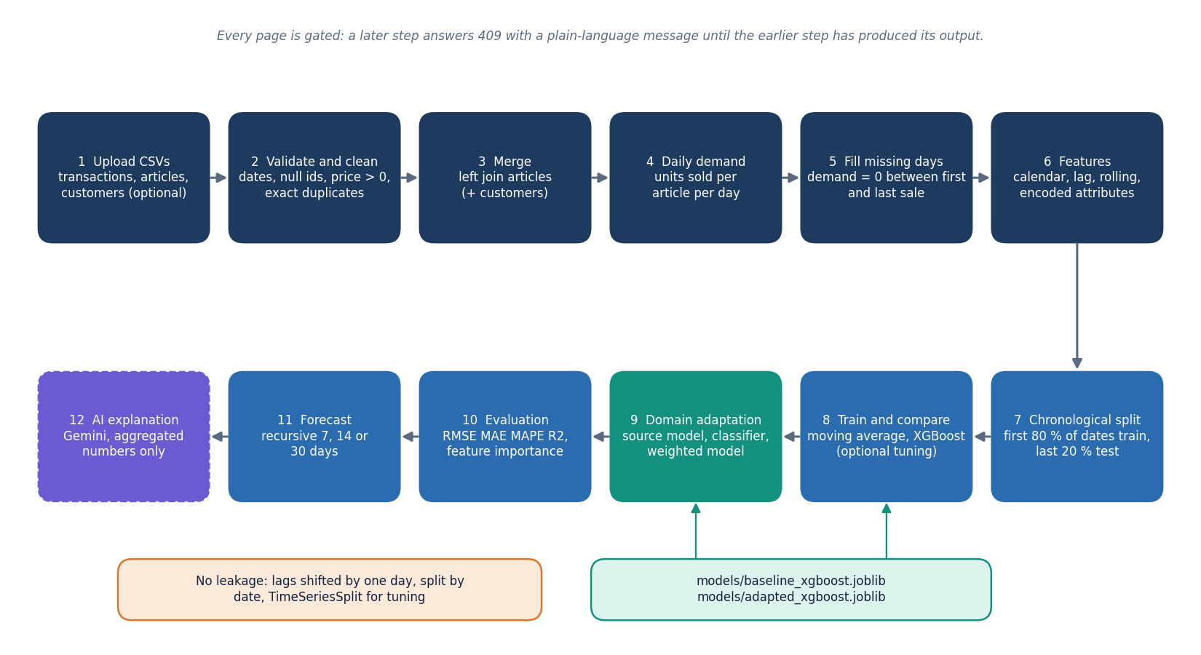
Figure 2: End-to-end workflow: upload, clean and merge, daily demand, features, chronological split, baseline and XGBoost, domain adaptation, evaluation, forecast and optional AI explanation.
The workflow has eight stages and every stage maps to one page of the console. Upload reads the files and returns the quality report. Explore and Demand show the aggregated series. Features builds the 31-input table. Training splits by date, fits the moving average and XGBoost and keeps the comparison. Domain trains on a source and tests on a target, with and without weights. Evaluation collects the comparison, the before-and-after table and the feature importance. Forecast rolls a chosen article forward. Insights asks Gemini to explain what is already on screen.

5.3 Data flow diagrams

5.3.1 Level 0: context
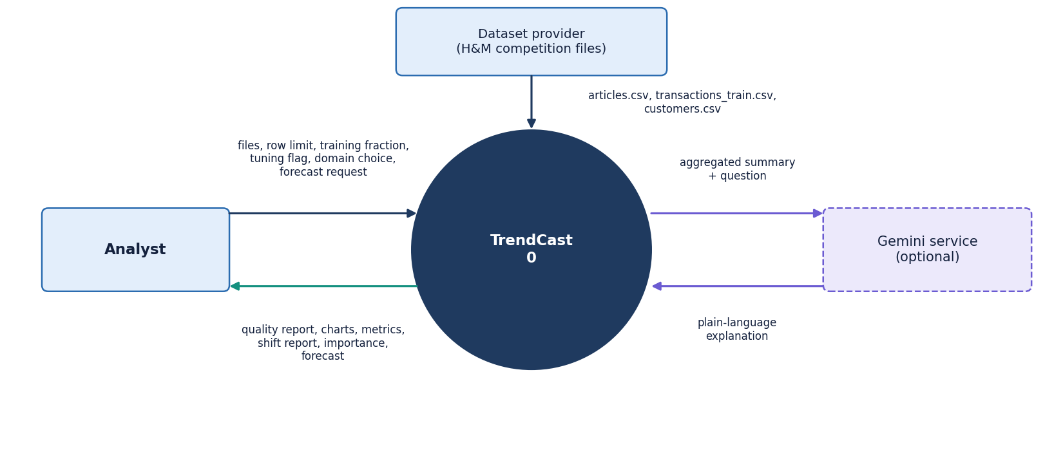
Figure 3: Context diagram (DFD level 0): TrendCast as one process with the analyst, the dataset provider and the optional Gemini service.
At level 0 TrendCast is one process with three external entities. The analyst supplies files and choices and receives reports, charts, metrics and forecasts. The dataset provider is the source of the three CSV tables, which in this project are the public H&M competition files. The Gemini service is optional and receives only an aggregated JSON summary and a question. Drawing the dataset provider and the analyst separately is deliberate: the product never downloads data, so every dataset arrives through the analyst's upload.

5.3.2 Level 1: seven processes
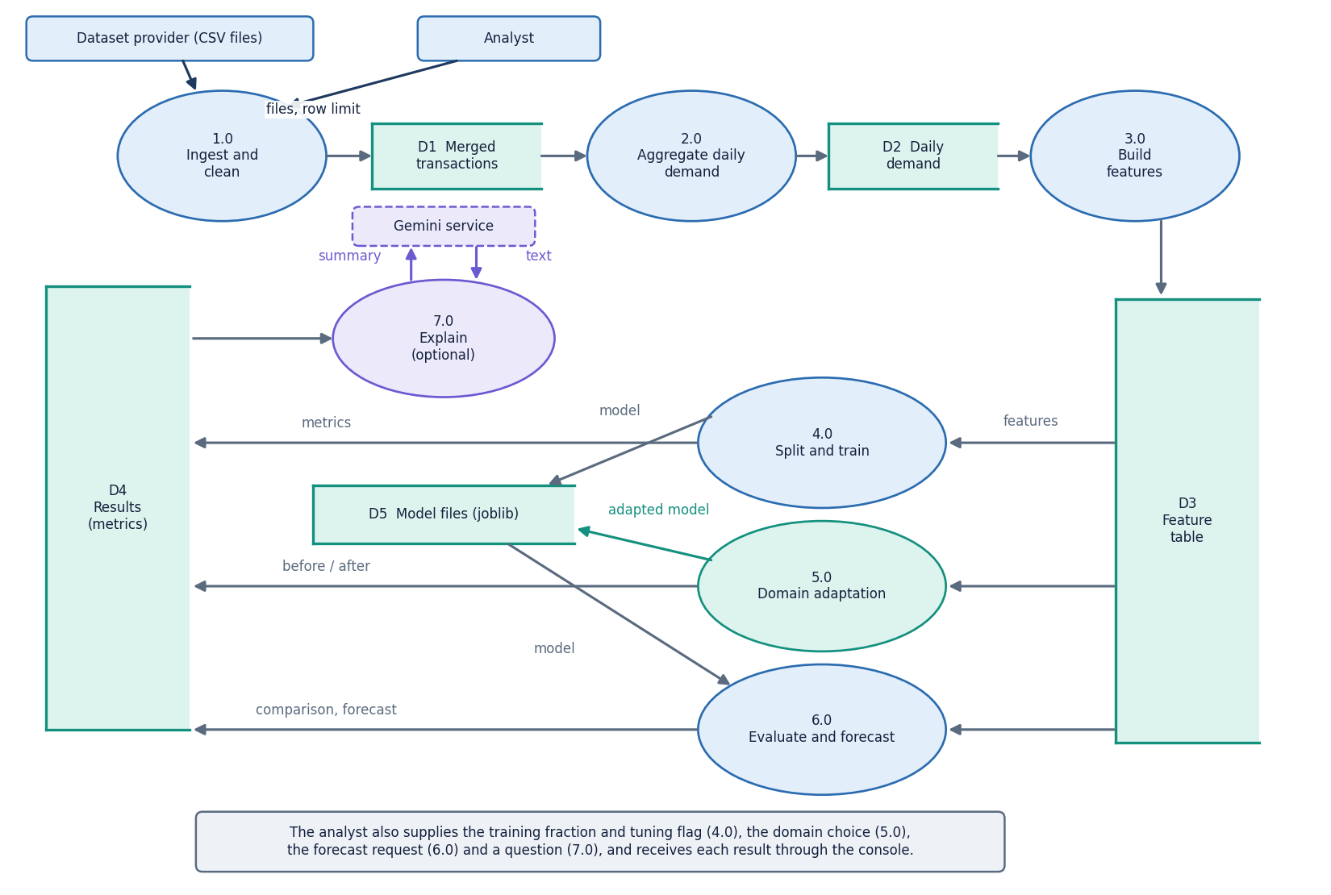
Figure 4: DFD level 1: seven processes (ingest, aggregate, features, train, adapt, evaluate and forecast, explain) and the data stores.
Level 1 shows the seven processes and four data stores. 1.0 Ingest validates the columns and writes the cleaned and merged tables (D1). 2.0 Aggregate writes the daily demand table (D2). 3.0 Build features writes the feature table (D3) and the category-code mappings. 4.0 Train reads D3 and writes the models (D5, joblib files). 5.0 Adapt reads D3 and writes the adapted model and the domain result. 6.0 Evaluate and forecast reads D3, D5 and the results store (D4). 7.0 Explain builds the aggregated context and calls Gemini. All stores except D5 are memory structures and are lost when the server stops.

5.3.3 Level 2: domain adaptation
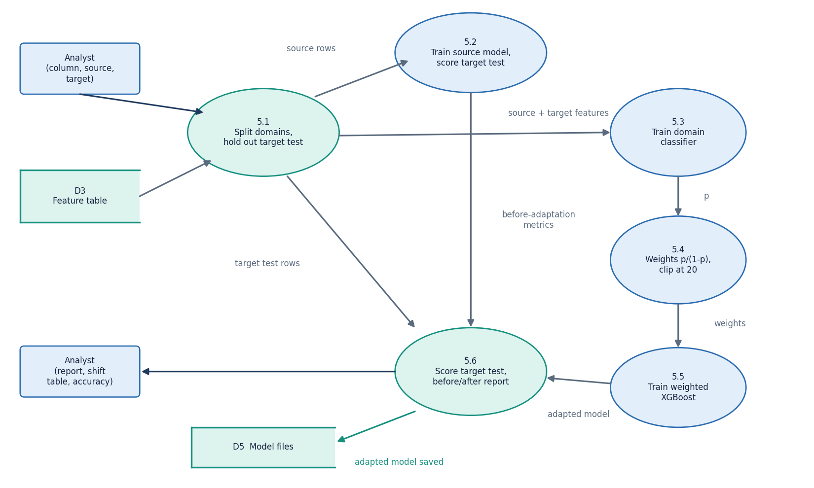
Figure 5: DFD level 2: the domain-adaptation process 5.0 expanded into six sub-processes.
Domain adaptation is the part of the product the project title names, so it is expanded to level 2. Six sub-processes take the feature table to a before-and-after report. Two design points matter. The domain column itself is removed from the model inputs, so neither the source model nor the classifier can read the answer off a feature. And the held-out target test rows are the later half of the target dates; they are used only to score the two models, never to fit them or the classifier's weights.

5.4 UML design

5.4.1 Class diagram
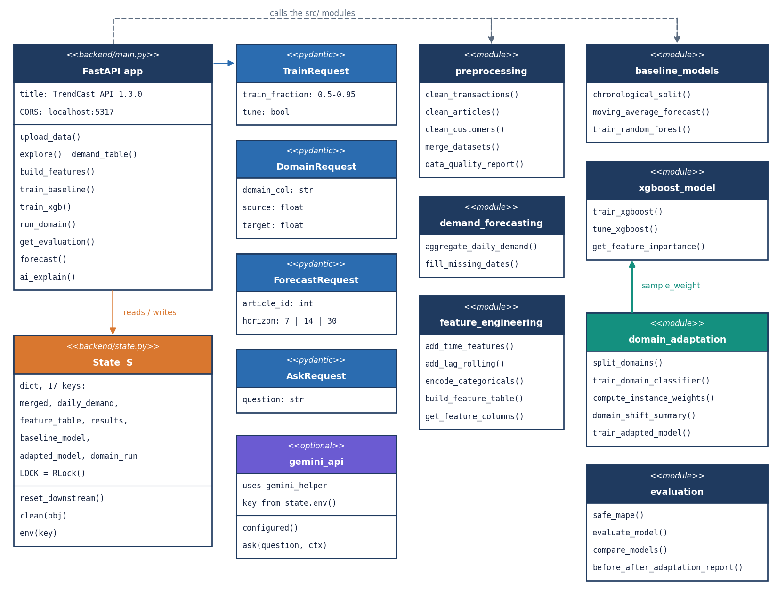
Figure 6: UML class diagram: the FastAPI application, request models, the shared state, and the src/ modules with their main functions.
The code base is organised as modules of functions rather than as classes, which suits a data pipeline in which each step takes a table and returns a table. The only classes are the four pydantic request models of the API, which validate input: TrainRequest (training fraction between 0.5 and 0.95, tuning flag), DomainRequest (column, source, target), ForecastRequest (article id, horizon) and AskRequest (question). The diagram draws each module as a class-like box so the dependencies are visible.

5.4.2 Sequence diagram
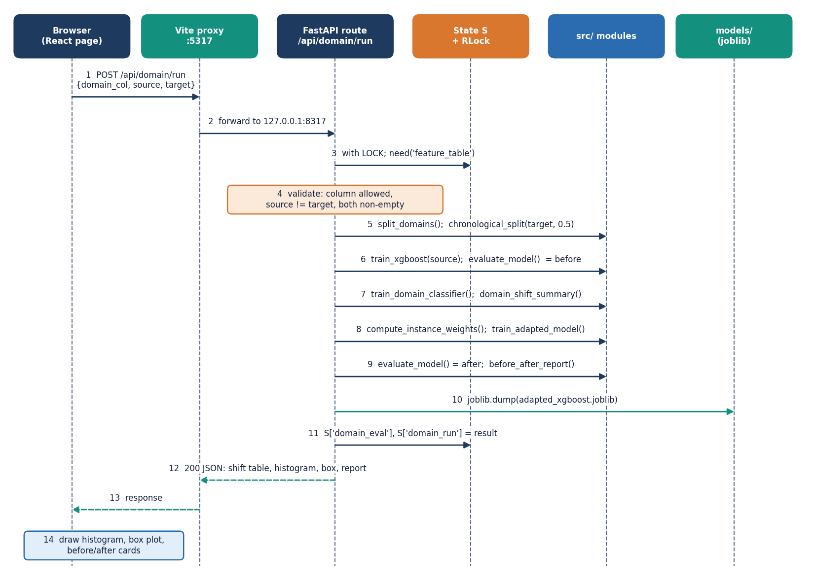
Figure 7: Sequence diagram: running domain adaptation from the browser, from the click to the before-and-after report.
The sequence follows POST /api/domain/run. The route takes the lock, checks the prerequisites (409 when the feature table is missing, 400 for an unknown column or equal values) and then runs six steps from the src/ package. It stores the result in S, writes the adapted model to models/adapted_xgboost.joblib and returns a JSON document that the page draws as the shift histogram, the box plot and four before-and-after cards. Holding the lock for the whole run serialises requests, which is what keeps the shared state consistent; the measured run takes about 3.7 s on the real subset, so the wait is short.

5.4.3 Use-case diagram
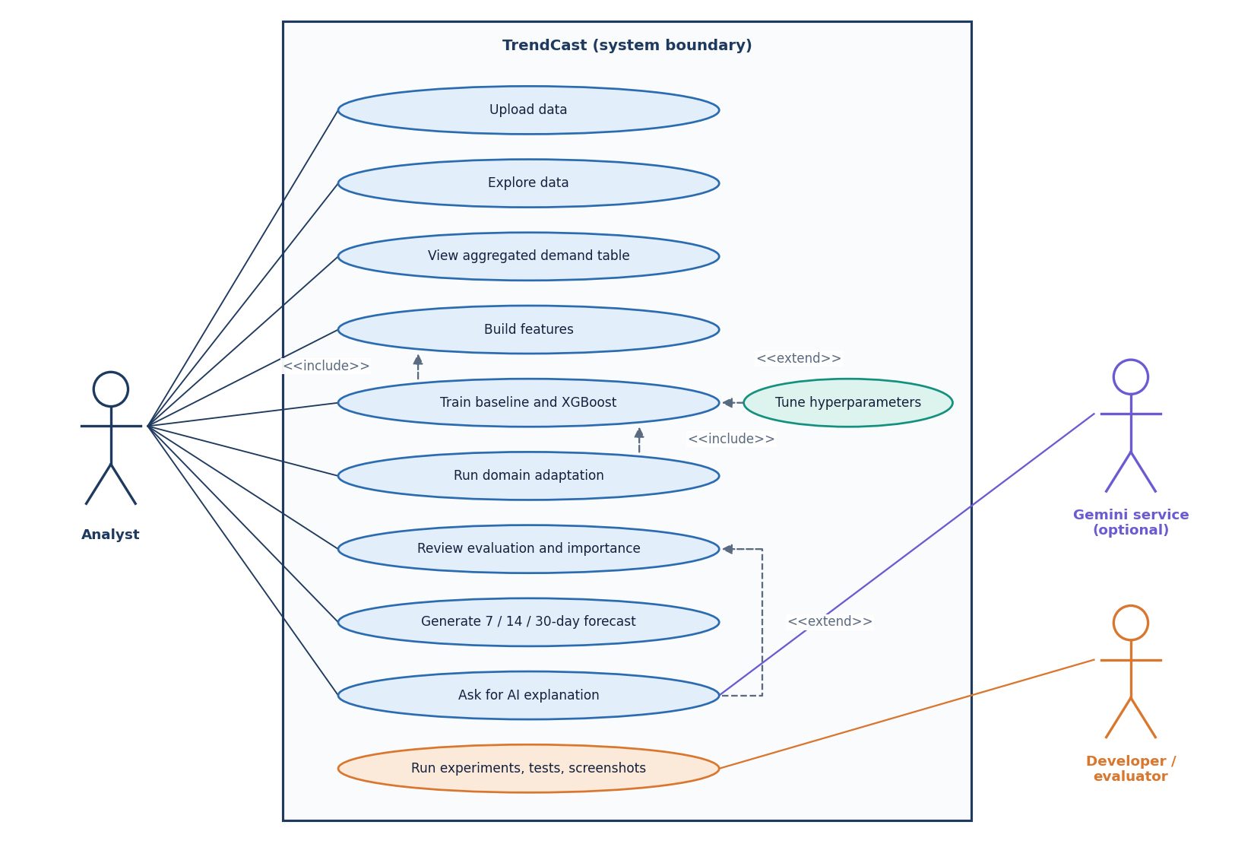
Figure 8: Use-case diagram with the analyst, the optional Gemini service and the developer or evaluator.

5.5 Database and state design
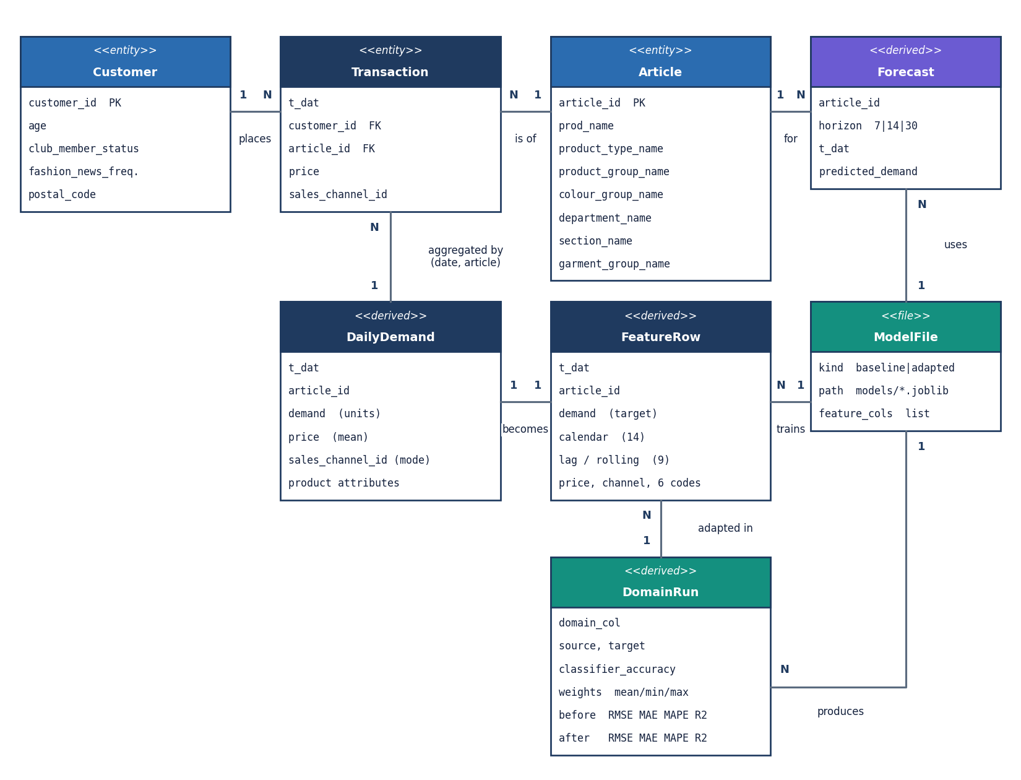
Figure 9: Logical entity-relationship diagram: TrendCast has no database; the entities are the uploaded tables, derived tables and model files.
The logical entities are the uploaded tables and the tables derived from them. A transaction row has the date, customer id, article id, price and sales channel. An article carries the product name and eight descriptive attributes (type, group, colour, department, section, garment group, index name and index group name) plus a free-text description. A customer row (optional) has age, club status and a postal code that the pipeline does not use. Aggregating by date and article gives the daily demand row: the count of transactions is the demand, the price is the mean of the day and the channel is the most frequent channel of the day. Each daily row becomes one feature row. A training run produces a model file, a domain run an adapted model and a result record, and a forecast a set of dated rows.

5.6 Core algorithm design
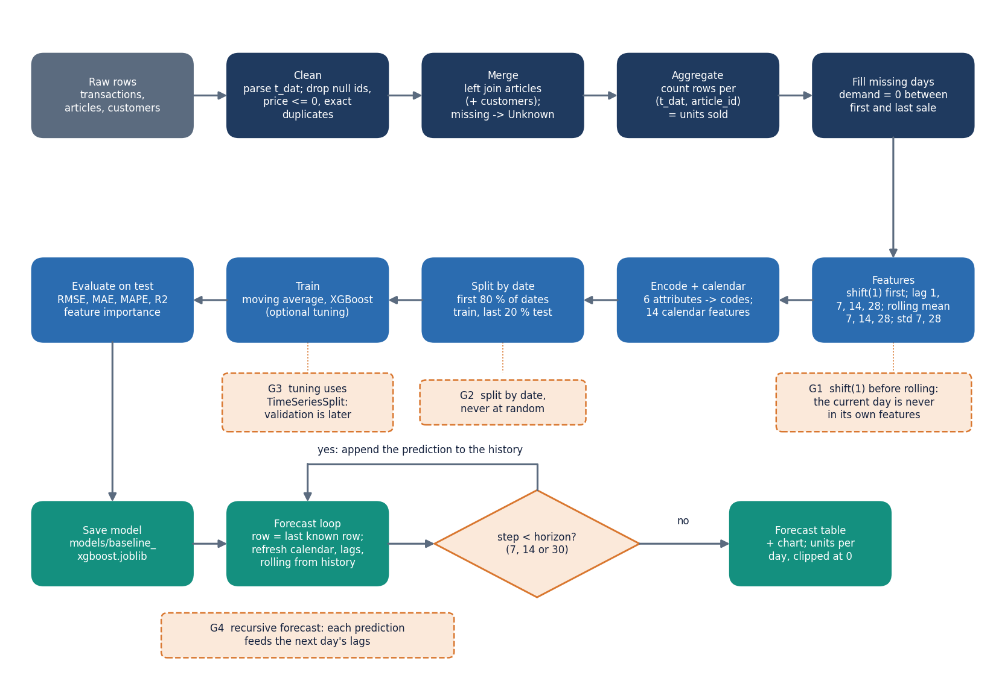
Figure 10: Flowchart of the core algorithm: from raw transactions to the recursive forecast, with the leakage guards marked.
The core algorithm is a sequence of table transformations with three leakage guards: the shifted lag and rolling features, the date-based split and the TimeSeriesSplit folds used when tuning. It ends in a recursive forecast: each predicted day is appended to the history so that the next day's lag and rolling features can be computed. A design consequence, documented honestly in Chapter 8, is that errors compound along the horizon. The forecast also reuses the last observed price and sales channel, and refreshes only the calendar features the route updates (year, month, day, weekday, weekend and the sine and cosine encodings).
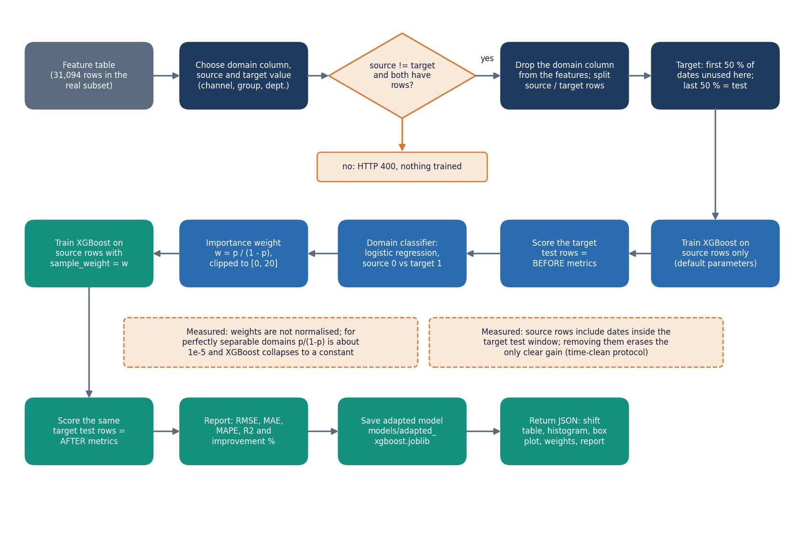
Figure 11: Flowchart of importance-weighted domain adaptation as implemented in domain_adaptation.py and the /api/domain/run route.
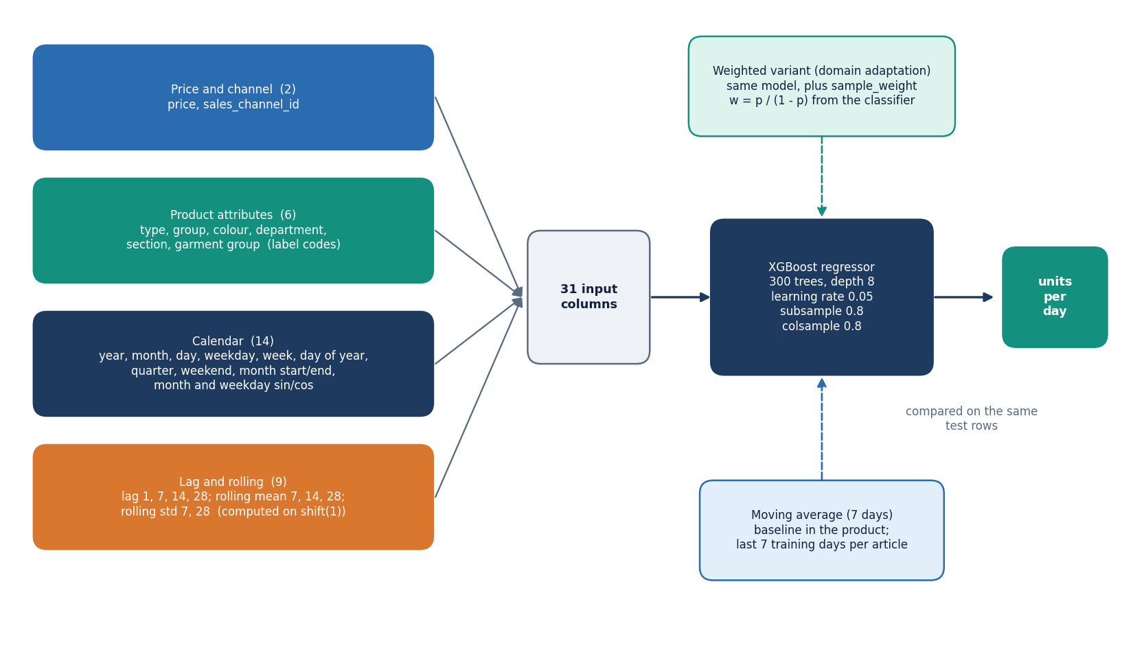
Figure 12: Model architecture: 31 input features in four groups feeding one XGBoost regressor, with the baselines and the weighted variant.

5.7 Module design
The code is split so that each file has one reason to change. Line counts below were measured from the repository.
Table 11: Modules, sizes and responsibilities.
Module | Lines | Responsibility
src/data_loader.py | 104 | Required-column lists and the friendly DataValidationError; Streamlit upload helpers (the API reuses only the validators)
src/preprocessing.py | 135 | Clean transactions, articles and customers; left-join; data-quality report
src/demand_forecasting.py | 121 | Aggregate to units per article per day; zero-fill the missing days
src/feature_engineering.py | 165 | Calendar, cyclical, lag and rolling features; label encoding; feature-column selection
src/baseline_models.py | 106 | Chronological split, moving average, random forest, LightGBM
src/xgboost_model.py | 95 | XGBoost with optional sample weights; TimeSeriesSplit random search; importance
src/domain_adaptation.py | 141 | Domain split, logistic domain classifier, importance weights, shift table, weighted model
src/evaluation.py | 117 | RMSE, MAE, safe MAPE, R2, comparison table, before-and-after report
src/visualization.py | 119 | Plotly figures for the Streamlit app
src/gemini_helper.py | 119 | Builds the aggregated, raw-data-free context for AI Insights
backend/main.py | 626 | FastAPI application: 22 routes, request models, gating helpers
backend/state.py | 90 | Shared pipeline state S, lock, model paths, .env reader, JSON cleaner
backend/gemini_api.py | 70 | REST call to Gemini with the key and model from .env
app.py | 597 | Original Streamlit application, 11 pages (kept unchanged)
frontend/src/ | 4,414 | React 19 console: 13 pages, UI kit, charts, API client and pipeline-progress context
tests/ | 390 | 39 pytest tests (22 unit, 17 API)

5.8 API design
All routes live under /api. Reads are GET and actions are POST. Failures return the FastAPI detail string, which the console shows verbatim, so error messages are written for the analyst: 'Upload and process your data first (Data Upload).' is what a 409 says. The status codes follow one rule: 409 means an earlier step is missing, 400 means the request is well-formed but not acceptable, 422 means the request body failed validation, 404 means a saved model is absent, 502 and 503 are reserved for the optional AI service.
Table 12: The 22 routes of the TrendCast API.
Method | Path | Purpose
GET | /api/health | Liveness check
GET | /api/state | Nine progress flags (data_loaded, daily_ready, features_ready, baseline_ran, xgboost_trained, domain_done, forecast_done, saved_model_exists, gemini_configured)
POST | /api/data/upload | Multipart transactions, articles, optional customers and a row limit; cleans, merges, resets everything downstream; returns the quality report
GET | /api/data/report | The last data-quality report
GET | /api/explore | Daily, monthly, weekly series, top-10 products, department, colour and channel totals, price histogram
GET | /api/demand/table | First limit rows (1-2,000) of the daily demand table
POST | /api/features/build | Zero-fill, build the 31-input feature table, clear models and results
GET | /api/features | Shape, feature columns and the first 50 rows
GET | /api/training/split | Date ranges and row counts for a training fraction
POST | /api/training/baseline | Moving-average baseline on the chronological split
POST | /api/training/xgboost | Default or tuned XGBoost; saves the model and feature list
POST | /api/training/load | Loads the saved model from models/
GET | /api/training/results | Model comparison rows
GET | /api/domain/options | Offered domain columns (channel, product group, department) and their values
POST | /api/domain/run | Source model, domain classifier, shift table, weights, adapted model, before/after report
GET | /api/domain/last | Most recent domain run, so the page survives a reload
GET | /api/evaluation | Comparison table, domain report, top-20 gain importance
GET | /api/forecast/articles | Article ids with product type and total units
POST | /api/forecast | Recursive 7, 14 or 30-day forecast for one article with 60 days of history
GET | /api/ai/status | Whether a Gemini key is configured and the model name
POST | /api/ai/explain | Plain-language answer built from aggregated metrics, importance and domain-shift numbers
POST | /api/ai/forecast-summary | Two-to-three-sentence summary of the latest forecast

5.9 User interface design
The console has thirteen pages: a public landing page, an about page, an overview that shows pipeline progress, seven working pages (upload, explore, demand, features, training, domain, evaluation, forecast), the AI insights page and a not-found page. The visual language is a flat, high-contrast grid with thick borders and one accent colour per state, which keeps charts and tables legible and prints well. A light and a dark theme are available from every page.

CHAPTER 6: METHODOLOGY AND SOFTWARE IMPLEMENTATION

6.1 Overall methodology
TrendCast treats demand forecasting as a supervised regression on a daily panel: one row per article per day, with the number of units sold as the target. The base paper [1] follows the same recipe with LightGBM on the UCI Online Retail II data and adds four layers of explanation; TrendCast keeps the recipe, uses XGBoost [2] as the batch abstract specifies, and adds the step the base paper leaves out: moving a trained model between differently distributed parts of the business. The method has eight steps.
1. Ingest. Read the transactions and articles files (customers optional), check that the required columns exist and stop with a plain message if they do not.
2. Clean and merge. Parse dates, remove unusable rows, left-join the product attributes so that no sale is lost because a catalogue entry is missing.
3. Aggregate. Count the transactions of each article on each day (the demand), average the price, take the most frequent sales channel, and fill the days without a sale with zero.
4. Engineer features. Add calendar, cyclical, lag, rolling and encoded attribute features, all computed only from the past.
5. Split by date. The earliest 80 % of the dates train the model, the latest 20 % test it; tuning uses time-ordered folds.
6. Fit and compare. Fit the moving-average baseline and XGBoost (optionally tuned) and report RMSE, MAE, safe MAPE and R2.
7. Adapt across domains. Choose a domain column, a source value and a target value; train on the source, test on the later half of the target, estimate importance weights with a domain classifier, retrain with the weights and report the change.
8. Forecast and explain. Roll the model forward 7, 14 or 30 days, show gain-based feature importance, and optionally ask Gemini to put the numbers in words.

6.2 Dataset
All measurements use the H&M Personalized Fashion Recommendations data [23]: 31,788,324 transactions, 105,542 articles and 1,371,980 customers according to the dataset card of the parquet mirror we downloaded. The files are used under the competition's academic terms and are not redistributed in the repository. Because the whole file is too large for the machine used (15.7 GB of memory, no GPU), we took the first transaction shard (4,541,190 rows from 2018-09-20 to 2019-01-04, 42,415 articles) and kept the 300 best-selling articles with all of their transactions: 684,392 rows over 2018-09-20 to 2019-01-04 (107 days), 276,168 customers. scripts/make_real_subset.py rebuilds this subset in the exact CSV schema the application expects.
Table 13: The real subset used for every reported number.
Quantity | Value
Transaction rows read | 684,392
Rows after cleaning | 605,178 (79,214 exact duplicates removed, 11.6 %)
Articles / customers | 300 / 276,168
Date range | 2018-09-20 to 2019-01-04 (107 days)
Rows per channel (cleaned) | channel 1: 227,131; channel 2: 378,047
Article-days with a sale | 30,481
Modelling rows after zero-filling | 31,094 (1.97 % zero demand)
Model inputs | 31
Chronological split | train 24579 rows (to 2018-12-13), test 6515 rows (2018-12-14 to 2019-01-04)

Three properties of this subset shape every result. It covers only 107 days, so no yearly seasonality can be learned; the test window contains the Christmas peak and the January sales, which the training window has never seen. It contains the best-selling articles, so zero-demand days are rare (2 %), whereas the full catalogue is intermittent. And the two sales channels are coded 1 and 2 in the files without a name; we call them channel 1 and channel 2 and use 'store' and 'online' in a few labels only as our own convention, which the data do not state. A synthetic file in the same schema (data/sample_hm, 90 articles) ships for smoke tests; no reported metric uses it.

6.3 Preprocessing
Preprocessing is implemented in src/preprocessing.py and src/demand_forecasting.py and is applied identically in the web application, the Streamlit application and the experiment script.

6.3.1 Cleaning and merging
clean_transactions parses t_dat to a date (invalid dates become missing), drops rows without a date, article id or customer id, keeps only rows with a positive numeric price, removes exact duplicate rows and sorts by date. clean_articles fills missing text attributes with Unknown rather than dropping the product, and clean_customers fills a missing age with the median. merge_datasets left-joins articles (and customers) onto the transactions, so a transaction whose article is absent from the catalogue survives with Unknown attributes. The data-quality report counts rows read and kept, missing values, duplicates, customers, products and the date range; the upload page shows it.
One cleaning rule deserves a warning. Removing exact duplicates dropped 79,214 rows (11.6 %) of the subset. In the H&M file a repeated identical row is usually a customer buying two units of the same article on the same day, so the rule understates demand slightly and flattens the largest days. We kept the rule because it is part of the shipped pipeline and applied it in every experiment; Chapter 9 lists it among the limitations.

6.3.2 From transactions to daily demand
aggregate_daily_demand groups the cleaned rows by date and article. The demand is the number of rows, since each row is one unit sold; the price is the mean price of that day; the sales channel is the most frequent channel of that day; and the article's descriptive attributes are carried along from the first non-null value. fill_missing_dates_per_article then re-indexes each article onto a continuous daily range between its first and last sale, sets the missing demand to zero and forward- and back-fills price, channel and attributes. Articles with fewer than five sale-days are skipped by this function and therefore leave the modelling table; none of the 300 subset articles is affected.
Two consequences follow from using the day's mean price and modal channel. Both are computed from the very transactions that make up the target, so they are not strictly known before the day, and on a zero-demand day they are copied from a neighbouring day. We treat price as a planned input and report this as a limitation rather than silently excluding it; the ablation in Section 6.5 shows what it is worth. The channel is also a mixture: demand counts units from both channels, while the label is only the day's majority channel.

6.4 Feature engineering
build_feature_table produces the 31 model inputs in four groups. The calendar, lag and rolling groups follow the same temporal-integrity rule as the base paper [1]: a feature of day t may use only information from day t-1 and earlier.
Table 14: The 31 model inputs.
Group | Inputs | Count
Price and channel | price, sales_channel_id | 2
Product attributes (label-encoded) | product_type, product_group, colour_group, department, section, garment_group | 6
Calendar | year, month, day, day_of_week, week_of_year, day_of_year, quarter, is_weekend, is_month_start, is_month_end, month_sin, month_cos, dow_sin, dow_cos | 14
Lag and rolling (past demand of the same article) | lag_1, lag_7, lag_14, lag_28, rolling_mean_7/14/28, rolling_std_7/28 | 9

Cyclical encoding. Month and weekday are also given as a sine and cosine pair so that December and January, or Sunday and Monday, are neighbours; a tree model cannot infer this from the raw integer. Lags. lag_k is the article's demand k days earlier, computed with groupby(article).shift(k). Rolling statistics. The demand is shifted by one day first and the window is applied afterwards, so the current day never enters its own mean or standard deviation. Rows without enough history take the value 0, which a tree reads as 'nothing observed'. Attributes. Text attributes are converted to integer codes with a stored mapping (one-hot would create hundreds of columns for the department and colour fields), which treats the codes as ordered numbers; trees cope with this, but the codes carry no meaning in themselves.
The domain-adaptation route removes the chosen domain column from this list, so a model or classifier cannot read the domain from a feature. The same list, saved as models/feature_info.joblib, is used to rebuild the input of a loaded model.

6.5 Algorithm choice and justification
The batch abstract names XGBoost as the learner, and the choice is easy to defend on engineering grounds: it handles mixed numeric and encoded features without scaling, trains in about a second on this table, has regularisation built in [2] and, decisively for this project, accepts a per-row sample_weight, which is the entry point for domain adaptation. Gradient boosting [8] also matched or beat deep learning in the M5 retail competition when given engineered features [6], which is the base paper's argument for its own choice.
Whether it is also the most accurate choice on our data is a separate, measured question. All learners below use the same 31 inputs and the same 80/20 split; the first four rows need no training.
Table 15: Model comparison on the real subset (test window 2018-12-14 to 2019-01-04, 6,515 rows).
Model | RMSE | MAE | R2 | WAPE %
Moving average (7d) | 12.891 | 8.090 | 0.101 | 65.3
Naive (lag 1) | 9.225 | 5.651 | 0.540 | 45.6
Seasonal naive (lag 7) | 12.032 | 7.293 | 0.217 | 58.9
Rolling mean 7 (shifted) | 9.307 | 5.653 | 0.531 | 45.6
Random forest | 13.258 | 7.527 | 0.049 | 60.8
LightGBM | 10.060 | 6.706 | 0.452 | 54.1
XGBoost (default, 5 seeds) | 11.089 | 7.077 | 0.335 | 57.1
XGBoost (tuned, 10 iters x 3 TS-CV) | 10.341 | 6.881 | 0.421 | 55.6

Three readings follow. Gradient boosting beats the product's own baseline: XGBoost reaches RMSE 11.09 against 12.89 for the 7-day moving average, and 10.34 when tuned. Seed noise is small (RMSE 11.089 ± 0.048 over five seeds), so differences of more than about 0.1 are real. A one-line baseline is better still: repeating yesterday's demand gives RMSE 9.22 and the shifted 7-day mean 9.31. The base paper reports the same ordering of difficulty: its LightGBM beats a 7-day moving average by 2.86 RMSE but its naive lag-1 baseline is far worse on its much more intermittent SKU data [1]. On our best-selling articles, demand is smooth enough that yesterday is a strong predictor.
The ablation explains why. We refit XGBoost with groups of features removed (three seeds each).
Table 16: Feature-group ablation (XGBoost default, mean of three seeds).
Feature set | Inputs | RMSE | R2 | WAPE %
all features (as shipped) | 31 | 11.056 | 0.339 | 57.0
no lag / rolling | 22 | 16.161 | -0.413 | 89.6
no price, no channel | 29 | 11.438 | 0.292 | 58.4
no product attributes | 25 | 11.213 | 0.320 | 55.0
calendar only | 14 | 15.178 | -0.247 | 93.6
lag / rolling only | 9 | 9.403 | 0.522 | 47.4
lag / rolling + price | 10 | 9.672 | 0.494 | 47.1

The lag and rolling features carry the model: without them R2 falls to -0.41, and calendar features alone are worse than predicting the mean of the test window. The most striking row is the last but one: a model that uses only the nine lag and rolling inputs (RMSE 9.40) is better than the shipped 31-input model (RMSE 11.06). The extra inputs include absolute-time features (year, quarter, day_of_year, month) whose test values lie beyond the training range; a tree can only predict the value of the last leaf it has seen for them. This agrees with the base paper's ablation, in which rolling statistics were the dominant group. We kept the shipped feature set for the product because changing it was outside the scope of a documentation run, and we report the better variant as a finding in Chapter 8.

6.6 Mathematical formulation

6.6.1 Features
Let y(a, t) be the units of article a on day t. The lag, rolling and cyclical features are
lag_k(a, t) = y(a, t - k), k in {1, 7, 14, 28} (1)
rolling_mean_w(a, t) = (1/w) * sum_{i=1..w} y(a, t - i), w in {7, 14, 28} (2)
month_sin = sin(2*pi*month/12), month_cos = cos(2*pi*month/12), dow_sin = sin(2*pi*dow/7), dow_cos = cos(2*pi*dow/7) (3)
The rolling standard deviation uses the same window over the shifted series (windows 7 and 28). Because every sum starts at i = 1, y(a, t) never appears in its own features.

6.6.2 The XGBoost objective
XGBoost [2] builds an additive ensemble of K regression trees, y_hat = sum_k f_k(x), by minimising a regularised squared-error objective. With per-row weights w_i, as used for domain adaptation, the objective is
L = sum_i w_i * (y_i - y_hat_i)^2 + sum_k [ gamma * T_k + (lambda/2) * ||v_k||^2 ] (4)
where T_k is the number of leaves of tree k and v_k its leaf values (library defaults gamma = 0 and lambda = 1). For squared error the second derivative of each row's loss is proportional to w_i, so the sum of the second derivatives in a candidate leaf is the sum of the weights in it. XGBoost refuses a split whose child has a derivative sum below min_child_weight, which is 1 by default. This detail looks technical but it decides what happens when the weights are tiny (Section 6.8).

6.6.3 Importance weights for covariate shift
Under covariate shift the inputs have different densities in the source (p_S) and target (p_T) domains but the relation between inputs and demand is the same. Training on the source with each row weighted by w(x) = p_T(x) / p_S(x) then minimises the target risk [10]. The ratio is not estimated directly. A classifier is trained to tell source rows (label 0) from target rows (label 1) [12]; by Bayes' rule its output p(x) = P(target | x) satisfies
p(x) / (1 - p(x)) = [ p_T(x) / p_S(x) ] * [ n_T / n_S ] (5)
where n_S and n_T are the numbers of source and target rows the classifier saw. TrendCast uses the odds themselves as the weight, clipped to avoid a few dominating rows:
w(x) = min( p(x) / (1 - p(x)), 20 ), with p clipped to [1e-6, 1 - 1e-6] (6)
The odds therefore equal the density ratio times n_T / n_S: the weights are not normalised to a mean of one. This is visible in the data: for the pair channel 2 to channel 1 the mean weight was 0.648 and n_T / n_S = 12,240 / 18,854 = 0.649. When the two classes are of similar size the factor is harmless; when the classifier separates the domains perfectly the odds become tiny and the factor no longer matters, because the weights are tiny anyway.

6.6.4 Metrics
RMSE = sqrt( (1/n) * sum (y_i - y_hat_i)^2 ), MAE = (1/n) * sum |y_i - y_hat_i| (7)
safe-MAPE = (100/m) * sum_{y_i != 0} |y_i - y_hat_i| / |y_i|, R2 = 1 - sum (y_i - y_hat_i)^2 / sum (y_i - mean(y))^2 (8)
Safe MAPE skips the rows with zero demand (there are 345 in the test window) and reports their number. Even so it is very large here (about 140 %) because low-volume days dominate a ratio of errors, so it is a poor guide on its own and we add the weighted absolute percentage error WAPE = sum|y - y_hat| / sum y (offline), which divides by total units and is stable [9]. The improvement from adaptation is (before - after) / before for the error metrics, so a negative value means the adapted model is worse.

6.7 Model architecture and training
The model is a single XGBRegressor. Its defaults, set in xgboost_model.DEFAULT_PARAMS, are 300 trees, depth 8, learning rate 0.05, row and column subsampling of 0.8, squared-error objective and random state 42. On this table a fit takes 1.9 s and a prediction 2.3 microseconds per row on the CPU.
Tuning is optional. tune_xgboost runs RandomizedSearchCV [25] over six parameters (n_estimators 100-500, max_depth 4-12, learning_rate 0.01-0.2, subsample and colsample_bytree 0.6-1.0, min_child_weight 1-7), with ten sampled settings, three TimeSeriesSplit folds (each validation fold lies after its training fold) and negative RMSE as the score; scikit-learn [24] supplies the search. The tuned model chose 400 trees of depth 12, learning rate 0.01, subsample 0.7, column sample 0.6 and min_child_weight 5; the search took 31 s and improved the test RMSE from 11.09 to 10.34. The training page shows the winning parameters.
Baselines. The moving average predicts each test row with the article's mean over the last seven training days, falling back to the article mean and then the global mean. A random forest (200 trees, depth 10) and LightGBM (300 trees, depth 8) are available as optional comparators. The trained default model is saved to models/baseline_xgboost.joblib together with its feature list.

6.8 Domain adaptation procedure
The procedure is implemented in backend/main.py::run_domain using the functions of src/domain_adaptation.py. The analyst chooses one of three domain columns (sales channel, product group, department) and two different values. The steps are:
1. Remove the domain column from the model inputs. Split the feature table into source rows (all dates) and target rows.
2. Hold out the later half of the target dates as the test set; the earlier half is not used for fitting in the product.
3. Train XGBoost on the source rows only and score the target test rows: the before metrics.
4. Fit a logistic regression that separates source from target rows (25 % of the stacked rows are held out to report its accuracy; the accuracy measures how different the domains are). The target rows given to the classifier include the test dates, but only their inputs, never their demand.
5. Compute the importance weight of each source row as p / (1 - p), clipped to [0, 20].
6. Retrain XGBoost on the source rows with those weights and score the same test rows: the after metrics. Save the model and report the change in RMSE, MAE, MAPE and R2.
The experiments of Chapter 8 repeat this procedure for six source-target pairs with five XGBoost seeds each and add controls that the product does not have: a target-only model trained on the first half of the target; a pooled model trained on the source plus the first half of the target without weights; the same weights shuffled randomly; the weights rescaled to a mean of one; and a 'time-clean' variant in which the source rows are limited to dates before the target test window.
Reading the procedure against the controls produced two implementation findings that we report as facts. First, the source model is trained on dates that overlap the target test window; for the channel pair the gain of +11.9 % turned into -2.8 % when the overlap was removed. Second, the weights are not normalised: for the department pair Knitwear to Trouser the classifier is perfectly accurate, the mean weight is 5.1e-05, no split can reach min_child_weight = 1 (Section 6.6.2), XGBoost stops splitting and predicts a constant, and the RMSE gets 46 % worse. Rescaling the same weights to a mean of one removed the collapse. Logistic regression is also fitted to unscaled features and does not reach convergence within 1,000 iterations, which scikit-learn reports as a warning on every run. None of these was changed in the product during this documentation; Chapter 8 gives the measurements and Chapter 10 the fixes.

6.9 Application architecture
The product exists in two front ends over one pipeline. The Streamlit application (app.py, 597 lines, 11 pages) is the original and is left unchanged. The web application has a FastAPI back end (backend/main.py, port 8317) and a React 19 front end built with Vite (port 5317). Both import the same src/ modules, so a number computed in one is computed identically in the other.
The back end is organised around one idea: a route does only HTTP work. It checks that the required state exists (the helper need raises a 409 with an instruction), validates the request with a pydantic model, takes the lock, calls the src/ function, stores the result in the shared state S, and converts the result to JSON with clean, which turns NaN and infinity into null and dates into ISO strings so that the browser never receives invalid JSON. The helper below is the gate used by every downstream route.
def need(key: str, message: str):
"""Return S[key] or raise a 409 with a plain-language 'do this first' message."""
value = S.get(key)
if value is None or (isinstance(value, pd.DataFrame) and value.empty):
raise HTTPException(status_code=409, detail=message)
return value

The front end reads progress from /api/state through a context provider and renders each page inside a gate. Pages call the API through one fetch wrapper that turns FastAPI error details into readable messages and reports status 0 when the server cannot be reached ('Cannot reach the TrendCast API. Start the backend (run.bat) and retry.'). Charts use Recharts; the layout, theme toggle, toasts and tables come from a small in-house UI kit.

6.10 API design
Chapter 5 lists the 22 routes. This section shows the shape of the most important exchange, domain adaptation. The request is a three-field JSON document; the response carries everything the page draws, so the page makes one call and no further computation happens in the browser.
POST /api/domain/run
{ "domain_col": "sales_channel_id", "source": 1, "target": 2 }

200 OK
{ "source_label": "Channel 1", "target_label": "Channel 2",
"source_rows": 12240, "target_rows": 18854, "target_test_rows": 9890,
"classifier_accuracy": 0.663,
"shift": [ {"feature": "lag_1", "source_mean": ..., "target_mean": ..., "mean_diff": ...}, ... 15 rows ],
"top_shift_feature": "lag_1", "histogram": [...30 bins...], "box": {...},
"weights": {"mean": 1.58, "max": 20.0, "min": 0.10},
"before": {"RMSE": 18.983, ...}, "after": {"RMSE": 18.989, ...},
"report": [ {"Metric": "RMSE", "Before Adaptation": ..., "After Adaptation": ..., "Improvement (%)": ...}, ... ] }

The values shown are those of the capture run on the real subset: the adapted model's RMSE (18.989) is marginally worse than the source model's (18.983), and the interface labels that as '0.0 % worse' instead of rounding it into a success. The forecast route follows the same pattern: the request is {article_id, horizon} and the response holds the last 60 days of history, the forecast rows, their sum and the number of history days used.
Measured behaviour (real subset, 127.0.0.1, other jobs running on the same machine): upload, clean and merge 3.5 s; daily aggregation 2.7 s; feature building 0.9 s; default XGBoost 1.1 s; tuned XGBoost 29.6 s; domain adaptation 3.7 s. Median latency of the forecast route over 20 calls is 45 ms (7 days), 75 ms (14 days) and 156 ms (30 days); the lightweight routes answer in about 3 ms. The forecast time grows linearly with the horizon because each day is one model call.

6.11 Security and error handling
TrendCast is a single-user analysis tool and its security model is correspondingly simple. We list what exists and what does not, so that nobody assumes more.
• No authentication or accounts. Anyone who can reach port 8317 can use the tool and read the shared state. This is acceptable on a student's machine and unacceptable on a server; it is listed in Chapter 9.
• CORS allows only http://localhost:5317 and http://127.0.0.1:5317, so a page from another origin cannot call the API from a browser.
• Input validation. Uploads must contain the required columns (t_dat, customer_id, article_id, price for transactions; article_id, prod_name for articles) or the route answers 400 with the missing names; empty and unreadable files answer 400; the training fraction is limited to 0.5-0.95 by the request model; the horizon must be 7, 14 or 30; the domain column must be one of three offered names.
• Secrets. The Gemini key is read from .env, which is git-ignored (and .streamlit/secrets.toml for the Streamlit app). The repository contains only .env.example. .env.example also lists DATABASE_URL and JWT_SECRET, which this code does not use because there is neither a database nor a login.
• Data sent to the outside. Only the optional AI Insights route contacts an external service. Its context is built by gemini_helper.build_context_summary from the metric dictionary, the top ten feature importances, the domain-shift summary and a forecast summary; raw rows are never included. The prompt tells the model to use only that data.
• Failure behaviour. Missing prerequisites answer 409 and a missing saved model 404. If Gemini is not configured the route answers 503; if the call fails or times out the route answers 502 with a message that every other page still works. During our screenshot run the service answered 503 ('high demand') and later timed out; the page showed the message and nothing else broke.
• Concurrency. A re-entrant lock serialises routes that read or change the pipeline tables, so two requests cannot interleave a split or a model assignment. The state itself is global, so two users share it.
The automated tests cover the gating, the validation messages, the reset-on-upload rule and the AI-not-configured path (Chapter 7).

6.12 Installation and execution
The project needs Python 3.10 or newer and Node.js 18 or newer. requirements.txt lists streamlit, pandas, numpy, scikit-learn, xgboost, lightgbm, plotly, joblib, python-dateutil, google-generativeai, fastapi, uvicorn, python-multipart and requests. Measurements in this report were taken with Python 3.11.9, scikit-learn 1.5.0, XGBoost 2.0.3, LightGBM 4.7.0, pandas 2.2.1 and NumPy 1.26.4 (LightGBM was installed only for the baseline comparison).
1. Open the project folder 8.ProjectCode. Copy .env.example to .env; ports 8317 and 5317 are preset, and the Gemini key is optional.
2. Run run.bat. It reads the ports from .env, creates .venv if it is absent, installs requirements.txt once (a marker file avoids repeating it), runs npm install in frontend/ if needed, starts the back end with uvicorn and the front end with Vite in two console windows, and opens the browser at http://localhost:5317.
3. Open Data upload, choose the transactions and articles CSV (customers optional), set the row limit (0 means no limit) and press 'Load & process data'. Then follow the pages in order; each one tells you if a step is missing.
4. To check the installation run run.bat test: it starts the back end, creates the synthetic sample if needed and runs scripts/smoke_test.py (26 checks). python -m pytest tests -q runs the 39 unit and API tests.
5. To use the original Streamlit application instead, run streamlit run app.py; to rebuild the real-data subset, run scripts/make_real_subset.py on the downloaded H&M files.
Appendix B gives the same instructions as a user guide with the screens. Two practical notes: a fresh environment may install newer package versions than those listed above, which is why the scikit-learn and XGBoost versions are recorded; and the first start of run.bat takes several minutes because of the package downloads.

CHAPTER 7: SYSTEM TESTING

7.1 Testing strategy
TrendCast was delivered as a working Streamlit application plus a FastAPI layer and a React console, with one end-to-end smoke script and a screenshot script. The documentation run added an automated pytest suite and the measurement scripts of Chapter 8. The pipeline in src/ is deterministic once the data and the XGBoost seed are fixed, so it is tested at unit level with exact assertions: what cleaning removes, how a daily demand row is counted, that a lag feature for day t equals the demand of day t minus k, that a chronological split never overlaps, and how the domain weights behave. The API is tested through FastAPI's test client on a small synthetic dataset, and through a smoke script against a running server. The screens are tested by driving every route of the console with the real H&M subset in a headless browser.
Table 17: Test levels, tools and results.
Level | Tool and scope | Count | Result
Unit | pytest: tests/test_pipeline.py (cleaning, aggregation, features, split, metrics, XGBoost, domain adaptation) | 22 tests | All passed
API / component | pytest with FastAPI TestClient: tests/test_api.py (gating, validation, whole pipeline) | 17 tests | All passed
Integration (live server) | scripts/smoke_test.py against a running backend (127.0.0.1, port 8317 code path) | 26 checks | 26 of 26 passed
Functional / screens | Playwright walk of the console with the real subset (scripts/capture_screens.py) | 25 screenshots | Rendered with real data; 3 problems, all from the Gemini call
Performance | scripts/measure_api.py against the live API | 8 stages, 6 endpoints x 20 calls | Section 7.7
Model validation | scripts/run_experiments.py (6 experiment groups) | 5 seeds; 6 domain pairs | Chapter 8

All tests ran on one machine: Intel Core i5-12500 (6 cores, 12 threads), 15.7 GB RAM shared with other programs, Windows 11, Python 3.11.9, scikit-learn 1.5.0, XGBoost 2.0.3, pandas 2.2.1 and FastAPI 0.143.3. The complete pytest suite of 39 tests finished in under 10 seconds. Timings in Section 7.7 were taken while other jobs were running on the same machine and are indicative.

7.2 Unit testing
The unit file tests/test_pipeline.py has 22 tests, and all of them passed. They use small synthetic frames built inside the tests (three articles over 40 to 60 days, a toy two-feature source and target), so they need no files or network. A synthetic frame is the right tool here because each assertion is about one rule, and the frame is constructed so that the right answer is known in advance.
Table 18: Unit tests of the pipeline, grouped by module (tests/test_pipeline.py).
Module (tests) | What is asserted
preprocessing (5): drops bad rows, non-positive price, fills Unknown and dedupes, merge keeps rows, quality report | Rows with an unparseable date, a missing customer or an exact duplicate are removed (5 rows become 2); prices of 0 or below are removed; missing article text becomes Unknown and duplicate article ids collapse; a left join never loses a transaction even when the article is missing from the catalogue; the quality report counts products and removed rows correctly
demand_forecasting (2): daily demand equals the row count, missing dates filled | The demand of an article on a day equals the number of its transaction rows that day; a gap between two sale days is filled with zero demand rows (3, 0, 0, 5)
feature_engineering (4): lags use only the past, cyclical time features, categorical encoding, feature columns | lag_1 of day 10 equals the demand of day 9 and lag_7 of day 20 equals that of day 13; the 7-day rolling mean of day 20 is the mean of days 13 to 19 and never includes day 20; weekend flags and sin/cos pairs are right (sin squared plus cos squared is 1); label codes are returned with a mapping; identifiers, date and the target are excluded from the model inputs
baseline_models (2): chronological split, moving-average fallback | The latest training date is before the earliest test date and no row is lost; an article unseen in training is forecast with the global mean
evaluation (4): safe MAPE, perfect prediction, improvement sign, before-and-after report | Zero-actual rows are excluded from MAPE and counted; a perfect prediction gives RMSE 0 and R2 1; improvement is positive when the error falls, negative when it rises, and undefined for a zero baseline; the report has the four metrics in order
xgboost_model (1): training and sample weights | XGBoost fits a linear target (correlation above 0.95) and accepts a sample_weight vector
domain_adaptation (4): classifier detects shift, near chance without shift, weights, shift summary | On two clearly shifted toy domains the classifier is above 70 % accurate; on identical domains it stays below 62 %; weights are non-negative, never above the clip value, and higher for target-like source rows; the shift table puts the shifted feature first

Two of these tests protect the properties the project's honesty rests on. The lag test fails if anyone removes the one-day shift in add_lag_rolling_features, which would let a row see its own target. The split test fails if the chronological split is replaced by a random one. Neither can be checked by looking at accuracy, because leakage makes accuracy go up.

7.3 Integration and API testing
The file tests/test_api.py has 17 tests, and all of them passed. A module-scoped test client is created once and the tests run in file order, because the pipeline state is a single shared dictionary: each test relies on the one before it, which is how a user moves through the console. The fixture redirects the model files to a temporary folder so the tests never overwrite the user's saved models. The data are a synthetic H&M-shaped set of four articles over 70 days and two sales channels.
The 17 tests run in this order: health; fresh state; gating before upload; wrong columns rejected (400); empty file rejected (400); valid upload and report; exploration and demand table; training gated until features; feature build; training fraction validated (422 and 400); baseline and XGBoost training with model save and load; domain options and validation (same domain 400, unknown column 400, valid run with accuracy in [0, 1], four report rows and maximum weight at most 20); evaluation; forecast horizons 7, 14, 30 with no negative value; bad horizon and unknown article rejected (400); a new upload clears the downstream state; and AI not configured gives 503 with a clear message.

7.4 Functional testing
scripts/smoke_test.py walks the product through a running backend, from the first request to the AI route, and prints one line per check. The recorded run on the synthetic sample (70,974 rows, 90 articles) gave 26 passes out of 26. The checks are: health; exploration gated before upload; a wrong file rejected with a column message; upload and quality report; the report route; exploration series and the demand table; training gated before features; building features (21,562 rows by 36 columns) and the 50-row preview; the split summary; the moving-average baseline (RMSE 2.581 on that sample); XGBoost training (RMSE 2.096); model persistence and loading; domain options; same-domain rejection; a domain run (classifier accuracy 58.75 %) with its histogram and box data; the evaluation page; the article list; forecasts of 7, 14 and 30 days; rejection of a 5-day horizon; and the AI route.
The smoke test ran on the synthetic sample because the real subset has no customers file; the real subset was exercised by the browser walk (Section 7.8) and the timing script (Section 7.7). The AI check passes with either a live Gemini answer or a clear error; during the recorded run Gemini did not answer and the route returned a 502 with AI Insights is temporarily unavailable, so it proves the failure is handled, not that Gemini text is useful.

7.5 Security testing
TrendCast is a single-user analysis tool, and its security posture is correspondingly small. This section states what exists and what does not, because neither has been penetration-tested.
Table 19: Security-relevant behaviour of the product.
Area | What exists | What does not exist
Access control | CORS allows only http://localhost:5317 and http://127.0.0.1:5317 | No login, roles or tokens: anyone who can reach port 8317 can upload data, train models and read results. The JWT_SECRET line in .env.example belongs to the shared batch template and is unused
Input validation | Required columns are checked (400 with a column message); empty and unparseable CSV files are rejected; request bodies are typed with pydantic (training fraction 0.5-0.95, horizon 7/14/30, known domain columns); an article with fewer than five history rows is refused | No file-size limit on the API (the UI offers a row cap, default 200,000); no content-type or virus scanning; no rate limiting
Secrets | The Gemini key is read from .env, which is git-ignored; the browser only learns whether a key is configured, never its value | The .env file is a plain-text file on disk; no secret manager
Data sent out | AI Insights sends only an aggregated summary (metrics, top features, domain-shift statistics, forecast totals), never raw rows | The summary is still sent to an external service when the key is set; no per-user consent screen
Model files | Models are saved with joblib to models/ and loaded back from there | joblib uses pickle: loading a model file that someone else could write is unsafe; the folder must be trusted. No signature on model files
Concurrency | One re-entrant lock serialises every route that touches the state | A single process-wide state means two users would overwrite each other's data

7.6 Validation and edge cases
The cases below were exercised by the unit, API or smoke tests unless a note says otherwise. They matter because retail files are rarely clean.
Table 20: Edge cases, expected behaviour and observed result.
Case | Expected behaviour | Observed
Wrong or incomplete transactions file | 400 with the names of the missing columns | Passed (API test 4, smoke check 3)
Empty file | 400, no crash | Passed (API test 5)
Calling a later step first | 409 with a plain-language instruction | Passed (API tests 3 and 8; smoke checks 2 and 9)
Rows with bad dates, null ids, prices of 0 or below, exact duplicates | Dropped and counted in the quality report | Passed (unit tests); on the real subset 79,214 of 684,392 rows (11.6 %) were removed, almost all exact duplicates
Product missing from the article catalogue | Row kept, attributes Unknown | Passed (unit test)
Day with no sales | Zero-demand row created between an article's first and last sale; MAPE excludes it and counts it | Passed; real test window has 345 excluded zero-demand rows
Training fraction outside 0.5-0.95 | Rejected | Passed (422 on training, 400 on the split route)
Same source and target domain | 400 | Passed
Target domain too small to hold out a test half | 400 with a message | Implemented in the route; not triggered by the test data
Forecast horizon other than 7, 14, 30 | 400 | Passed
Article with fewer than five days of history | 400, not enough history for lag features | Passed (unknown article id)
New upload after a trained pipeline | Everything downstream is cleared | Passed (API test 16)
Gemini not configured or unreachable | Clear message, rest of the app works | Passed; on the real run Gemini answered 503 and then timed out

Two edge cases revealed real defects rather than passes, and both are reported in Chapter 8. First, perfectly separable domains give importance weights near 10^-5 and XGBoost then predicts a constant: the case is valid input and the product accepts it silently. Second, a source file with repeated identical rows is silently reduced by drop_duplicates, which on H&M data removes real repeat purchases. Neither was caught by a test because both are statistical, not functional, failures; they were found by the experiments.

7.7 Performance testing
scripts/measure_api.py runs the whole pipeline through the live API on the real subset (684,392 transaction rows, 300 articles, 31,094 feature rows) and then calls the light routes 20 times each. Calls were made to 127.0.0.1 because on this machine the name localhost adds about two seconds per request through an IPv6 fallback and would make every latency four times too high.
Table 21: Stage times of the pipeline on the real subset (one run, seconds).
Stage | Seconds
Upload, clean and merge (684,392 rows) | 3.49
Daily-demand aggregation (first call of the Explore page) | 2.71
Build the feature table (31,094 rows) | 0.94
Moving-average baseline | 0.08
Train XGBoost, default parameters | 1.05
Train XGBoost with tuning (10 iterations x 3 time-ordered folds) | 29.64
Domain adaptation run (classifier, shift table, two models) | 3.67
Train XGBoost, default parameters (second run) | 1.33

Table 22: Latency of repeated calls (20 each, milliseconds).
Endpoint | Calls | Median | 95th percentile | Maximum
GET /api/health | 20 | 3.2 | 28.7 | 28.7
GET /api/state | 20 | 3.1 | 28.7 | 30.4
GET /api/evaluation | 20 | 17.1 | 34.3 | 36.1
POST /api/forecast (7 d) | 20 | 44.9 | 58.8 | 66.1
POST /api/forecast (14 d) | 20 | 75.3 | 95.8 | 101.8
POST /api/forecast (30 d) | 20 | 155.9 | 168.8 | 178.0

Everything a user waits for is a few seconds, except tuning, which takes about 30 seconds because it fits 30 models. A 30-day forecast takes a median of 156 ms because the recursive loop calls the model once per day. The experiment script measured a prediction cost of about 2.3 microseconds per row for the default model and a fit time of about 1.9 seconds, so the web layer, not the model, dominates the small latencies. These numbers say nothing about larger inputs: the full H&M table has 31,788,324 rows (per its dataset card), and the per-article loops in fill_missing_dates_per_article and the group-wise rolling transforms would not scale to it without a rewrite.

7.8 User acceptance and the browser walk-through
No user study was run. No planner, student or teacher other than the project team used the application under observation, so there are no task times, error counts or satisfaction scores, and none is claimed. What was done instead is a scripted walk of the console that a user would follow.
scripts/capture_screens.py opens the console in headless Chrome at 1440 by 900, uploads the real subset files with the row limit set to 0 (no cap), loads and cleans them, opens every page, builds the features, runs the baseline, trains XGBoost with and without tuning, runs domain adaptation on the default pair, opens the evaluation and forecast pages, asks the AI Insights page a question and visits the overview and about pages, saving 25 screenshots. While walking, it listens for console errors, page errors and failed requests. It reported three problems, all caused by the Gemini call: an HTTP 502 response from /api/ai/explain, the matching browser console line (Failed to load resource: 502) and the script's own note that no answer appeared within 90 seconds. A later script retried the question eight times with a 90-second wait each and Gemini never answered, so the AI Insights screenshot shows the error banner (Gemini returned 503: This model is currently experiencing high demand). No other console error, page error or failed request was seen on any page, in light or dark mode.
The walk found two things that were fixed in the script rather than in the product: after the first file is chosen, its drop zone is replaced by a Remove button, so the next file input is always the first one left (the first script run chose the wrong input); and the upload page must be given a row limit of 0 for a file that has already been reduced to the subset, because the default of 200,000 would keep only the first thirty days.

7.9 Limits of the testing done
• Test data are synthetic. The 39 tests and the smoke test use generated data; the real H&M subset is used by the experiments, the timing run and the browser walk, but there are no assertions on the real data's values.
• No load or concurrency test. The application keeps one shared state by design; two simultaneous users were never tried and would interfere.
• One browser. The walk used headless Chrome only, at one viewport for the screenshots; responsive layouts and other browsers were not checked.
• Statistical failures are not covered by pytest. The tests check rules, not forecast quality; the model-quality defects found in Chapter 8 (collapsing weights, time overlap, frozen calendar features in the recursive loop) have no regression test yet.
• No full-size run. The product was never run on all 31.8 million H&M rows; the 200,000-row default cap of the upload page is itself a limit.
• No accessibility, security or usability audit beyond the notes in Section 7.5.
• The Gemini path is untested against a live answer. Only the failure branch was observed.
• Timings are from a shared machine and should be read as orders of magnitude.
In short: the pipeline rules and the API contract are well covered (39 automated tests and 26 smoke checks, all passing), the screens render real data without browser errors, and the quality of the forecasts is established by experiments, not by tests.

CHAPTER 8: RESULTS AND OUTPUT SCREENS

8.1 Experimental set-up
All measurements in this chapter were made on one machine: an Intel Core i5-12500 (6 cores, 12 threads) with 15.7 GB of memory, no GPU, Windows 11, Python 3.11.9, scikit-learn 1.5.0, XGBoost 2.0.3, LightGBM 4.7.0, pandas 2.2.1 and FastAPI 0.143.3. Other programs were running at the same time, so absolute timings are indicative; the accuracy numbers do not depend on load. Every table and figure was produced from the stored files experiments/**/metrics.json by scripts/run_experiments.py, scripts/measure_api.py and scripts/docs/make_figures.py, and the same numbers are listed in docs/REPORT_FACTS.md; no result was typed in by hand.
Table 23: Data used in the evaluation.
Item | Content
Source | H&M Personalized Fashion Recommendations [23]: real purchase transactions, article catalogue (Kaggle competition data, obtained from a Hugging Face parquet mirror; used for academic work and not redistributed in the repository)
Subset | First transaction shard (4,541,190 rows, 2018-09-20 to 2019-01-04), reduced to the 300 best-selling articles with all their transactions: 684,392 rows, 300 articles, 276,168 customers
After cleaning | 605,178 rows (79,214 exact-duplicate rows removed, 11.6 %); channel 1 227,131 rows, channel 2 378,047 rows
Modelling table | 30,481 article-days of units sold, 31,094 rows after zero-filling (1.97 % zero demand), 31 model inputs; mean 19.46 units per article-day, median 14, maximum 566
Split | Chronological 80/20: train 24579 rows (2018-09-20 to 2018-12-13), test 6515 rows (2018-12-14 to 2019-01-04)
Synthetic sample | data/sample_hm (90 articles, 70,974 rows) is used only by the smoke test; no number in this chapter comes from it

Two properties of this window shape every result. It is only 107 days long, so a model cannot learn a yearly pattern, and the test window (14 December to 4 January) holds the Christmas peak and the January sales that the training window has not seen. The H&M files also do not say which of the two sales channels is a store and which is online; they are coded 1 and 2. Where the pair labels below say Store and Online, that is our convention, not something the data state. XGBoost was run with random seeds 42 to 46; tables give the mean over seeds, and a standard deviation where it matters. Metrics are RMSE, MAE, R2 and WAPE (the sum of absolute errors divided by the sum of actual units); MAPE is also stored but is very large on low-volume days (about 140 % for every model), so it is not used to rank models.

8.2 Output screens
The screens below were captured from the running application at 1440 by 900 pixels with the real H&M subset loaded; none is a mock-up. The numbers visible in each caption can be found in the picture. The capture run ended with the tuned XGBoost model, so the evaluation, importance and forecast screens show the tuned model; the default model is reported in Section 8.3. The landing page, the dark theme and the overview and about pages are shown in Appendix C.
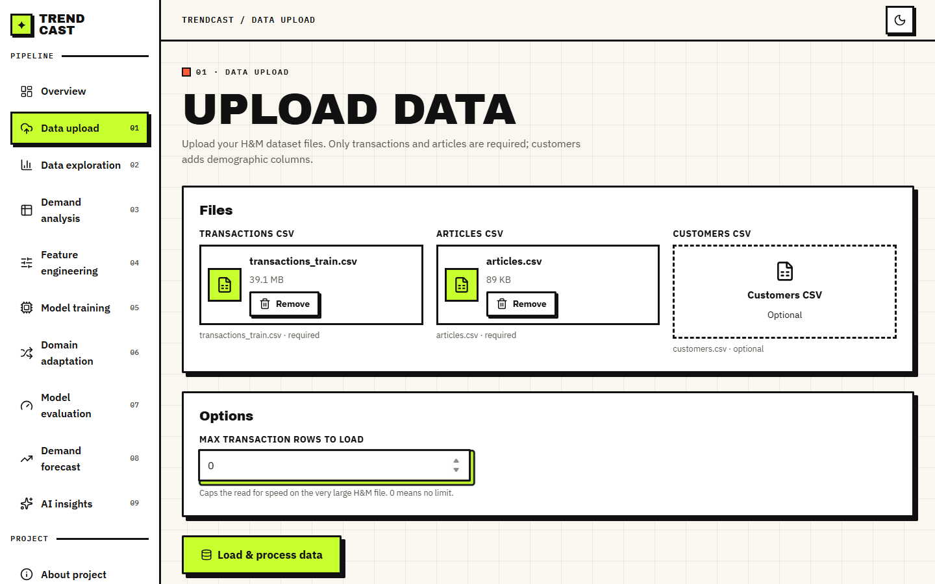  Figure 13: Data Upload page with the transactions file (39.1 MB) and the articles file chosen and the row limit set to 0, meaning no limit. The optional customers file was not supplied. | 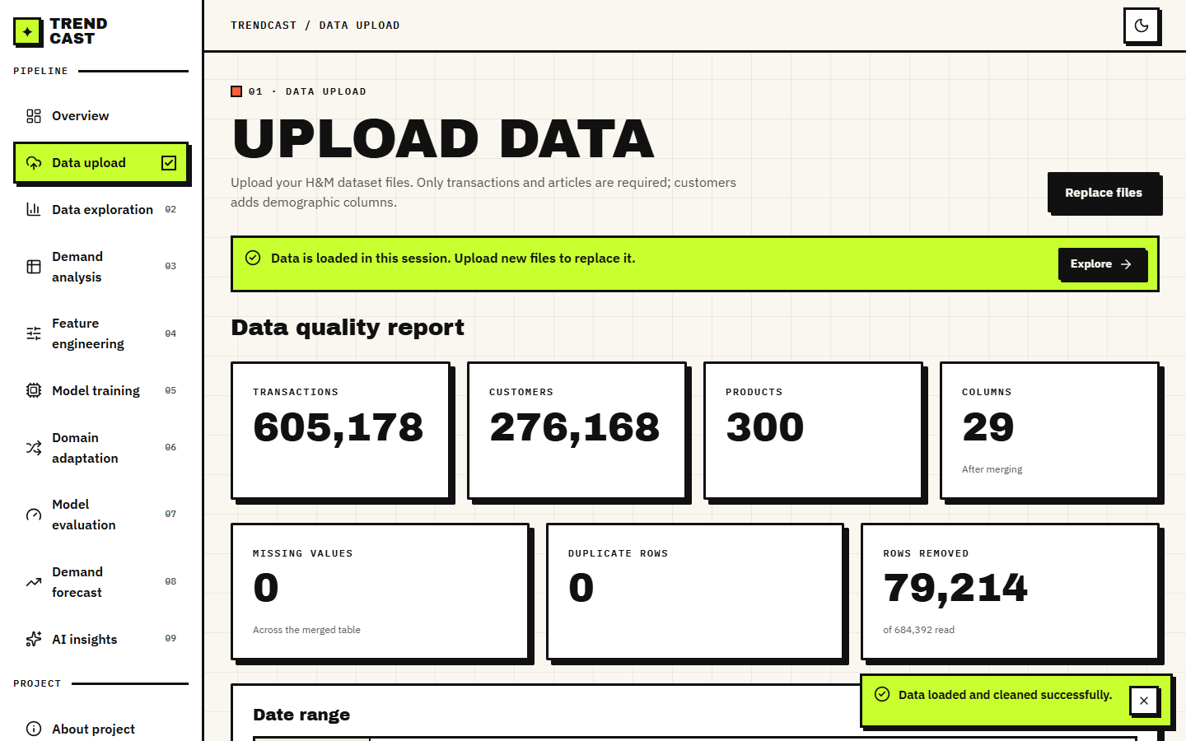  Figure 14: Data quality report after loading: 605,178 transactions, 276,168 customers, 300 products, 29 columns, 0 missing values, 0 duplicate rows remaining and 79,214 rows removed of the 684,392 read.

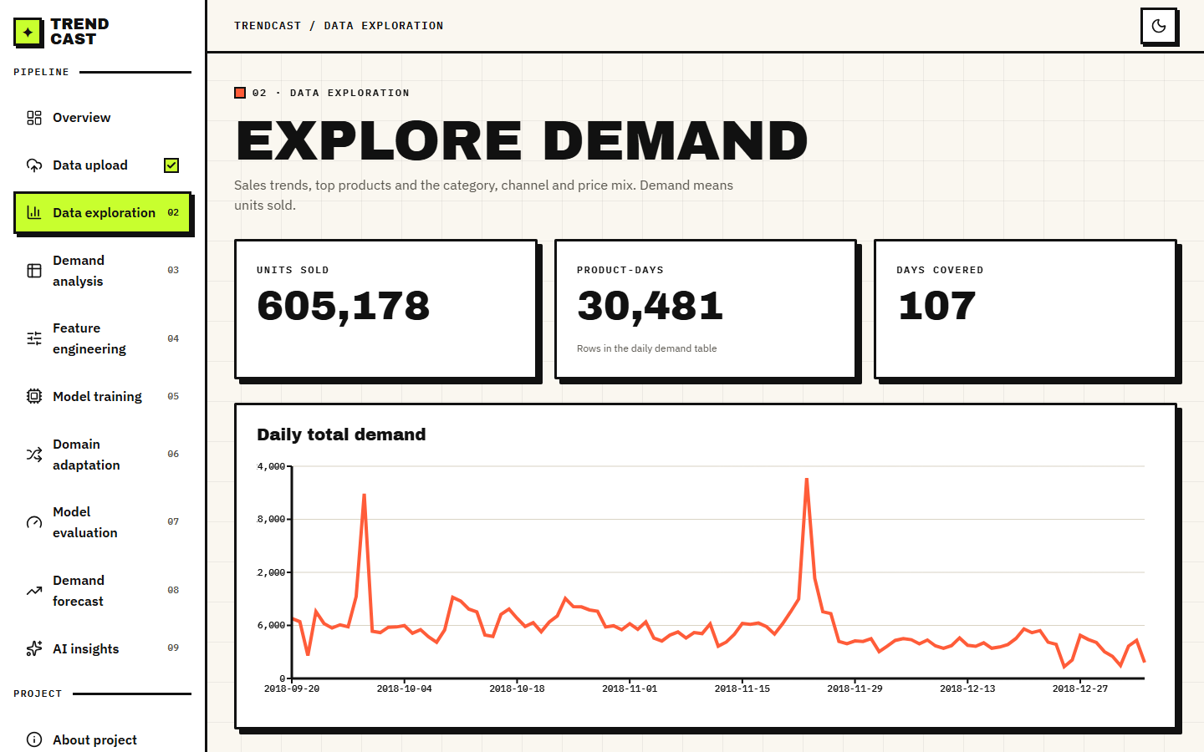  Figure 15: Data Exploration: 605,178 units sold, 30,481 product-days over 107 days, and the daily total demand line with the pre-Christmas peak. | 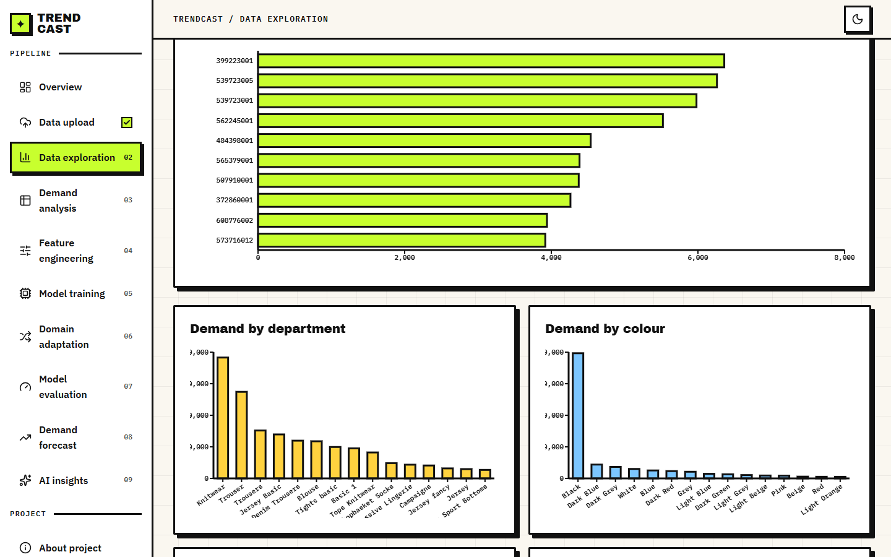  Figure 16: Data Exploration, lower part: units by department and by colour group and the other category charts that show where the demand is concentrated.

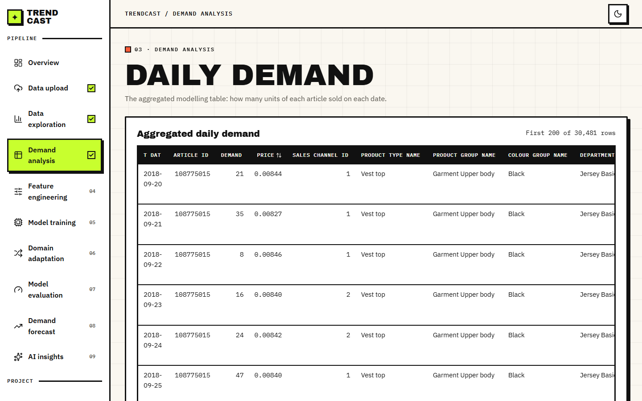  Figure 17: Demand Analysis: the aggregated daily table, one row per article per day with units sold, mean price and channel, beginning with article 108775015 on 2018-09-20 (21 units). | 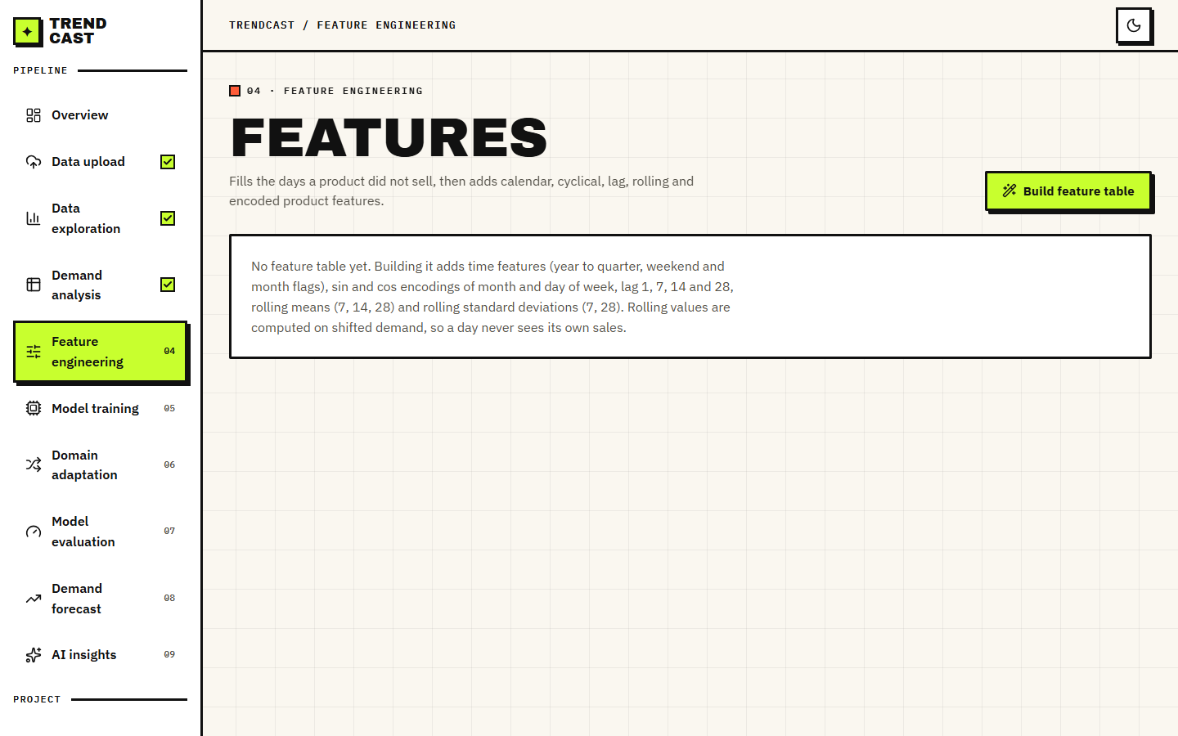  Figure 18: Feature Engineering page before the table is built, with the description of what will be added (calendar, cyclical, lag and rolling features).

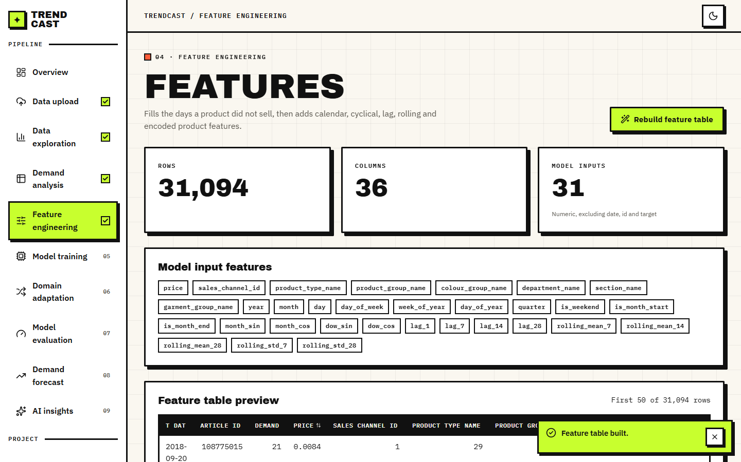  Figure 19: Feature table built: 31,094 rows, 36 columns and 31 model inputs, with the list of input names and a preview of the first rows. | 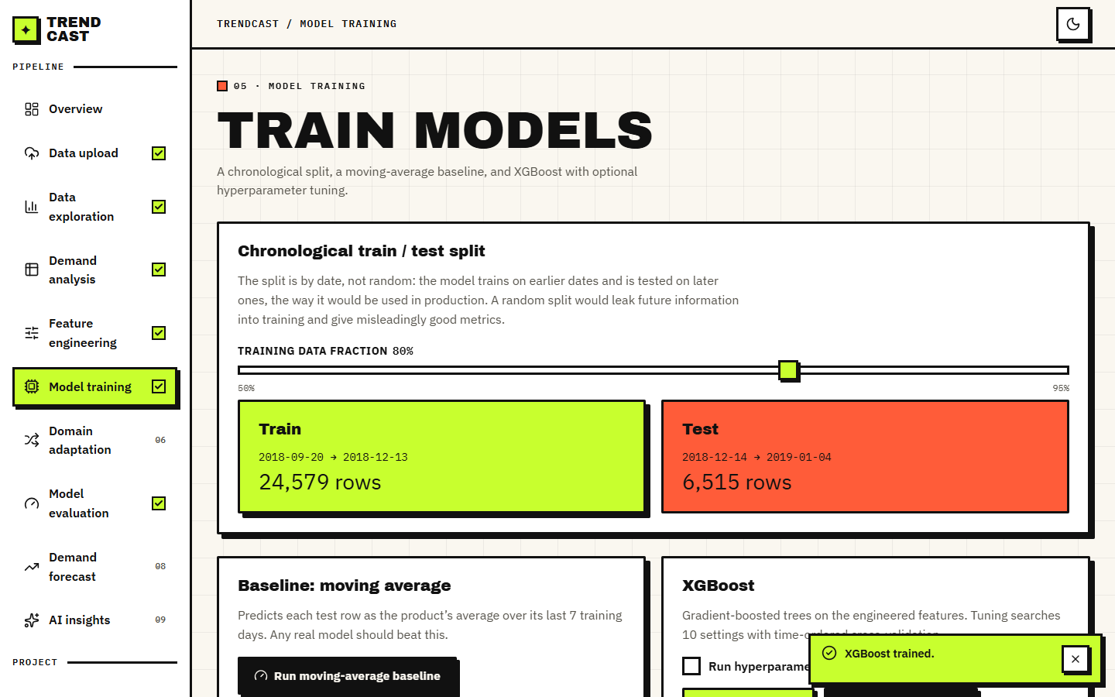  Figure 20: Model Training: chronological split (24,579 training rows to 2018-12-13, 6,515 test rows from 2018-12-14) and the test metrics of the default XGBoost run: RMSE 11.065, MAE 6.991, MAPE 140.5 %, R2 0.337, with the moving-average baseline in the comparison below (RMSE 12.891, R2 0.101).

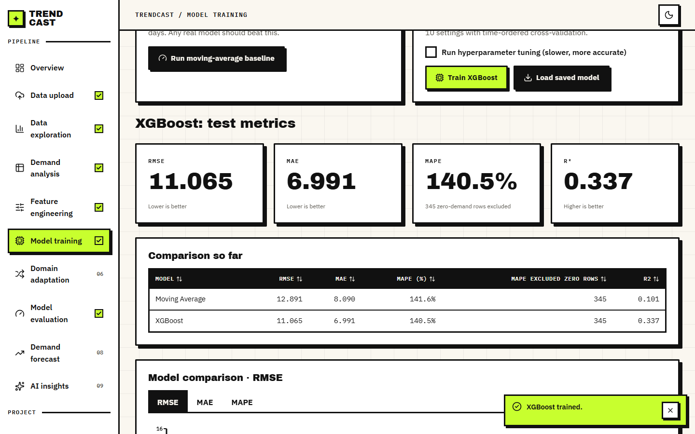  Figure 21: Model comparison table and bar chart for the moving average and XGBoost, switchable between RMSE, MAE and MAPE. | 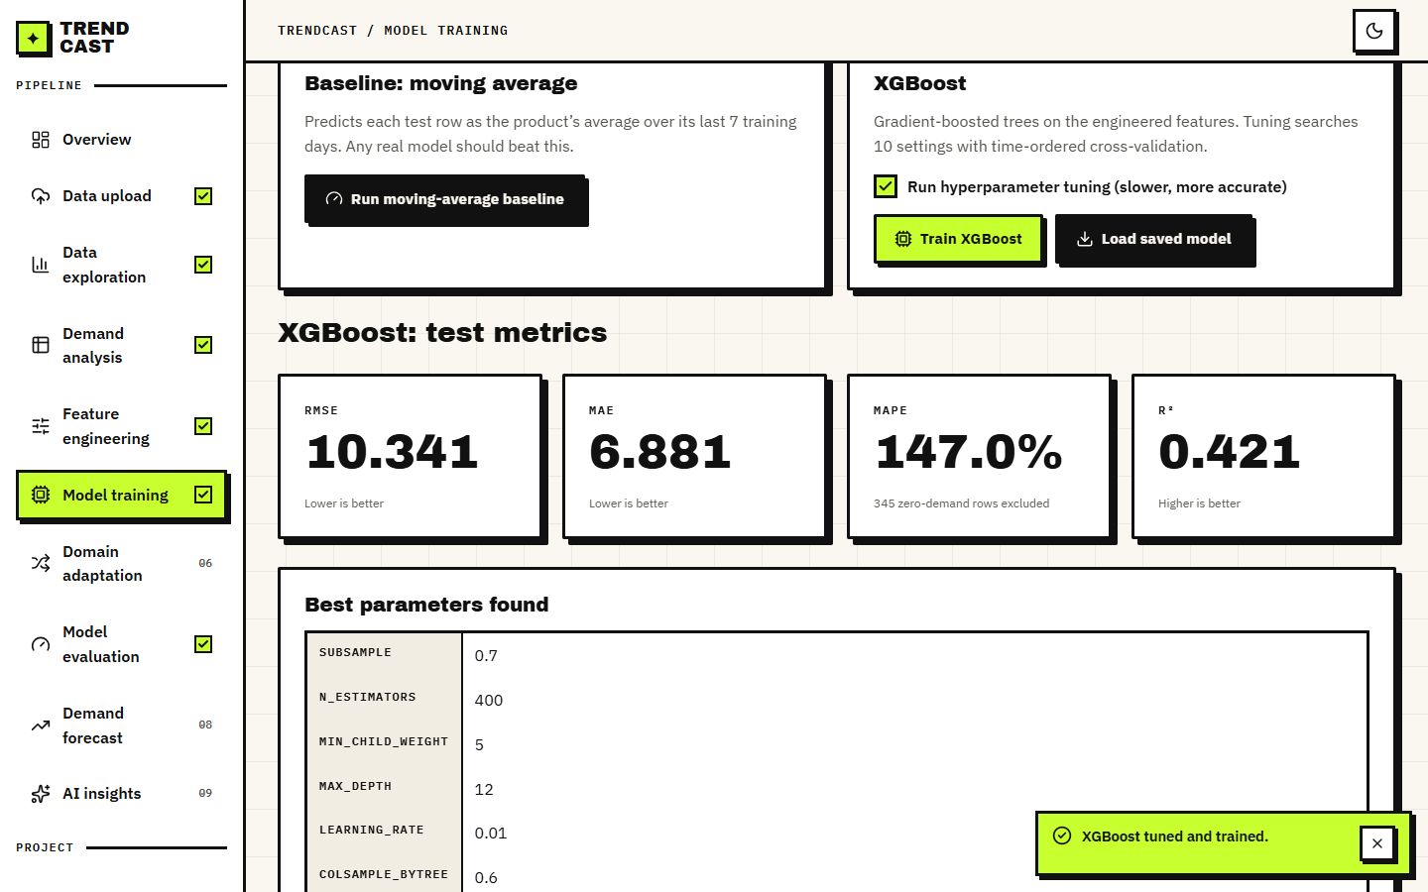  Figure 22: Tuned XGBoost: RMSE 10.341, MAE 6.881, MAPE 147.0 %, R2 0.421, and the best parameters found (subsample 0.7, 400 trees, minimum child weight 5, depth 12, learning rate 0.01, column sample 0.6).

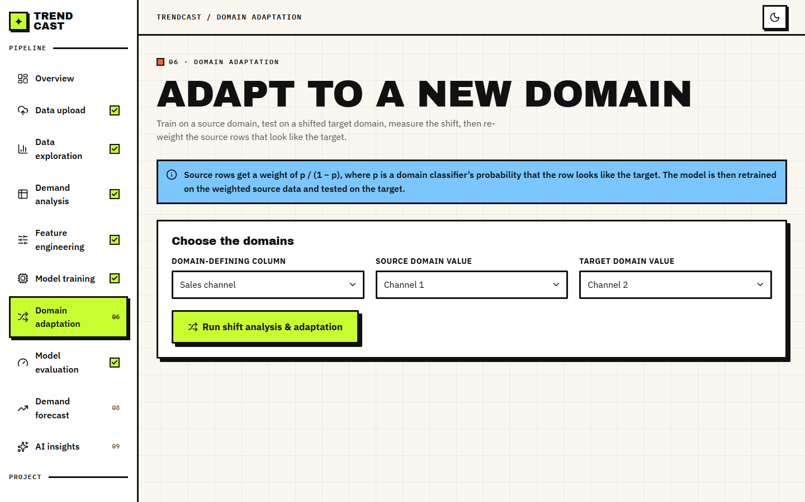  Figure 23: Domain Adaptation form: domain-defining column (sales channel), source value (channel 1) and target value (channel 2), with the explanation of the weight p/(1-p). | 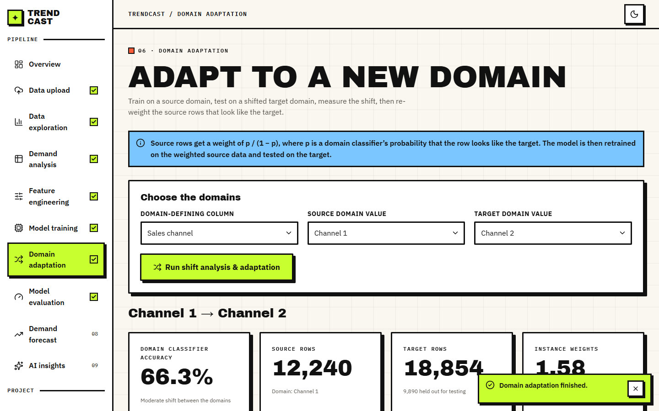  Figure 24: Result header for channel 1 to channel 2: the domain classifier is 66.3 % accurate (a moderate shift), 12,240 source rows, 18,854 target rows of which 9,890 are held out for testing, and a mean instance weight of 1.58.

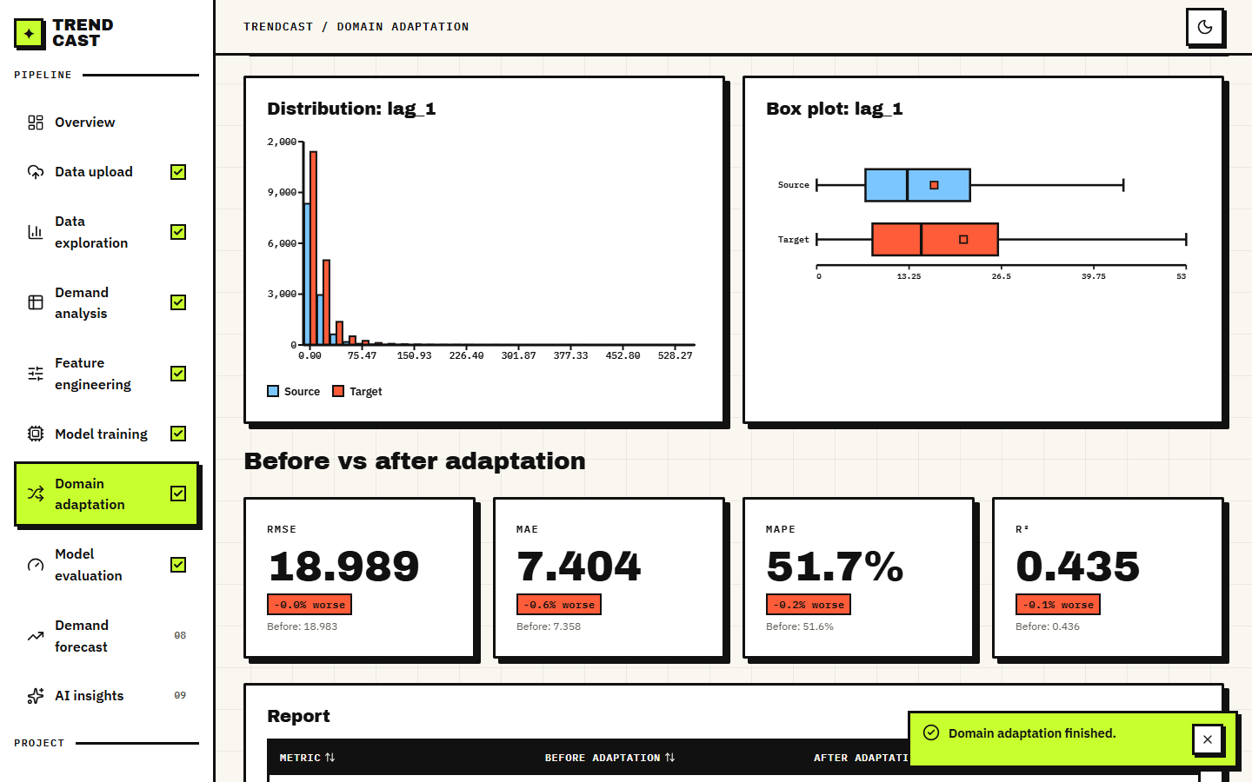  Figure 25: Distribution and box plot of the most shifted feature (lag_1), and the before-and-after cards: RMSE 18.989 (0.0 % worse), MAE 7.404 (0.6 % worse), MAPE 51.7 % (0.2 % worse), R2 0.435 (0.1 % worse). The page reports a result that is not an improvement without softening it. | 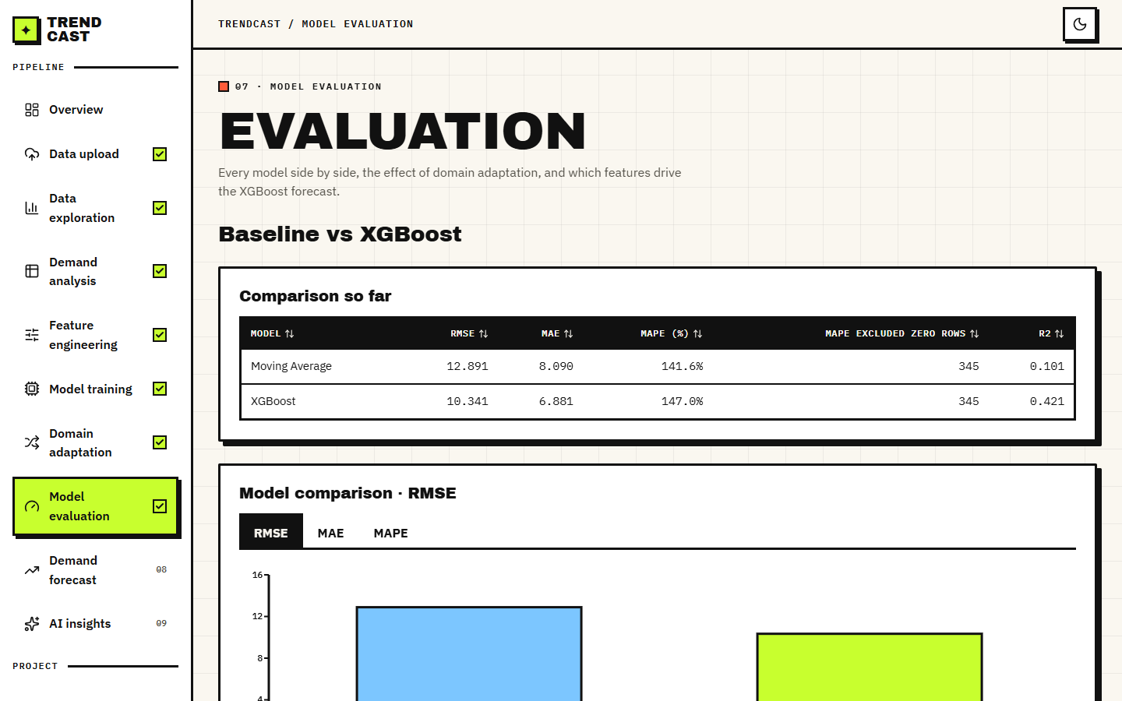  Figure 26: Model Evaluation: baseline versus XGBoost with the RMSE, MAE and MAPE charts.

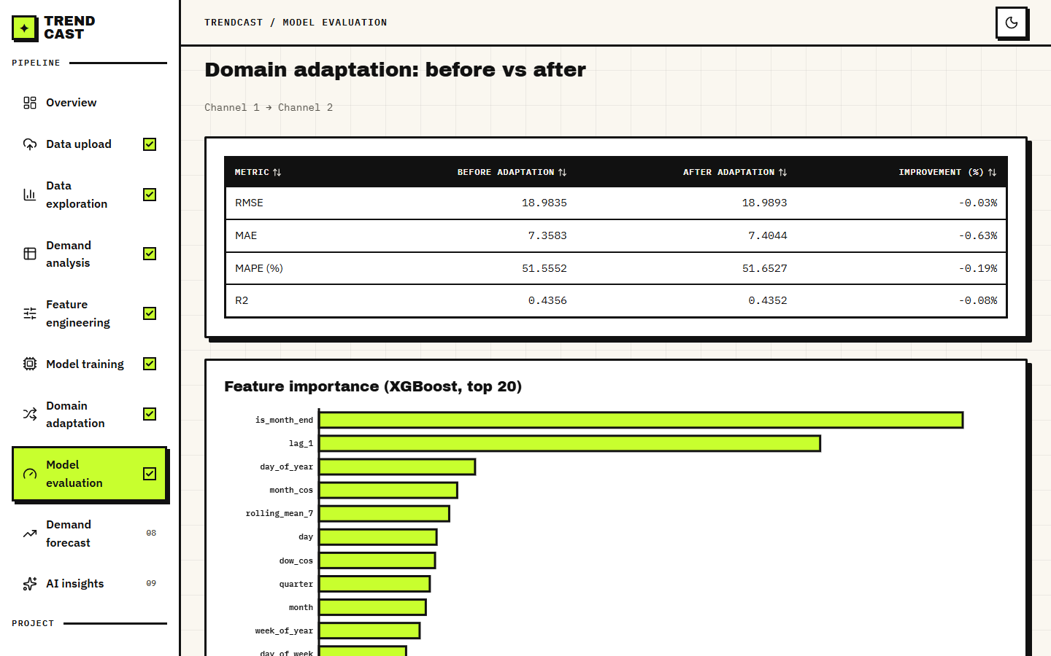  Figure 27: Domain adaptation before-versus-after table (RMSE 18.9835 to 18.9893, improvement -0.03 %) and the top-20 feature importance of the tuned model, led by is_month_end, lag_1, day_of_year, month_cos and rolling_mean_7. | 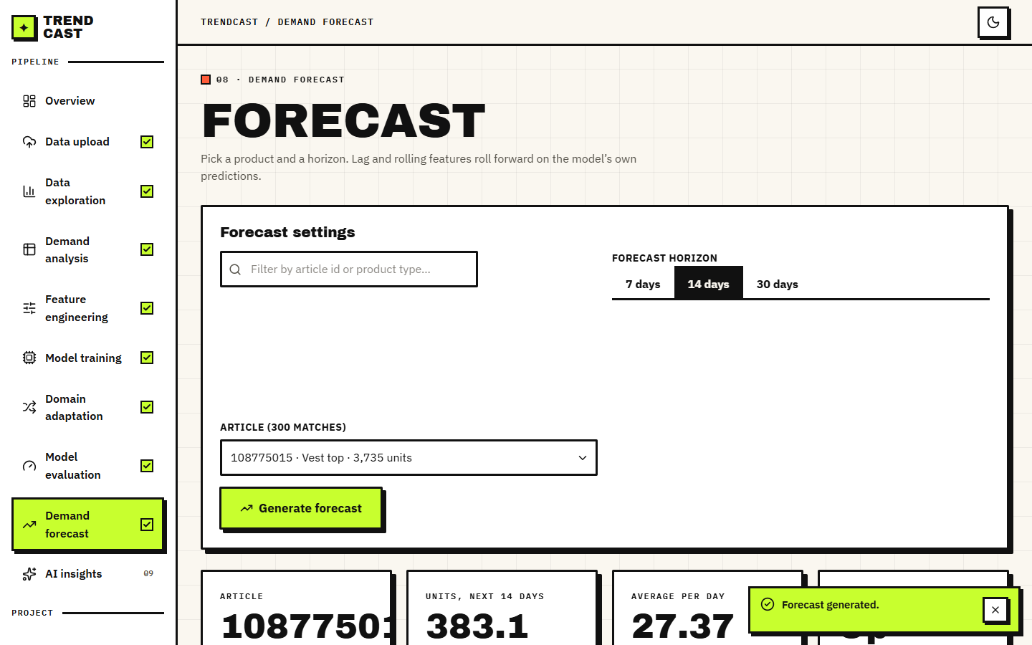  Figure 28: Demand Forecast settings and result: article 108775015 (Vest top, 3,735 units sold), 14-day horizon, 383.1 units in total and 27.37 units per day.

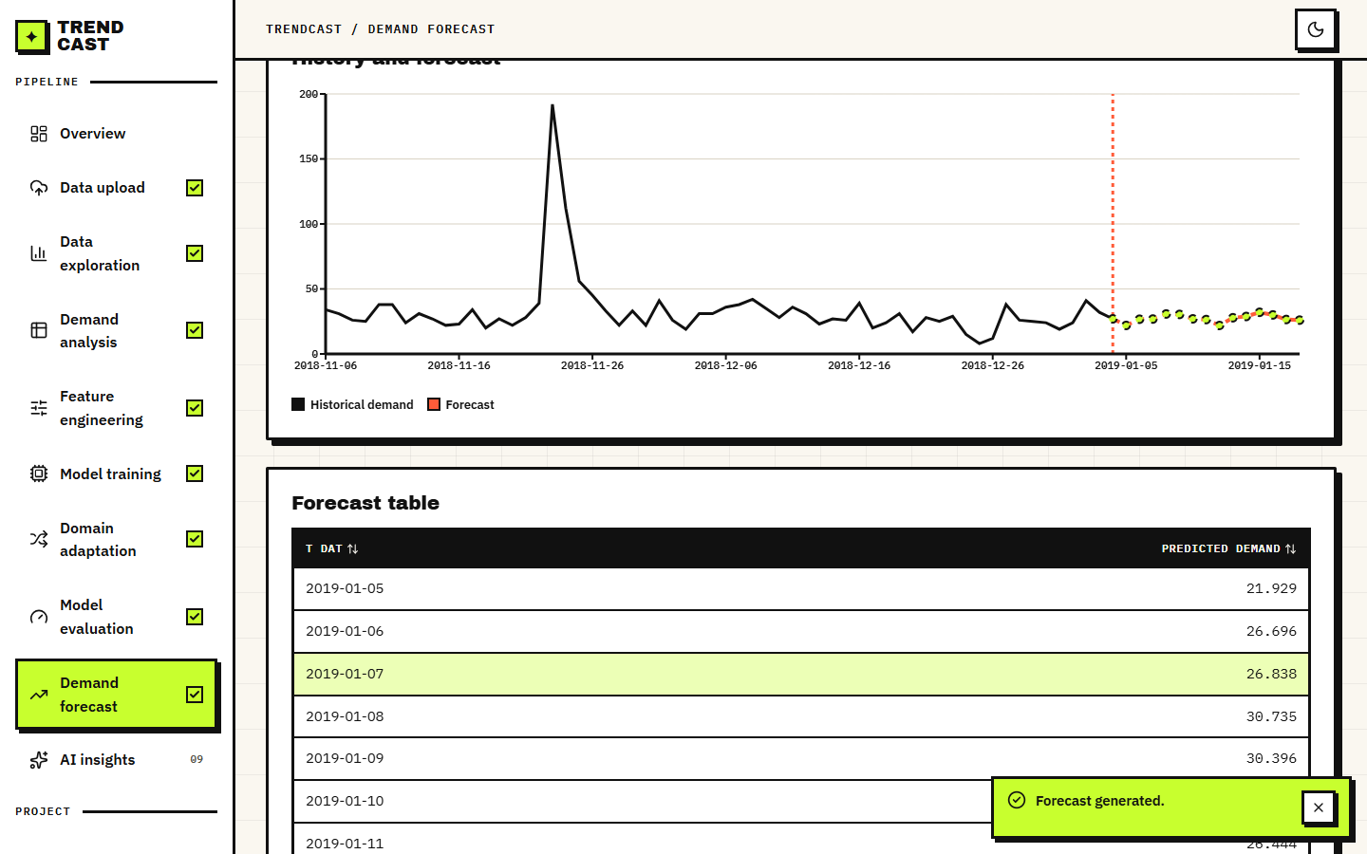  Figure 29: History-and-forecast chart for the same article and the dated forecast table, which starts on 2019-01-05, the day after the data end. | 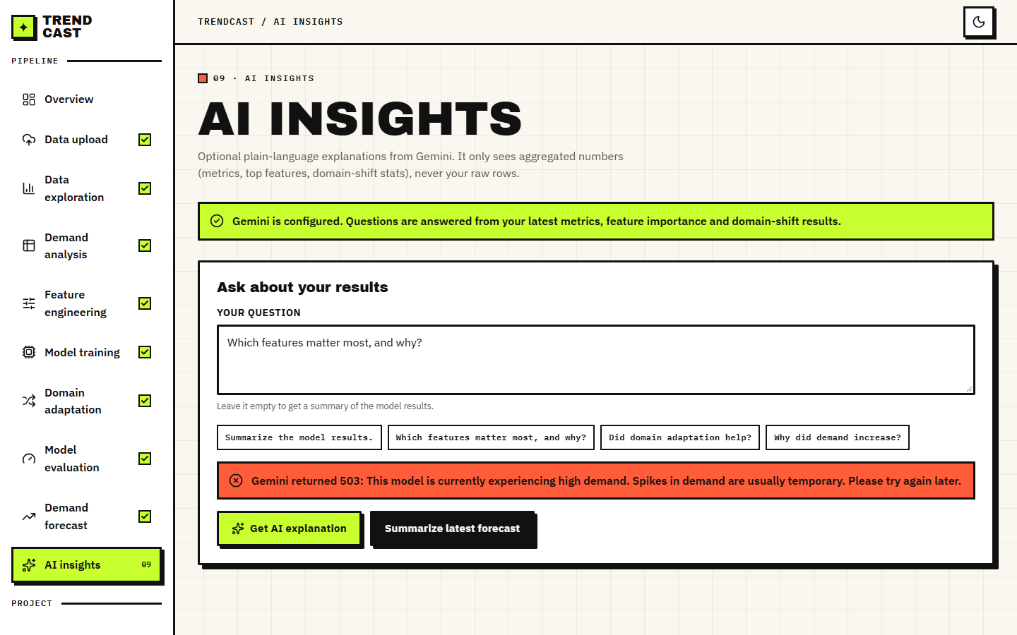  Figure 30: AI Insights page. Gemini is configured but returned 503: This model is currently experiencing high demand; the application shows the message and every other page keeps working. A retry script tried eight times and never obtained an answer, so no AI explanation text could be captured.

8.3 Forecast accuracy
The first table below gives the test-window results of every model on the same 6,515 rows. The default XGBoost reaches RMSE 11.09 (standard deviation 0.05 over five seeds) and R2 0.335, against 12.89 and 0.101 for the 7-day moving average that the product uses as its baseline: a 14.0 % lower RMSE. Tuning lowers it further to 10.34, and LightGBM, run with the same parameters as the product's optional baseline, gives 10.06. The seed-to-seed spread is small (0.048), so the differences between the models are not seed noise.
Table 24: Test-window accuracy of all models (RMSE and MAE in units per article-day; lower is better, R2 higher is better).
Model | RMSE | MAE | R2 | WAPE %
Naive: repeat yesterday (lag 1) | 9.22 | 5.65 | 0.540 | 45.6
Rolling mean of the last 7 days | 9.31 | 5.65 | 0.531 | 45.6
Moving average, 7 days (the product's baseline) | 12.89 | 8.09 | 0.101 | 65.3
Seasonal naive: same day last week (lag 7) | 12.03 | 7.29 | 0.217 | 58.9
Random forest | 13.26 | 7.53 | 0.049 | 60.8
LightGBM | 10.06 | 6.71 | 0.452 | 54.1
XGBoost, default parameters (mean of 5 seeds) | 11.09 | 7.08 | 0.335 | 57.1
XGBoost, tuned (10 iterations x 3 time-ordered folds) | 10.34 | 6.88 | 0.421 | 55.6

The table also contains the result that matters most for honesty: two one-line rules beat the shipped XGBoost. Repeating yesterday's demand gives RMSE 9.22 (R2 0.540) and the shifted 7-day rolling mean gives 9.31, both better than the default (11.09), the tuned model (10.34) and LightGBM. The product's own baseline, the moving average of the last seven days in the training set, is the weakest model except the random forest, because it is frozen at the end of training and cannot follow the December level; it is a weak yardstick. The comparison with a naive lag-1 forecast is the standard one in the base paper [1], whose gradient-boosted model beat it by a wide margin on its own data; here it does not.
The test window is the likely reason. Demand rises towards Christmas, falls sharply afterwards and the training window has never seen that. A model that has memorised absolute dates (is_month_end, quarter, day_of_year and month_sin carry the largest gain importance, see Section 8.6) cannot extrapolate to dates outside its training range, whereas lag-1 follows the level automatically. The ablation in the second table below confirms it.
Table 25: Feature-group ablation (default XGBoost, mean of three seeds).
Feature set | Inputs | RMSE | WAPE % | R2
all features (as shipped) | 31 | 11.06 | 57.0 | 0.339
no lag / rolling | 22 | 16.16 | 89.6 | -0.413
no price, no channel | 29 | 11.44 | 58.4 | 0.292
no product attributes | 25 | 11.21 | 55.0 | 0.320
calendar only | 14 | 15.18 | 93.6 | -0.247
lag / rolling only | 9 | 9.40 | 47.4 | 0.522
lag / rolling + price | 10 | 9.67 | 47.1 | 0.494

Lag and rolling features carry the model: without them RMSE rises from 11.06 to 16.16 and R2 becomes negative (-0.413); calendar features alone are worse than predicting the mean (-0.247). Removing price and channel costs a little (RMSE 11.44); removing the product attributes changes little. The model using only the nine lag and rolling features scores RMSE 9.40 and R2 0.522, better than the shipped 31-input model (11.06). This agrees with the base paper's ablation, where removing rolling statistics caused the largest loss [1], and it shows that on a short window extra calendar inputs hurt.
Across three different origins XGBoost beats the moving average every time, but beats naive lag-1 only in the first fold (27.65 against 30.10), so the conclusion does not hinge on the one 80/20 split. The errors are largest in the weeks before Christmas, where volume itself is largest.

8.4 Multi-day recursive forecast
The Forecast page predicts 7, 14 or 30 days ahead by feeding each prediction back as the next day's lag and rolling inputs. We scored exactly that loop on 296 articles: a model trained on dates before 2018-12-06 forecasts the following 30 days, and the forecast is compared with the actual units. The table below gives RMSE by cumulative horizon and WAPE by band.
Table 26: Recursive forecast accuracy by horizon (RMSE; WAPE % by band).
Method | RMSE d1-7 | RMSE d1-14 | RMSE d1-30 | WAPE d1-7 | WAPE d8-14 | WAPE d15-30
XGBoost recursive, as shipped | 7.99 | 11.96 | 17.50 | 41 | 77 | 124
XGBoost recursive, calendar features refreshed | 7.99 | 11.96 | 18.60 | 41 | 77 | 134
Flat mean of the last 7 days | 6.60 | 8.35 | 12.09 | 34 | 48 | 79
Repeat last week's pattern | 7.45 | 9.21 | 12.86 | 39 | 52 | 82

The forecast is worse than a flat 7-day mean at every horizon and error compounds: WAPE is 41 % in the first week, 77 % in the second and 124 % in days 15 to 30, against 34, 48 and 79 % for the flat mean. The loop in the application updates only part of the calendar (month, day, weekday and their sine and cosine) and leaves week_of_year, day_of_year, quarter and the month-start and month-end flags at the last observed day, and it holds price and channel at their last values. Refreshing the missing calendar features did not help; it was slightly worse at 30 days (WAPE 134 % in the last band). The long-range forecast should therefore be read as an illustration of the interface, not as a planning tool; the base paper itself notes that multi-step forecasting accumulates error as predictions feed back into lag features [1].

8.5 Domain adaptation
The adaptation experiment follows the application's procedure (Chapter 6): train on all source-domain rows, test on the later half of the target domain's dates, estimate the weight p/(1-p) with a logistic domain classifier, retrain with those weights and compare. Six source-to-target pairs were run with five XGBoost seeds each: two sales-channel pairs, two product-group pairs and two department pairs. Four controls were added: a model trained on the first half of the target (target-only), a model trained on the source plus that first half without weights (pooled), the same weights randomly shuffled, and the same weights rescaled to a mean of 1. A time-clean variant removes source rows dated inside the target's test window. The table below gives the results.
Table 27: Domain adaptation, RMSE on the held-out target rows (mean of five seeds). Change columns are % change in RMSE (positive = better).
Pair (source to target) | Domain clf acc % | RMSE before | RMSE adapted | Change as shipped | Seeds better | Change, mean-1 weights | Change, time-clean | Pooled RMSE | Target-only RMSE
Online -> Store (channel 2 -> 1) | 66.5 | 10.80 | 9.50 | +11.9 | 5/5 | +12.1 | -2.8 | 9.78 | 10.05
Store -> Online (channel 1 -> 2) | 66.3 | 19.00 | 18.99 | +0.0 | 3/5 | +0.1 | -0.3 | 17.84 | 22.46
Upper body -> Lower body | 93.3 | 13.90 | 14.80 | -6.5 | 0/5 | -6.0 | +3.0 | 13.51 | 18.21
Lower body -> Upper body | 93.3 | 11.91 | 12.78 | -7.3 | 0/5 | -8.3 | +1.3 | 12.13 | 16.49
Knitwear -> Trouser | 100.0 | 17.23 | 25.21 | -46.3 | 0/5 | +1.9 | -24.4 | 16.88 | 21.79
Jersey Basic -> Blouse | 100.0 | 12.20 | 16.99 | -39.4 | 0/5 | -38.7 | -19.4 | 11.54 | 13.55

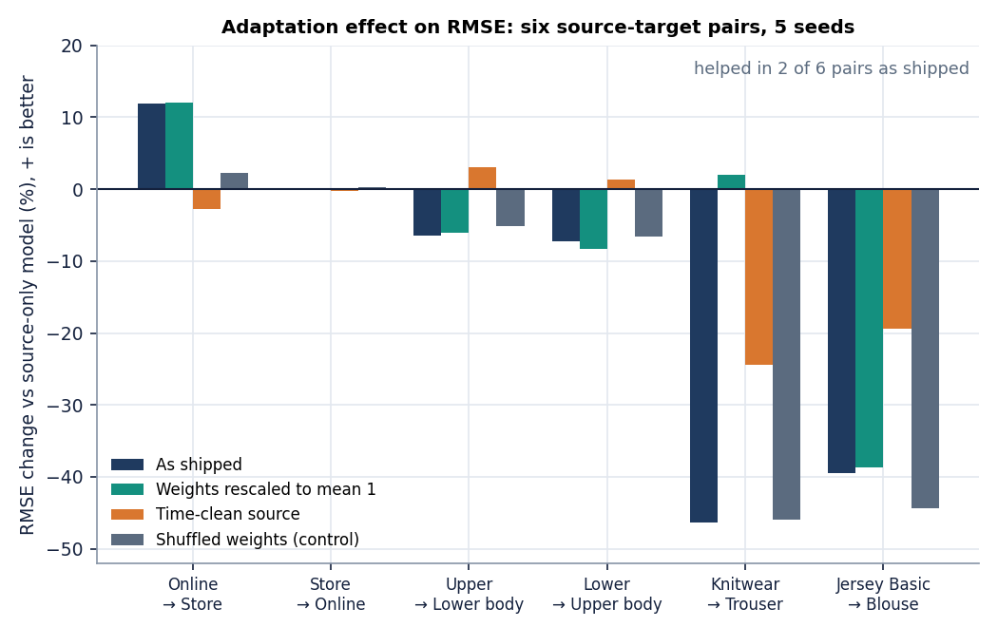
Figure 31: Change in target RMSE for the six pairs: as shipped, with weights rescaled to mean 1, in the time-clean protocol, and with randomly shuffled weights.
Adaptation as shipped improved the target RMSE on 2 of 6 pairs. The change ranges from -46.3 % to +11.9 % with a mean of -14.6 %. The two channel pairs are the realistic case: a moderate shift (the domain classifier is only about 66 % accurate) with plenty of data on both sides. The product-group pairs are more clearly different (93 % accuracy) and adaptation made them worse by 6.5 and 7.3 %. The department pairs are perfectly separable (100 %) and adaptation made them much worse (-46.3 and -39.4 %).

Finding 1: the one clear gain came from time overlap
Online to Store (channel 2 to channel 1) improved by +11.9 % in all five seeds, but the source model was allowed to train on source rows from the same dates as the target's test window. When those rows are removed, the same pair changes by -2.8 %. Random weights on the original protocol already gave +2.2 %, so part of the original gain is noise. The gain was information from the future of the target, not transfer.

Finding 2: perfectly separable domains starve XGBoost
When the classifier separates the domains perfectly, p is close to zero for every source row, so the weights p/(1-p) are tiny: for Knitwear to Trouser the mean weight is 5e-5 and the largest 1.3e-4. XGBoost's min_child_weight is 1, and the summed weight of any candidate leaf can never reach it, so no tree splits and the model predicts a constant (R2 about 0, RMSE 25.21 against 17.23). The five seeds give the same RMSE, because there is nothing random left. Rescaling the same weights to mean 1 removes the collapse: Knitwear to Trouser then changes by +1.9 % instead of -46.3 %. The product accepts this input silently.
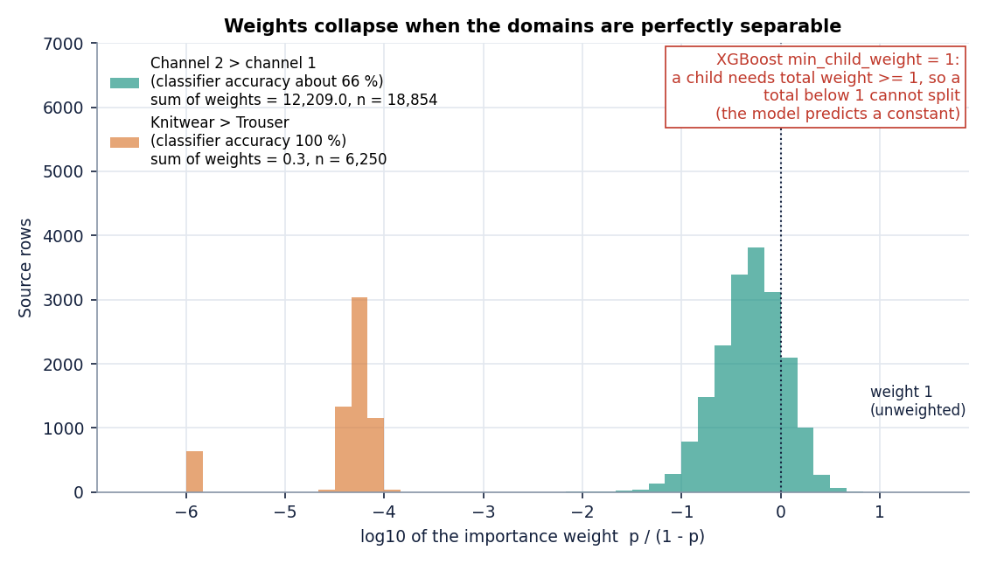
Figure 32: Distribution of the importance weights for the channel pair and for the department pair Knitwear to Trouser. Weights far below the minimum child weight of 1 prevent XGBoost from splitting.

Finding 3: plain pooling beats weighting
A model trained on the source rows plus the first half of the target rows, with no weights at all, has a lower RMSE than the weighted model on five of six pairs (the exception is Online to Store, 9.78 against 9.50). The target-only model is worse than the source-only model on five of six pairs, because half of a small target domain is too little data. In this data the useful move is to include some target rows, not to re-weight the source.
Taking the stricter protocol and the safer weights together, the mean change across the six pairs is +0.2 %: no change on average. The result does not show that importance weighting is wrong in general; it shows that on this retail table, with one shard of three and a half months, a logistic classifier on unscaled features does not produce weights that help, and that the product's way of testing adaptation can report a gain that is not transfer. The theory [10], [12] assumes that source and target inputs overlap and that the weights are estimated well; neither holds for departments that sell different products.

8.6 Explainability
The product explains forecasts with the gain importance of the XGBoost model (the Evaluation page, top 20). The base paper uses SHAP values [4], [5] in addition. To see how much the choice matters, exact TreeSHAP values were computed offline with XGBoost's built-in pred_contribs on all 6,515 test rows (they add up to the model prediction with a maximum error of 8e-05). The table below lists the ten features with the largest mean absolute SHAP value next to their gain importance.
Table 28: Mean absolute SHAP value (units of demand) and gain importance of the ten most influential features.
Feature | Mean |SHAP| | Gain importance
lag_1 | 8.75 | 0.120
rolling_mean_7 | 3.12 | 0.045
day_of_year | 1.97 | 0.043
price | 1.90 | 0.014
sales_channel_id | 1.53 | 0.020
day | 1.12 | 0.043
dow_cos | 0.81 | 0.031
rolling_mean_28 | 0.79 | 0.014
dow_sin | 0.69 | 0.019
week_of_year | 0.68 | 0.033

The two rankings agree only moderately: the Spearman rank correlation is 0.40. By SHAP, lag_1 dominates (8.75 units on average, more than twice the next feature) and the three leading features carry 52 % of all attribution. By gain, the top three are is_month_end, lag_1, quarter: is_month_end and quarter split often but move predictions little. A planner reading only the gain chart (the evaluation screen in Section 8.2) would conclude that calendar flags drive demand, while the SHAP view says yesterday's sales do. This is the kind of mismatch that a SHAP view is meant to reveal; the product does not yet show it, and it shows no per-forecast explanation either.

8.7 Inventory impact
The sixth objective asks for forecast error to be translated into inventory impact. The product does not do this, so it was computed offline from the test predictions: the units by which a forecast falls short of actual demand (stock the shop would lack) and the units by which it exceeds it (stock left over), over the 80,699 units actually sold in the test window.
Table 29: Shortfall and excess of each forecast on the test window (units and share of actual demand).
Forecast | Predicted units | Bias % | Under-forecast (shortfall) | Over-forecast (excess)
XGBoost | 99,704 | +23.6 | 13,198 (16.4 %) | 32,203 (39.9 %)
Moving average (7d) | 85,932 | +6.5 | 23,735 (29.4 %) | 28,968 (35.9 %)
Seasonal naive (lag 7) | 87,148 | +8.0 | 20,531 (25.4 %) | 26,980 (33.4 %)

XGBoost over-forecasts the window by 23.6 % in total, yet misses fewer sales (16.4 % of demand) than the moving average (29.4 %); it buys less risk of stock-out with more excess (39.9 % against 35.9 %). Because the errors are individually large, both kinds of error are large for every forecast: a typical article-day is wrong by about half its demand. The claim in the abstract that the system reduces inventory shortages and overstock is therefore not demonstrated. What is shown is that the forecast loses fewer units than the product's baseline; no stock policy, safety-stock level or service level was simulated or tested out of sample.

8.8 Products without history
The problem statement stresses new products with no sales history. The product has no cold-start mode: its forecast needs at least five days of the article's own history because every strong feature is a lag or rolling value. To see how far attributes alone go, five-fold cross-validation was run with whole articles held out of training. This is an offline experiment, not a feature of the application.
Table 30: Forecasting articles unseen in training (5-fold grouped cross-validation).
Model | RMSE | MAE | R2 | WAPE %
XGBoost, attributes + calendar + price (no lags) | 18.45 | 11.01 | 0.274 | 56.5
Mean demand of the product type | 21.71 | 13.13 | -0.006 | 67.4
Reference: full features with the article's own lags | 12.25 | 6.28 | 0.680 | 32.3

Attributes, calendar and price give R2 0.27 for unseen articles, clearly better than the product-type mean (-0.01), but far below the 0.68 reached when the article's own lags are available. Attribute-based new-item forecasting is a research topic of its own [18], [19], [20] that uses images, similar products or external signals; TrendCast's objective of handling new products is only partly addressed and was not implemented in the product.

8.9 Comparison with the base paper
The base paper [1] is Mishra et al.'s four-level explainable LightGBM framework. The datasets, targets, scales and horizons differ: its data are a UK online wholesaler's gift-ware orders so the scale of demand differs and an RMSE of 33.71 and ours of 11.09 cannot be put on one scale, and the paper's moving-average and naive RMSEs are derived here from the gaps it states. Only relative findings are compared, and only indicatively.
Table 31: TrendCast against the base paper (different data; indicative only).
Aspect | Base paper (Mishra et al.) | TrendCast (this project)
Data | UCI Online Retail II (UK wholesaler), 1.07 M transactions, 4,631 SKUs | H&M, 300 best-selling articles, 684,392 rows, 107 days
RMSE of main model | 33.71 (R2 0.243) | 11.09 (R2 0.335); tuned 10.34
RMSE of moving average (7-day) | 36.57 (the paper reports the gap, 2.86) | 12.89
RMSE of naive lag-1 | 47.77 (the paper reports the gap, 14.06) | 9.22
Reduction versus moving average | 7.8 % | 14.0 %
Reduction versus naive lag-1 | 29.4 % | -20.2 % (i.e. worse)
Domain shift / new products | Not addressed (listed as a limitation) | Importance-weighted adaptation implemented and tested; no cold-start mode

Three findings carry across. In both studies a gradient-boosted model beats the 7-day moving average (by 7.8 % in the base paper and 14.0 % here). In both, rolling and lag features are the dominant group. They differ on the naive lag-1 yardstick: the base paper's model beats it by 29 %, while here the one-line rule is better than XGBoost by 20 %, which we attribute (without being able to prove it with one shard) to the short window, the holiday-spanning test period and the absolute-date inputs. The base paper stops at global and local explanations and leaves multi-step forecasting and external shifts as limitations [1]; TrendCast adds a domain-adaptation step and a multi-step forecast and reports that neither is yet reliable.

8.10 Sample inputs and outputs
Input. The transactions file has one row per purchased item. Three real rows of article 108775015 on the first day (the first two are identical, which is why the cleaning step removes exact duplicates even though they are two units bought):
The articles file gives the same article as Strap top, product type Vest top, group Garment Upper body, colour Black, department Jersey Basic, section Womens Everyday Basics. After cleaning and counting rows per day the article has 21 units on 2018-09-20, 35 on 2018-09-21, 8 on 2018-09-22, 16 on 2018-09-23, 24 on 2018-09-24 and 47 on 2018-09-25 (screen 09).
Output. The last seven actual days of that article and the 7-day forecast of the default model, produced by POST /api/forecast on the final day of the data:
Table 32: Article 108775015, last actual days and 7-day recursive forecast (default XGBoost).
Actual date | Units | Forecast date | Predicted units
2018-12-29 | 25 | 2019-01-05 | 20.51
2018-12-30 | 24 | 2019-01-06 | 26.56
2018-12-31 | 19 | 2019-01-07 | 21.60
2019-01-01 | 24 | 2019-01-08 | 22.32
2019-01-02 | 41 | 2019-01-09 | 24.03
2019-01-03 | 32 | 2019-01-10 | 22.82
2019-01-04 | 27 | 2019-01-11 | 21.35

The seven forecasts total 159.2 units (22.7 per day), close to the recent average of about 27 units per day but flatter than the real series, which swings between 19 and 41; recursive forecasts tend to settle near the recent level, as Section 8.4 measured. The 14-day forecast shown in screen 19, made with the tuned model, totals 383.1 units (27.37 per day).

8.11 Success and failure analysis
Where it works. Real transactions go from upload to forecast in about twelve seconds of compute without tuning (Chapter 7); 39 tests and 26 smoke checks pass; every screen renders real data and the domain page reports a null result without softening it. One-day-ahead forecasting at article level beats the product's baseline by 14 % in RMSE in all five seeds and all three backtest folds, and leakage is controlled by shifted lags, a chronological split and time-ordered tuning folds.
Where it fails. It does not beat repeat-yesterday on the test window, and the all-feature model is worse than a nine-feature lag/rolling model. Recursive 7/14/30-day forecasts are worse than a flat 7-day mean. Domain adaptation helps on 2 of 6 pairs, the clearest gain is a time-overlap artefact and unnormalised weights can collapse XGBoost to a constant. New products cannot be forecast (offline R2 0.27 from attributes only). Cleaning removes 11.6 % of rows that are mostly real repeat purchases, and AI Insights gave no answer because the external service was unavailable.

8.12 Limitations of the evaluation
• One shard of the data (107 days, 300 best-selling articles, two channels): no yearly seasonality can be learnt and the test window is a holiday peak.
• The domains are mixtures (the channel label is the most frequent channel of the day while demand counts both), and no promotions, stock levels or weather exist in the files.
• Five seeds capture only XGBoost's randomness; the inventory and SHAP analyses are offline; the base-paper comparison is indicative because the data differ.

8.13 Objectives versus outcomes
Table 33: The six project objectives against what was measured.
Objective | Status | Evidence
1. Collect fashion sales data; engineer seasonal, pricing and category features | Achieved | Real H&M subset; 31 inputs (price, channel, 6 attributes, 14 calendar, 9 lag/rolling); shifted lags, chronological split. No promotion or fabric data exist in H&M
2. Train gradient-boosting models at product and category level | Achieved at article level | XGBoost per article-day with category as an input; no separate category-level model
3. Apply domain adaptation across markets and categories | Implemented and applied | Importance weighting on channel, product-group and department domains; "markets" are the two sales channels (no regions in the data)
4. Compare adapted and non-adapted models on a shifted target | Done, result negative | 6 pairs x 5 seeds + controls: helped 2/6 (mean -14.6 %); mean-1 weights -6.5 %; time-clean -7.1 %; pooling beats it on 5/6
5. Explain forecast drivers | Partly | Gain importance (top 20) in the app; offline SHAP agrees only moderately (rank correlation 0.40); no per-forecast explanation; Gemini text unavailable in the run
6. Evaluate with MAE, RMSE, MAPE and translate error into inventory impact | Metrics achieved; impact offline | RMSE, MAE, MAPE, R2, WAPE reported; inventory impact computed offline only (XGBoost 16.4 % short, 39.9 % excess); stock-out reduction not demonstrated

8.14 Summary of findings
• On a real H&M subset XGBoost forecasts one day ahead with RMSE 11.09 (tuned 10.34), better than the product's moving average (12.89) but worse than repeating yesterday (9.22).
• Lag and rolling features do almost all the work; absolute-date features hurt on a short window.
• Recursive multi-day forecasts are worse than a flat 7-day mean and degrade quickly with the horizon.
• Importance-weighted domain adaptation, as built, is not reliable: it helped on 2 of 6 pairs, the clear gain is a time-overlap artefact, and degenerate weights collapse the model. Rescaling weights and pooling target rows are the first fixes to try.
• Gain importance and exact SHAP rank features differently; the offline SHAP view shows yesterday's demand as the main driver.
• Inventory impact and cold-start performance are not part of the product; offline numbers show the gaps.
• The application is complete, tested and fast; the forecasting claims in the abstract are supported only in part, and this chapter says which part.

CHAPTER 9: CONCLUSION

9.1 Summary
TrendCast was built to forecast fashion demand with machine learning and to move a model from one retail context to another by domain adaptation. The product takes the three H&M tables, validates, cleans and merges them, aggregates units sold per article per day, fills quiet days with zero, builds calendar, price, attribute, lag and rolling features without leakage, splits by date, trains a moving-average baseline and an XGBoost model, adapts a source-domain model to a target domain with importance weights, evaluates with RMSE, MAE, safe MAPE and R2, forecasts 7, 14 or 30 days ahead and, optionally, asks Gemini to explain the numbers in words. It runs as a FastAPI service with 22 routes and a 13-page React console; the original Streamlit app is unchanged.

9.2 Objectives achieved
Table 34: Objectives against outcomes
Objective | Outcome | Evidence
1 Collect real data, engineer seasonal, price and category features | Achieved | H&M subset, 31 inputs, shifted lags, no promotions or fabric in the data
2 Train XGBoost at product and category level | Product level achieved | Article-level model; category enters as features only
3 Apply domain adaptation across markets and categories | Implemented | Importance weighting on channel, group and department; no regional markets in the data
4 Compare adapted and non-adapted on a shifted target | Done; result negative or mixed | 2 of 6 pairs improved; mean -14.6 percent
5 Explain forecast drivers | Partly | Gain importance in the app; offline SHAP agrees only moderately (Spearman 0.40)
6 Evaluate with MAE, RMSE, MAPE and inventory impact | Metrics yes; inventory offline | XGBoost under-forecasts 16.4 percent and over-forecasts 39.9 percent of test demand

Objectives 1, 2 and 3 were met as built; objective 4 was carried out and answered with a mostly negative result; objectives 5 and 6 were met in part, because SHAP and inventory units exist only in the offline harness.

9.3 Key findings
1. The model is useful but not unbeatable. On the real test window XGBoost (RMSE 11.09, R2 0.33) beats the moving average (12.89) and random forest (13.26); LightGBM (10.06) and the tuned model (10.34) come closer to naive lag-1 (9.22), which still wins.
2. Recent demand does the work. Without lag and rolling features R2 falls to -0.41; with only those features RMSE is 9.40, better than the shipped all-feature model. This agrees with the base paper's own ablation on different data.
3. Domain adaptation, as shipped, is not a reliable gain. It improved 2 of 6 pairs; the one clear gain disappears when source rows may not overlap the target test dates (-7.1 percent on average in that protocol).
4. Weights must be normalised. Perfectly separable domains produce weights near 1e-5 and XGBoost predicts a constant; rescaling the same weights to mean 1 removes the collapse.
5. Multi-day forecasts are weak. WAPE grows from 41 to 124 percent over the horizon, worse than a flat seven-day mean at every horizon.
Two further findings come from the controls. The offline TreeSHAP ranking puts lag_1 first, with three features carrying 52 percent of the total attribution, while gain importance puts is_month_end and quarter first: gain overstates calendar features that split often.
Table 2 repeats the six pairs (channel, product group, department). The department pairs are separated perfectly and collapse under the shipped weights; the product-group pairs lose 6-7 percent; only the first pair gains, and its gain vanishes in the time-clean column.
Table 35: Domain adaptation on six source-target pairs (RMSE on held-out target rows, mean of 5 seeds; improvement in percent)
Pair | Clf acc. % | Before | Adapted | As shipped | Mean-1 weights | Time-clean
Online -> Store (channel 2 -> 1) | 66.5 | 10.80 | 9.50 | +11.9 | +12.1 | -2.8
Store -> Online (channel 1 -> 2) | 66.3 | 19.00 | 18.99 | +0.0 | +0.1 | -0.3
Upper body -> Lower body | 93.3 | 13.90 | 14.80 | -6.5 | -6.0 | +3.0
Lower body -> Upper body | 93.3 | 11.91 | 12.78 | -7.3 | -8.3 | +1.3
Knitwear -> Trouser | 100.0 | 17.23 | 25.21 | -46.3 | +1.9 | -24.4
Jersey Basic -> Blouse | 100.0 | 12.20 | 16.99 | -39.4 | -38.7 | -19.4

9.4 Practical applications
• A forecasting baseline with a built-in sanity check. The comparison table puts XGBoost beside a moving average; adding the naive lag-1 forecast to it, as the offline harness does, is the check a planner should demand before trusting a model.
• Short-horizon planning only. Seven-day forecasts are the most trustworthy output; 15-30 day forecasts should not drive orders.

9.5 Known limitations
The data cover 107 days and one retailer, so seasonality, new-market transfer and slow movers were not measured. The cleaning step removes repeat purchases, the price and channel of the forecast day are inputs, and the recursive loop freezes several calendar features. The product has no cold-start mode, no per-forecast explanation and no inventory view, runs for one user with in-memory state, and depends on an external service for AI Insights, which was unavailable during capture. Chapter 8 and the limitations chapter give the full list.
Figure 33: RMSE improvement of the adapted model for the six source-target pairs under four protocols.

CHAPTER 10: FUTURE SCOPE

10.1 Improvements to the existing system
• Normalise and floor the importance weights. Rescaling the same weights to mean 1 removed the constant-prediction collapse on the department pairs in the offline study (Knitwear to Trouser from -46.3 to +1.9 percent). The product should do this by default and show the effective sample size beside the clipped share.
• Time-clean adaptation by default. Restrict source rows to dates before the target test window and report the gap to the current protocol, so a gain that comes from time overlap is visible.
• A correct recursive forecast. Refresh week of year, day of year, quarter and month-start flags, take price and channel from a plan, and accept the forecast only if it beats a flat seven-day mean on a backtest; otherwise fall back to that mean.

10.2 Additional features
• Cold-start forecasting. The offline test shows attributes and calendar reach R2 0.27 on unseen articles; a product mode with nearest-neighbour or diffusion-style life-cycle models [18], [22] would serve new fashion items.
• Explanations. SHAP values per forecast in the console, ICE-style curves for the strongest features as in the base paper, and a naive lag-1 row in every comparison table.
• Inventory view. Convert error into under- and over-stock units, then into reorder points and cost, using service levels set per product class.

10.3 Scalability and deployment
TrendCast was built for one analyst and a sampled file. Its state is a Python dictionary, its upload is read whole into memory and its long operations hold one lock, which is enough for the 684,392-row subset (upload in 3.5 seconds, features in 0.9 seconds, a tuned model in 29.6 seconds) and not enough for a production system.
• Replace the in-memory dictionary with a database and a job queue, so uploads, models and results belong to a user and survive restarts.
• Read the full 31.8-million-row file in chunks and aggregate to daily demand before it enters memory; the subset here loads in 3.5 seconds, the full file will not.
• Add authentication, a container build, scheduled retraining and drift monitoring based on the shift table and the classifier accuracy.

10.4 Further research
• Compare importance weighting with CORAL and adversarial alignment [16], [15], and with the simple pooled model that won here, on a window that includes a previous year.
• Test transfer to real new markets (stores, countries) and measure how many target rows are needed before adaptation beats pooling.
• Quantify the value of explanations: do planners override fewer forecasts when they see SHAP? The base paper's motivation [1] is a trust gap that a user study could measure.

REFERENCES
[1] L. N. Mishra, B. Senapati, S. K. Nayak and A. J. Rangari, "Explainable retail demand forecasting: A hybrid LightGBM-SHAP framework for inventory optimization," IEEE Access, vol. 14, pp. 43613-43633, 2026, doi: 10.1109/ACCESS.2026.3675540.
[2] T. Chen and C. Guestrin, "XGBoost: A scalable tree boosting system," in Proc. 22nd ACM SIGKDD Int. Conf. Knowledge Discovery and Data Mining, Aug. 2016, pp. 785-794.
[3] G. Ke, Q. Meng, T. Finley, T. Wang, W. Chen, W. Ma, Q. Ye and T.-Y. Liu, "LightGBM: A highly efficient gradient boosting decision tree," in Proc. Advances in Neural Information Processing Systems (NIPS), 2017, pp. 3146-3154.
[4] S. M. Lundberg and S.-I. Lee, "A unified approach to interpreting model predictions," in Proc. Advances in Neural Information Processing Systems (NIPS), 2017, pp. 4765-4774.
[5] S. M. Lundberg et al., "From local explanations to global understanding with explainable AI for trees," Nature Machine Intelligence, vol. 2, no. 1, pp. 56-67, Jan. 2020.
[6] S. Makridakis, E. Spiliotis and V. Assimakopoulos, "M5 accuracy competition: Results, findings, and conclusions," International Journal of Forecasting, vol. 38, no. 4, pp. 1346-1364, Oct. 2022.
[7] L. Breiman, "Random forests," Machine Learning, vol. 45, no. 1, pp. 5-32, 2001.
[8] J. H. Friedman, "Greedy function approximation: A gradient boosting machine," The Annals of Statistics, vol. 29, no. 5, pp. 1189-1232, 2001.
[9] R. J. Hyndman and A. B. Koehler, "Another look at measures of forecast accuracy," International Journal of Forecasting, vol. 22, no. 4, pp. 679-688, 2006.
[10] H. Shimodaira, "Improving predictive inference under covariate shift by weighting the log-likelihood function," Journal of Statistical Planning and Inference, vol. 90, no. 2, pp. 227-244, 2000.
[11] M. Sugiyama, M. Krauledat and K.-R. Mueller, "Covariate shift adaptation by importance weighted cross validation," Journal of Machine Learning Research, vol. 8, pp. 985-1005, 2007.
[12] S. Bickel, M. Brueckner and T. Scheffer, "Discriminative learning under covariate shift," Journal of Machine Learning Research, vol. 10, pp. 2137-2155, 2009.
[13] S. J. Pan and Q. Yang, "A survey on transfer learning," IEEE Transactions on Knowledge and Data Engineering, vol. 22, no. 10, pp. 1345-1359, Oct. 2010.
[14] S. Ben-David, J. Blitzer, K. Crammer, A. Kulesza, F. Pereira and J. W. Vaughan, "A theory of learning from different domains," Machine Learning, vol. 79, no. 1-2, pp. 151-175, 2010.
[15] Y. Ganin et al., "Domain-adversarial training of neural networks," Journal of Machine Learning Research, vol. 17, no. 59, pp. 1-35, 2016.
[16] B. Sun and K. Saenko, "Deep CORAL: Correlation alignment for deep domain adaptation," in Proc. ECCV Workshops, 2016, pp. 443-450.
[17] S. Thomassey, "Sales forecasts in clothing industry: The key success factor of the supply chain management," International Journal of Production Economics, vol. 128, no. 2, pp. 470-483, Dec. 2010.
[18] V. Ekambaram, K. Manglik, S. Mukherjee, S. S. K. Sajja, S. Dwivedi and V. Raykar, "Attention based multi-modal new product sales time-series forecasting," in Proc. 26th ACM SIGKDD Int. Conf. Knowledge Discovery and Data Mining, 2020, pp. 3110-3118, doi: 10.1145/3394486.3403362.
[19] P. K. Singh, Y. Gupta, N. Jha and A. Rajan, "Fashion retail: Forecasting demand for new items," arXiv:1907.01960, 2019.
[20] G. Skenderi, C. Joppi, M. Denitto and M. Cristani, "Well Googled is half done: Multimodal forecasting of new fashion product sales with image-based Google Trends," arXiv:2109.09824, 2021 (rev. 2024).
[21] S. I. Papadopoulos, C. Koutlis, S. Papadopoulos and I. Kompatsiaris, "Multimodal quasi-autoregression: Forecasting the visual popularity of new fashion products," arXiv:2204.04014, 2022.
[22] R. Zhou, Z. Zhang, J. Han, Y. Peng and X. Zhang, "Cold-start forecasting of new product life-cycles via conditional diffusion models," arXiv:2604.20370, Apr. 2026.
[23] H&M Group, "H&M Personalized Fashion Recommendations," Kaggle competition data (articles, customers, transactions), 2022. [Online]. Available: https://www.kaggle.com/competitions/h-and-m-personalized-fashion-recommendations
[24] F. Pedregosa et al., "Scikit-learn: Machine learning in Python," Journal of Machine Learning Research, vol. 12, pp. 2825-2830, 2011.
[25] J. Bergstra and Y. Bengio, "Random search for hyper-parameter optimization," Journal of Machine Learning Research, vol. 13, pp. 281-305, 2012.
[26] "Impact of AI-driven demand forecasting on retail inventory efficiency," 2026 (title as listed in the batch literature survey; not located online and not quoted).
[27] "Enhancing inventory planning in retail SMEs through data-driven demand forecasting," Int. J. of Innovative Inventions in Social Science and Humanities, 2026 (title as listed in the batch literature survey; not located online and not quoted).
[28] "Does the forecaster matter? A systematic evaluation of demand forecasting and inventory control policies across retail demand regimes," 2026 (title as listed in the batch literature survey; not located online and not quoted).
[29] "Predictive inventory management for retail distribution networks: Reorder point optimization and machine learning demand forecasting," 2026 (title as listed in the batch literature survey; not located online and not quoted).

APPENDIX A: IMPORTANT CODE
The key functions are copied from 8.ProjectCode as they stood when the results were measured; docstrings are removed to save space (the full files are in the repository). The lag features and importance weights are also explained in Chapter 6 and the walk-throughs of the design document.

A.1 Cleaning (`preprocessing.py`)
def clean_transactions(transactions: pd.DataFrame) -> pd.DataFrame:
df = transactions.copy()

# 1. Parse dates
df["t_dat"] = pd.to_datetime(df["t_dat"], errors="coerce")

# 2. Drop rows that are missing essential identifiers
essential = ["t_dat", "article_id", "customer_id"]
df = df.dropna(subset=essential)

# 3. Validate price: must be a positive number
df["price"] = pd.to_numeric(df["price"], errors="coerce")
df = df[df["price"] > 0]

# 4. Remove exact duplicate transaction rows
df = df.drop_duplicates()

# 5. Sort chronologically -- this matters a lot for lag/rolling features later
df = df.sort_values("t_dat").reset_index(drop=True)

return df

A.2 Importance weights and weighted training (`domain_adaptation.py`)
def compute_instance_weights(
domain_classifier: LogisticRegression, source_features: pd.DataFrame, clip_max: float = 20.0
) -> np.ndarray:
p_target = domain_classifier.predict_proba(source_features)[:, 1]
p_target = np.clip(p_target, 1e-6, 1 - 1e-6) # avoid divide-by-zero
weights = p_target / (1 - p_target)
weights = np.clip(weights, 0, clip_max)
return weights

def train_adapted_model(source_X, source_y, weights, params: dict | None = None):
from src.xgboost_model import train_xgboost

return train_xgboost(source_X, source_y, params=params, sample_weight=weights)

A.3 The domain-adaptation route (`backend/main.py`)
@app.post("/api/domain/run")
def run_domain(req: DomainRequest):
with LOCK:
ft = need("feature_table", "Build the feature table first (Feature Engineering).")
if req.domain_col not in DOMAIN_COLUMNS or req.domain_col not in ft.columns:
raise HTTPException(status_code=400, detail="Choose one of the offered domain columns.")
if req.source == req.target:
raise HTTPException(status_code=400, detail="Source and target values must be different.")

# The domain column is excluded from the features so the classifier cannot read the label off a feature.
cols = [c for c in feature_cols_of(ft) if c != req.domain_col]
source_df, target_df = domain_adaptation.split_domains(ft, req.domain_col, req.source, req.target)
if source_df.empty or target_df.empty:
raise HTTPException(status_code=400, detail="One of the domains has no data. Choose different values.")

source_X, source_y = source_df[cols], source_df["demand"]
target_train, target_test = baseline_models.chronological_split(target_df, train_fraction=0.5)
if target_test.empty or target_train.empty:
raise HTTPException(status_code=400, detail="The target domain has too few dates to hold out a test half. Choose a larger target domain.")
target_test_X, target_test_y = target_test[cols], target_test["demand"]

source_model = xgboost_model.train_xgboost(source_X, source_y)
metrics_before = evaluation.evaluate_model(target_test_y, source_model.predict(target_test_X))

classifier, acc = domain_adaptation.train_domain_classifier(source_X, target_df[cols])
shift = domain_adaptation.domain_shift_summary(source_X, target_df[cols])
top_feature = shift.iloc[0]["feature"]

weights = domain_adaptation.compute_instance_weights(classifier, source_X)
adapted = domain_adaptation.train_adapted_model(source_X, source_y, weights)
metrics_after = evaluation.evaluate_model(target_test_y, adapted.predict(target_test_X))

S["source_model"], S["adapted_model"] = source_model, adapted
S["domain_eval"] = (metrics_before, metrics_after)
MODEL_DIR.mkdir(exist_ok=True)
joblib.dump(adapted, ADAPTED_MODEL_PATH)

report = evaluation.before_after_adaptation_report(metrics_before, metrics_after)
mapping_labels = {o["value"]: o["label"] for o in _domain_values(ft, req.domain_col)}
result = clean({
"domain_col": req.domain_col,
"source_label": mapping_labels.get(req.source, str(req.source)),
"target_label": mapping_labels.get(req.target, str(req.target)),
"source_rows": int(len(source_df)),
"target_rows": int(len(target_df)),
"target_test_rows": int(len(target_test)),
"classifier_accuracy": acc,
"shift": shift.head(15),
"top_shift_feature": top_feature,
"histogram": _hist(source_X[top_feature], target_df[top_feature]),
"box": {"source": _box(source_X[top_feature]), "target": _box(target_df[top_feature])},
"weights": {"mean": float(np.mean(weights)), "max": float(np.max(weights)), "min": float(np.min(weights))},
"before": metrics_before,
"after": metrics_after,
"report": report,
})
S["domain_run"] = result
return result

A.4 One domain pair with its controls (`scripts/run_experiments.py`)
def domain_run(ft, col, src, tgt, seed, cols, time_clean=False):
fcols = [c for c in cols if c != col]
s_df, t_df = domain_adaptation.split_domains(ft, col, src, tgt)
t_tr, t_te = baseline_models.chronological_split(t_df, train_fraction=0.5)
test_start = t_te["t_dat"].min()
if time_clean:
s_df = s_df[s_df["t_dat"] < test_start]
sX, sy = s_df[fcols], s_df["demand"]
tX, ty = t_te[fcols], t_te["demand"]
out = {}
src_m = fit(sX, sy, seed)
out["before"] = met(ty, src_m.predict(tX))
key = (col, src, tgt, time_clean)
if key not in _CLF_CACHE: # the classifier and weights do not depend on the XGBoost seed
t0 = time.time()
clf, acc = domain_adaptation.train_domain_classifier(sX, t_df[fcols])
_CLF_CACHE[key] = (acc, domain_adaptation.compute_instance_weights(clf, sX), time.time() - t0)
acc, w, _ = _CLF_CACHE[key]
out["adapted"] = met(ty, fit(sX, sy, seed, w).predict(tX))
out["adapted_normalised"] = met(ty, fit(sX, sy, seed, w / w.mean()).predict(tX)) # same weights rescaled to mean 1
rng = np.random.default_rng(seed)
out["shuffled_weights"] = met(ty, fit(sX, sy, seed, rng.permutation(w)).predict(tX))
out["target_only_oracle"] = met(ty, fit(t_tr[fcols], t_tr["demand"], seed).predict(tX))
pool = pd.concat([sX, t_tr[fcols]])
out["pooled_unweighted"] = met(ty, fit(pool, pd.concat([sy, t_tr["demand"]]), seed).predict(tX))
diag = {"clf_accuracy": float(acc), "source_rows": len(s_df), "target_rows": len(t_df), "target_test_rows": len(t_te),
"w_mean": float(w.mean()), "w_max": float(w.max()), "w_min": float(w.min()),
"clipped_share_pct": float((w >= 20.0 - 1e-9).mean() * 100),
"effective_sample_size": float(w.sum() ** 2 / (w ** 2).sum()),
"ess_share_pct": float(w.sum() ** 2 / (w ** 2).sum() / len(w) * 100)}
return out, diag

A.5 Safe MAPE (`evaluation.py`)
def safe_mape(y_true, y_pred) -> tuple[float, int]:
y_true = np.asarray(y_true, dtype=float)
y_pred = np.asarray(y_pred, dtype=float)

nonzero_mask = y_true != 0
excluded = int((~nonzero_mask).sum())

if nonzero_mask.sum() == 0:
return float("nan"), excluded

ape = np.abs((y_true[nonzero_mask] - y_pred[nonzero_mask]) / y_true[nonzero_mask])
mape = float(np.mean(ape) * 100)
return mape, excluded

APPENDIX B: INSTALLATION AND USER GUIDE

B.1 Requirements
Python 3.10 or newer (3.11.9 was used), Node.js 18 or newer, the packages in requirements.txt, and for tests and screenshots pip install pytest httpx playwright. Data: H&M-style transactions_train.csv and articles.csv (customers optional); scripts/make_sample_data.py makes a synthetic set.

B.2 Installation and start with run.bat
1. Copy or clone the project so that 8.ProjectCode is on a local disk.
2. Open the folder and double-click run.bat (or run it from a command prompt). On the first run it creates .venv, installs requirements.txt (several minutes) and runs npm install in frontend.
3. It starts the FastAPI backend on port 8317 and the Vite frontend on port 5317 and opens http://localhost:5317 in the browser. The two console windows must stay open.
4. run.bat test starts the backend, creates the synthetic sample if it is missing and runs the 26-check smoke test.
5. During the documentation run the servers were started manually with the commands in B.3; a fresh-machine installation through run.bat was not repeated.

B.3 Manual start
# backend (from 8.ProjectCode)
python -m uvicorn backend.main:app --host 127.0.0.1 --port 8317

# frontend (from 8.ProjectCode/frontend)
npm install
npm run dev

# original Streamlit app (optional, from 8.ProjectCode)
streamlit run app.py

B.4 Configuration (`.env`)
Table 36: Settings read from .env
Key | Meaning
BACKEND_PORT / FRONTEND_PORT | Ports for the API (default 8317) and the interface (default 5317); run.bat and vite.config.js read them
GEMINI_API_KEY | Optional. Without it AI Insights shows a notice and every other page works. The key is never committed (.env is git-ignored)
GEMINI_MODEL | Model name for AI Insights (default gemini-flash-latest)

B.5 Using the console
Table 37: Pages and what to do on them
Page | What to do
Data upload | Choose transactions and articles (customers optional), set the row limit (0 = no limit), press Load and process data
Data exploration | Inspect daily, weekly and monthly demand, top products, department, colour and channel mix, price histogram
Feature engineering | Press Build feature table
Model training | Set the training fraction, run the moving average, train XGBoost (optionally tuned), or load the saved model
Domain adaptation | Pick the domain column, source and target values and run
Model evaluation | Compare models, read the domain report and the top-20 feature importance
Demand forecast | Pick an article and a 7, 14 or 30-day horizon
AI insights | Ask a question or summarise the forecast (needs a key)

Use 0 for the row limit: the default of 200,000 reads only the first rows of a date-sorted file. Pages stay locked, with a message, until the step before them has run.

B.7 Tests and experiments
python -m pytest tests -q
python scripts/smoke_test.py --base http://127.0.0.1:8317
python scripts/run_experiments.py
python scripts/capture_screens.py --rows 0 --tune

B.8 Troubleshooting
Table 38: Common problems
Symptom | Cause and fix
Upload returns 400 with 'missing required column' | The transactions file needs t_dat, customer_id, article_id, price; articles need article_id and prod_name
A page shows a 409 message | An earlier step has not run (upload, then features, then training); follow the message
Only a few weeks of data after upload | The row limit cut the file; set it to 0
Department pairs give R2 near 0 after adaptation | Weights are near 1e-5 and XGBoost predicts a constant; see Chapter 8 (rescale the weights to mean 1)
AI Insights shows 502 or 503 | The Gemini service was busy or unreachable (it was, during the screenshot run); retry later. Other pages are unaffected
LightGBM crashes with an access violation | Import lightgbm before pandas and XGBoost (as scripts/run_experiments.py does)

APPENDIX C: ADDITIONAL SCREENS
The screens below were not shown in Chapter 8; all were captured at 1440 x 900 with the real H&M subset loaded.
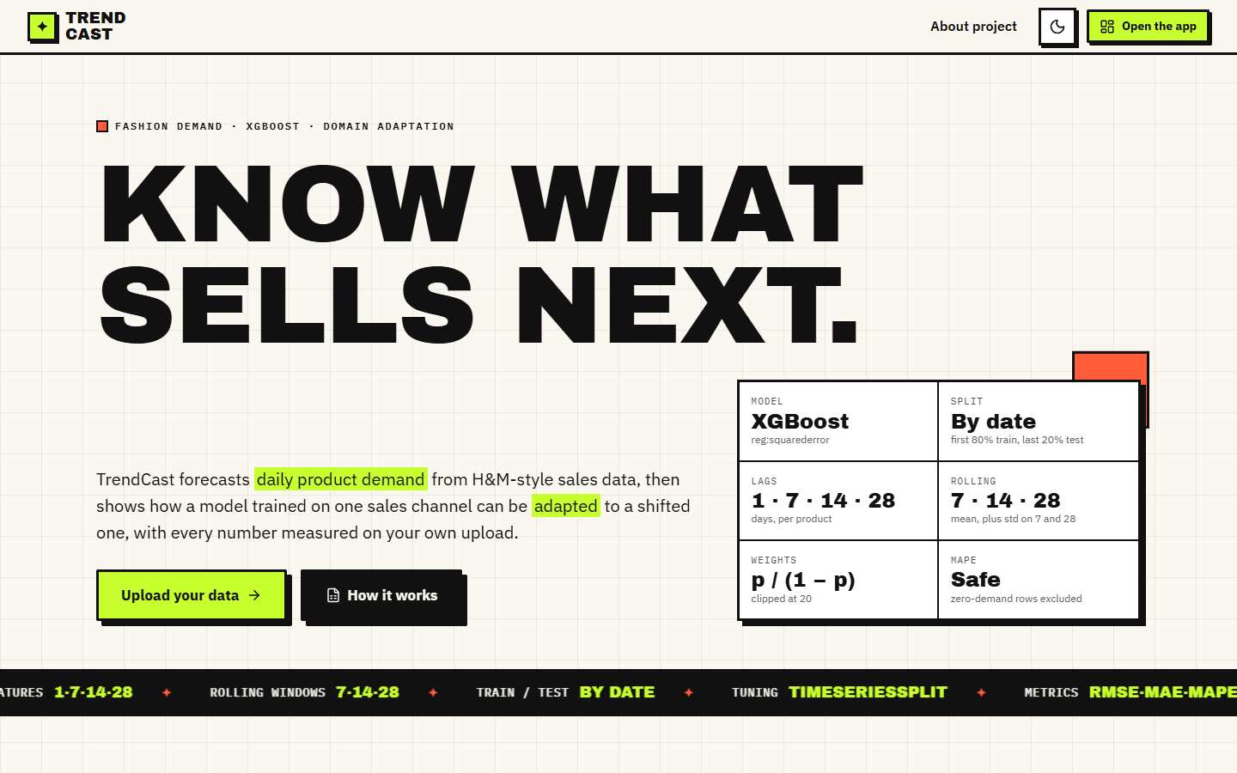  Figure 34: Additional screen: landing page, light theme, with the model, split, lag, rolling, weight and MAPE summary card. |   Figure 35: Additional screen: landing page, dark theme.

The landing page is public and needs no data; its card restates how the model is built (XGBoost, split by date, lags 1/7/14/28, rolling windows, weights p/(1-p) clipped at 20, safe MAPE).
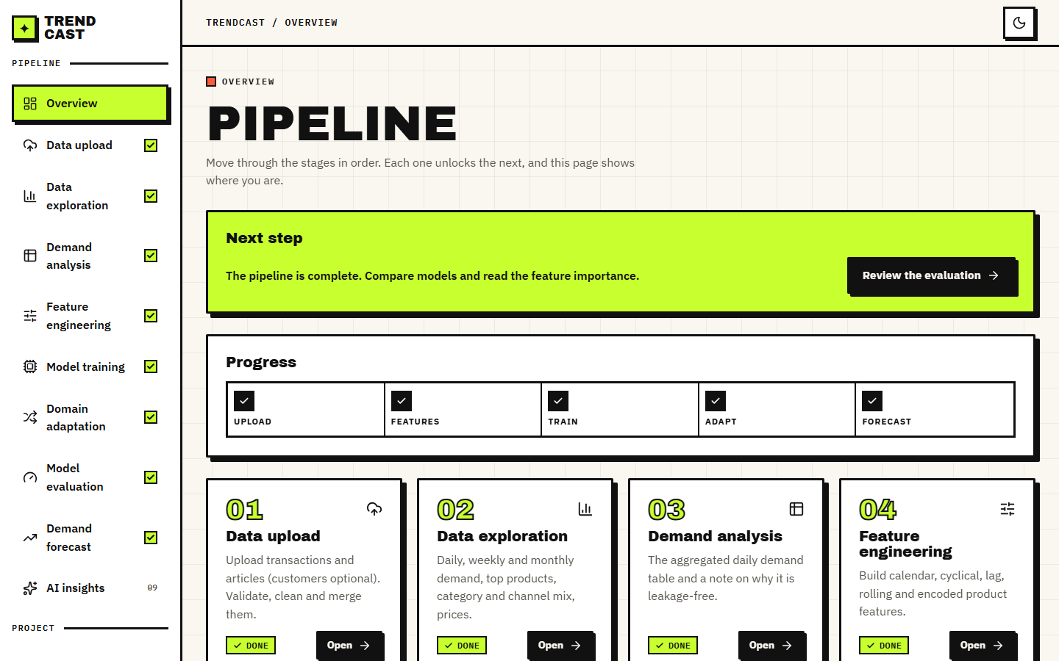  Figure 36: Additional screen: Overview page after the whole pipeline has run, with the progress checklist and the step cards. | 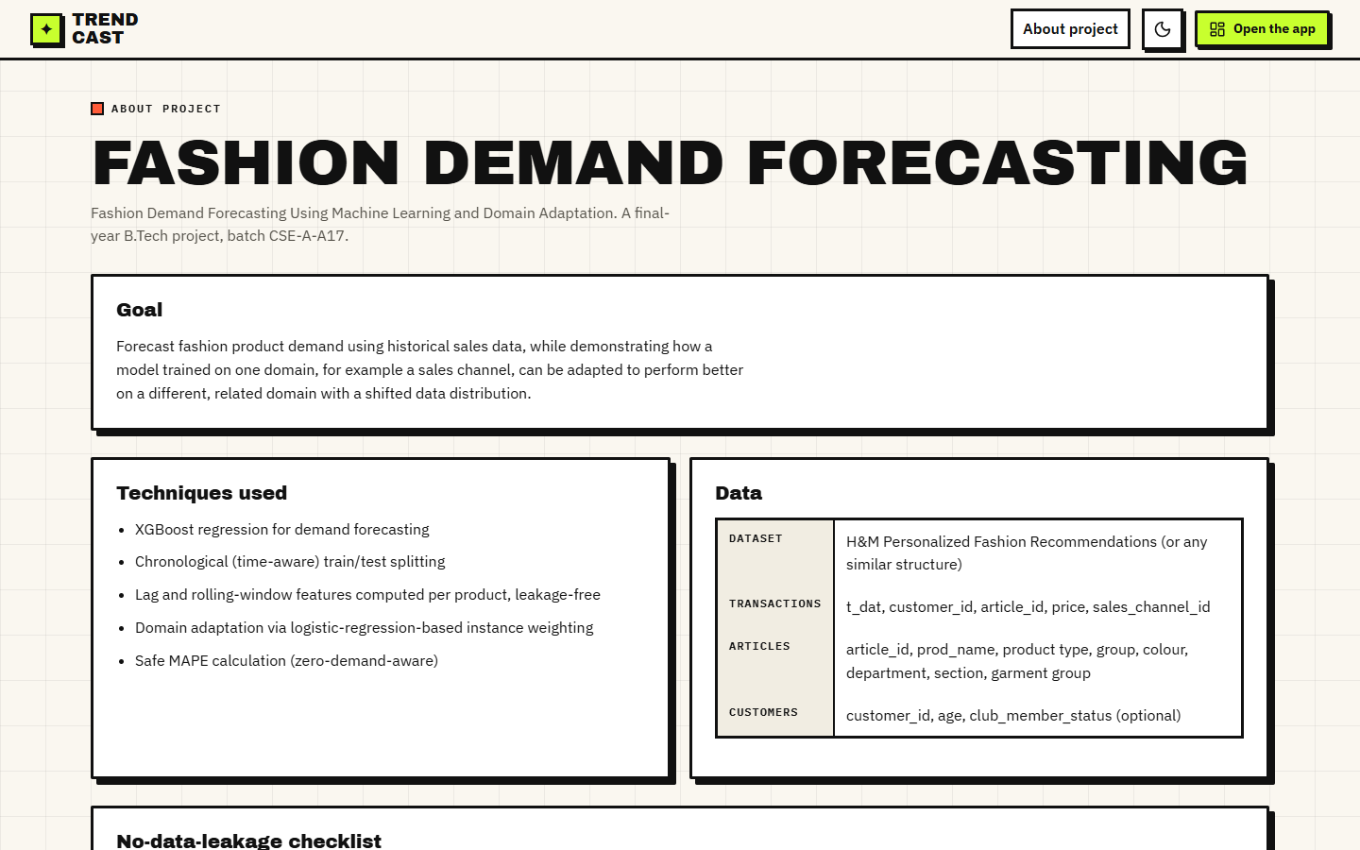  Figure 37: Additional screen: About page with the goal, the techniques used and the data tables.

The overview page shows the progress checklist and the next step; the about page lists the goal, the techniques and the columns each uploaded table needs.
Figure 38: Additional screen: Feature engineering page before the feature table is built. | Figure 39: Additional screen: Domain adaptation form with the domain column, source and target values.

Before the feature table exists the page shows an empty state and one button; the domain form offers the three domain columns, with channel 1 as source and channel 2 as target by default.
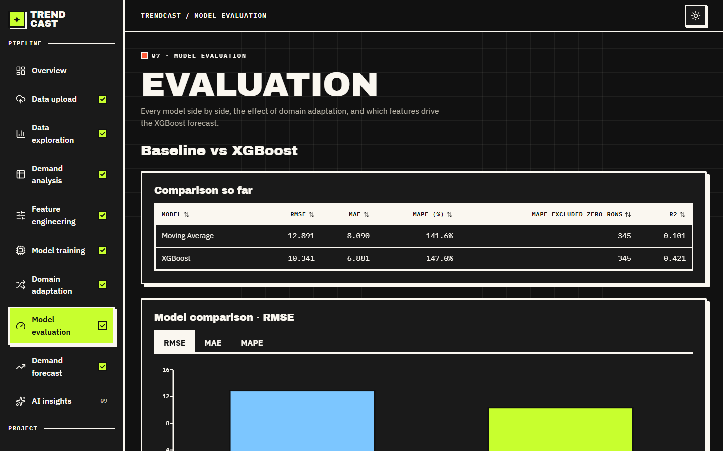
Figure 40: Additional screen: Model evaluation page in the dark theme, with the comparison table and the RMSE chart.
The comparison table shows the tuned XGBoost that was the last model trained during the screenshot run (RMSE 10.341, R2 0.421), not the default model whose five-seed mean is 11.089.

